No Limit Genetics Faces Limitations During The 2020 Show Season

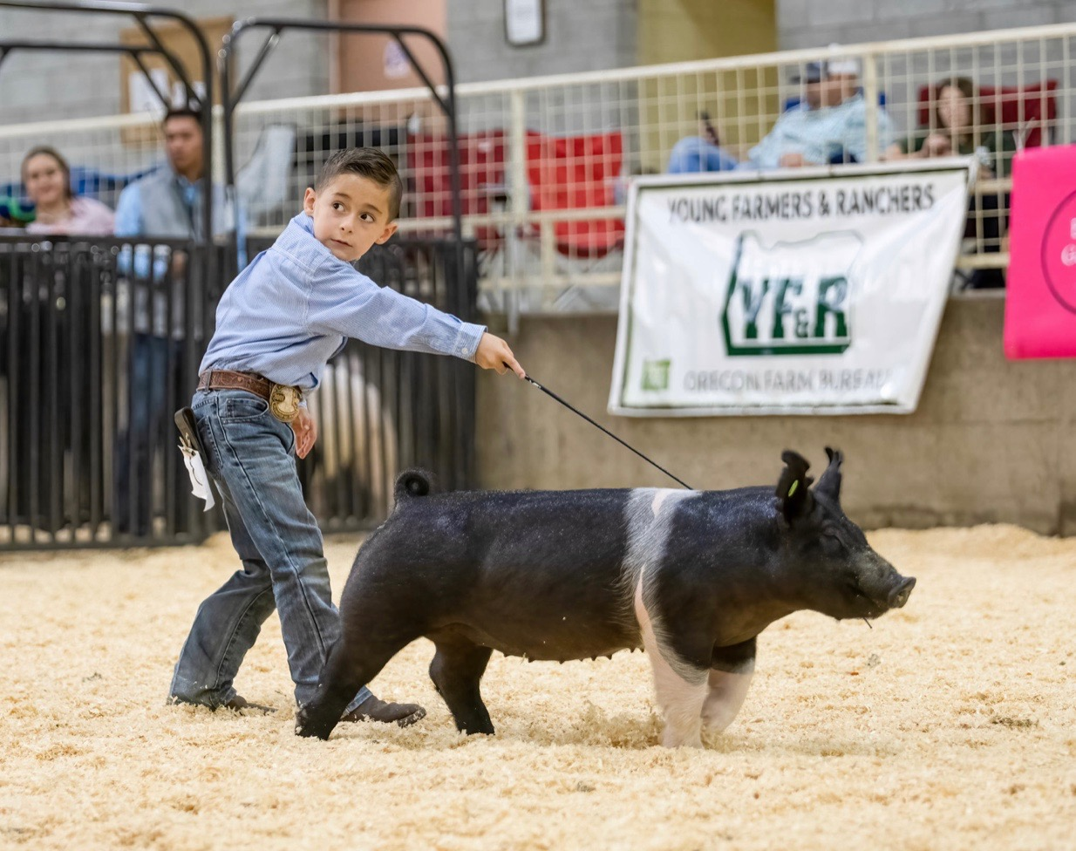

Mackenzie Wille
December 2, 2020

The COVID-19 Pandemic has caused many livestock shows across the United States to be canceled, thus causing families to not purchase as many, if any hogs for this show season.

No Limit Genetics is a family owned show pig business which is owned by the Mendonza family and they are located in Modesto, California. The Mendonza’s have been raising show pigs for 15 years, this is something that Adam did with his father. Adam now has three of his own boys and he hopes that they will carry out the family tradition.

The Mendonza’s own 25 sows and those sows usually have 30 to 35 litters in an average year. Each litter has an average of six to twelve piglets, these piglets are sold as weanling pigs to youth members across the nation. No Limit Genetics is represented with the pigs they sell show at local county fairs, state fairs, and national shows. The two older Mendonza boys also show pigs that they breed at multiple shows across the country.

The piglets that No Limit Genetics are usually cosigned to an online, they have roughly two to three sales each year. On average, No Limit Genetics makes $500 per piglet if not more. This is the Mendonza’s family main source of income each year along with the few crops they farm. Adam Mendonza said, “I raise show pigs because I am building a future for my boys and I hope they will continue to do this with their children.” Adam strives to breed competitive show pigs to ensure that they pig they sell are successful in the show ring, this is to make sure that No Limit Genetics is becoming a well-known name.

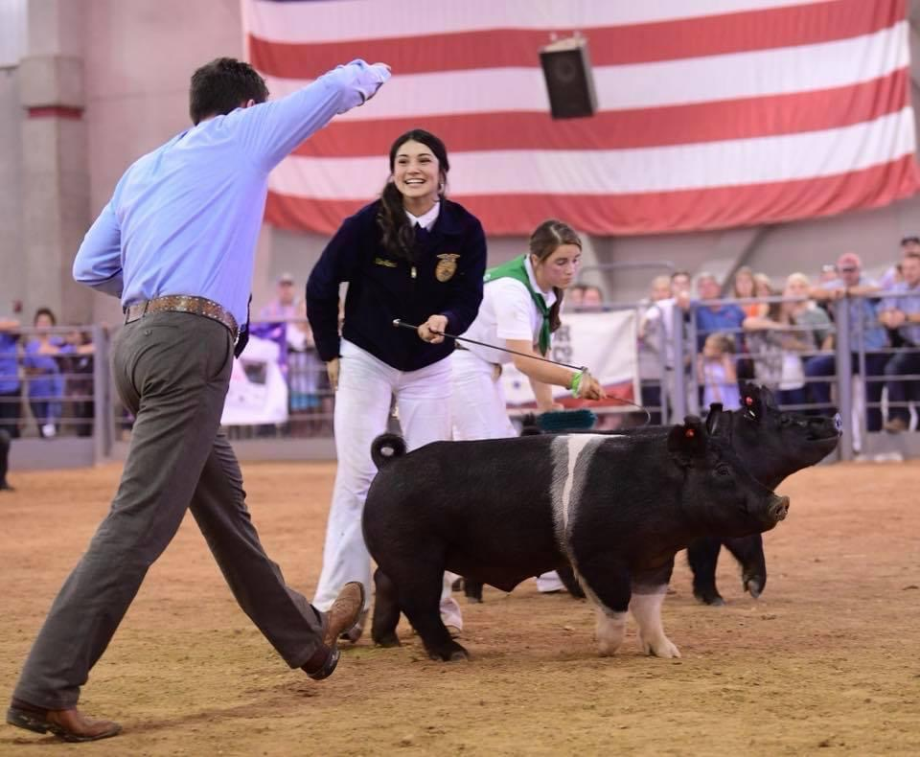

Kilee Gilland receiving the “Champion Slap” at the 2018 California State Fair with her market barrow bred by No Limit Genetics.

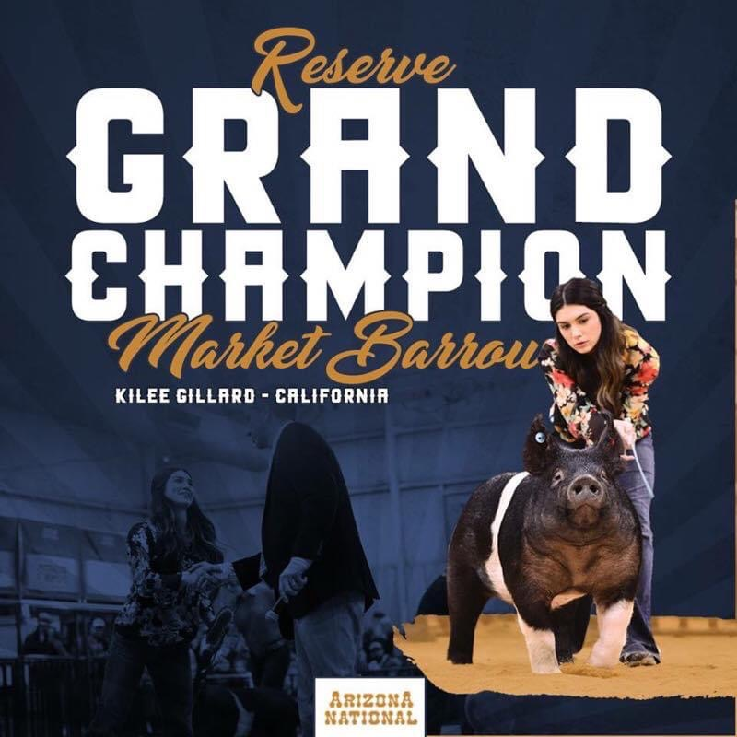
2018 and 2019 were very successful years during the show seasons for No Limit Genetics. They had two major success, one at the California State fair and the Arizona National Stock Show in 2018. Both of these were made possible for No Limit Genetics by Kille Gilland. Adam Mendonza said, “These past few years had me very excited for the 2020 show season. We had some of our best sows bred to the best the boars you can get in the nation.” The Mendonza family had every right to be excited about the 2020 show season, like many of their customers. They had already sold their winter litters which was a total of 103 piglets and as March approached they were excited to see these pigs in a show ring. Until it became prevalent the COVID-19 Pandemic would shortly take over the show pig industry.

Shortly after the stay at home order was put into place across the country many show committees began to cancel their events, thus causing youth throughout the country having nowhere to show their hogs. Almost every national show, state fair, and local county fairs canceled their shows immediately. Some shows postponed but only to cancel later in the year as the virus is still spreading rapidly. No Limit Genetics had 15 sows bred for late spring and early summer litters, these litters would usually be worth the most money because they are sold for state fairs and national shows. This made the Mendonza family nervous about their finical outcome for the remainder of 2020.

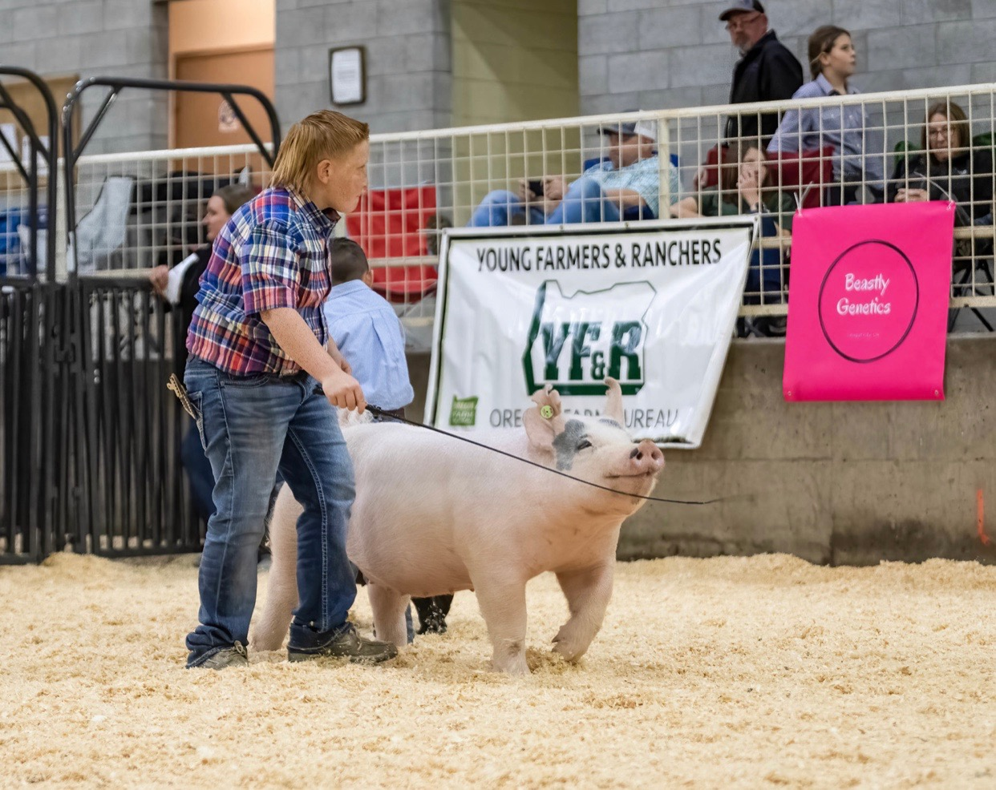
Carson Mendonza, seen in the picture to the right, said “No matter what happened I told my dad I wanted show pigs in the barn this year because I didn’t have to go to school so I could just be in the barn all day”. Carson was not the only one who had this mindset at the virus continued to spread. When May came around and the rest of No Limit Genetics litters started to be born, many families started to call about purchasing pigs. Adam Mendonza was surprised at the amount of families that were still purchasing pigs for the fall and winter shows, in hopes that something might change.

Adam Mendonza said, “We made hardly any money this year and this was scary for us, but we grew as a family. We still fed out a small show string of pigs because it’s what my sons, Carson and Alex wanted. With the future so uncertain my wife and I decided we needed to do this for them, no matter what the finical consequence may be.” While No Limit Genetics did not sell as many pigs as they usually do, nor did they sell those pigs for as much money as normal, they still had a successful year.

Many of the families on the West Coast that decided to take the finical risk of feeding out a show string of hogs had an opportunity to show at a live show. Despite the pandemic at hand the Northwest Regional Fall Standoff, took the risk and held a live show. This show was held in Klamath Falls, Oregon on Veterans Day weekend. There was a total of 132 youth members that arrived with a total of 329 head of hogs.

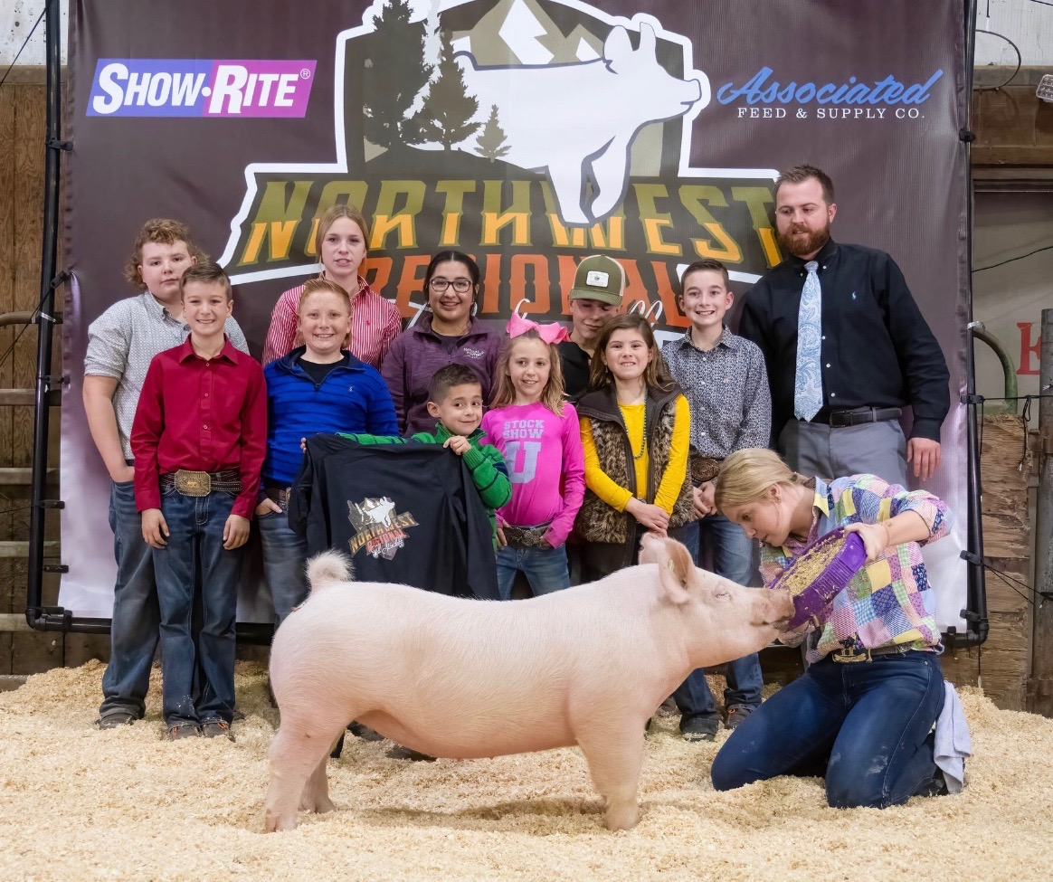
The Mendonza family was able to travel the 374 miles to the show so that Carson and Alex could have the opportunity to show their hogs. There were multiple families that attend the show that had hogs which were purchased from No Limit Genetics out of there later litters. Many of these exhibitors found themselves placing rather high in their respective classes, this caused the Mendonza family to be so excited that their hogs they had bred were still doing well. The Mendonza family themselves had great success at the show as well. Their middle son, Alex, had the Champion Yorkshire Female. This was only young Alex’s third show and he said, “I am stoked to be here and so happy with how Snow Flake did in the show ring”. Seeing Alex standing at the backdrop made the Mendonza family realize that the financial risk that they took was well worth it.

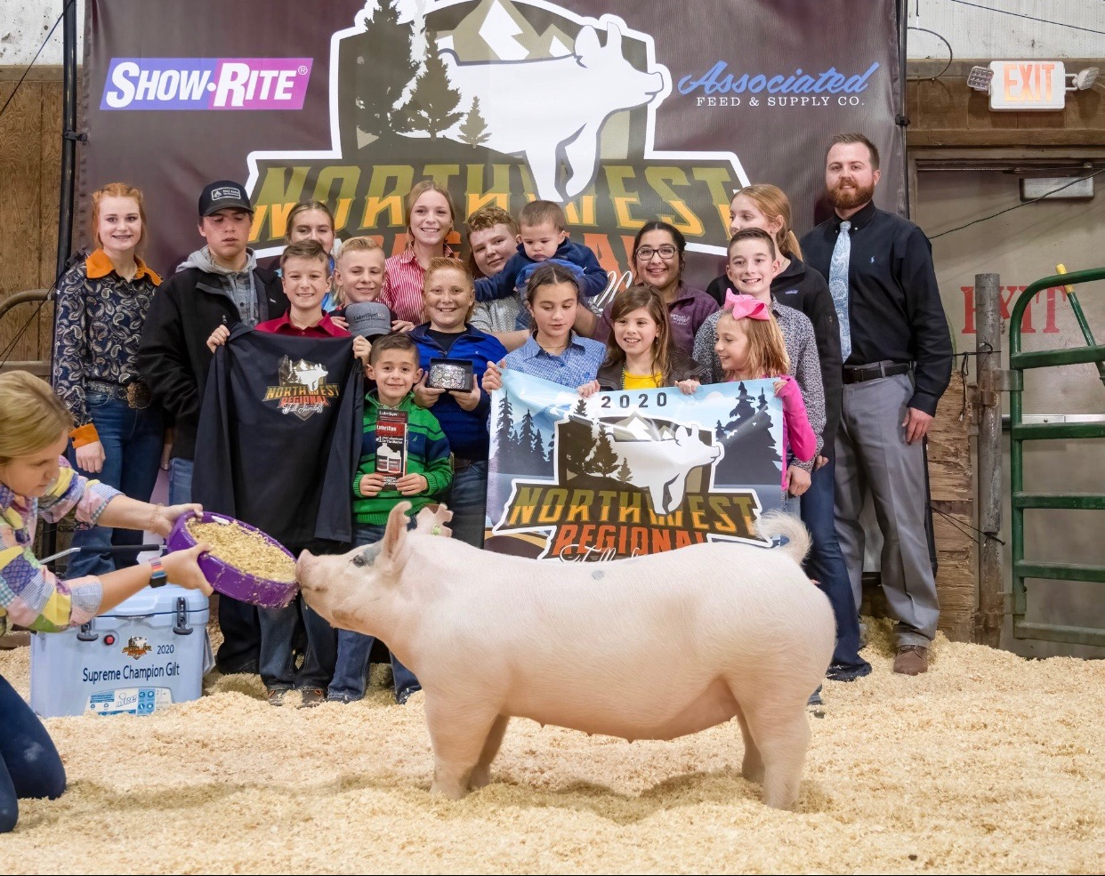
Carson Mendonza’s Supreme Champion Gilt, along with all the youth members who purchased hogs from No Limit Genetics and the Judge of the show, Brennen North.

On the final day at the Northwest Regional Fall Standoff Carson Mendonza, the oldest son, won Supreme Champion Female which is the highest award you can win. When they went to the backdrop for their champion photo, the Mendonza family asked everyone who had purchased pigs from them to join their backdrop photo. Everyone in the photo took a chance purchasing pigs from No Limit Genetics and feeding those pigs out. No Limit Genetics is grateful that they were able to continue their success in the show ring in 2020. But they are also thankful for everyone who purchased pigs from them, this experience has allowed the Mendonza family to grow and overcome hard times.

