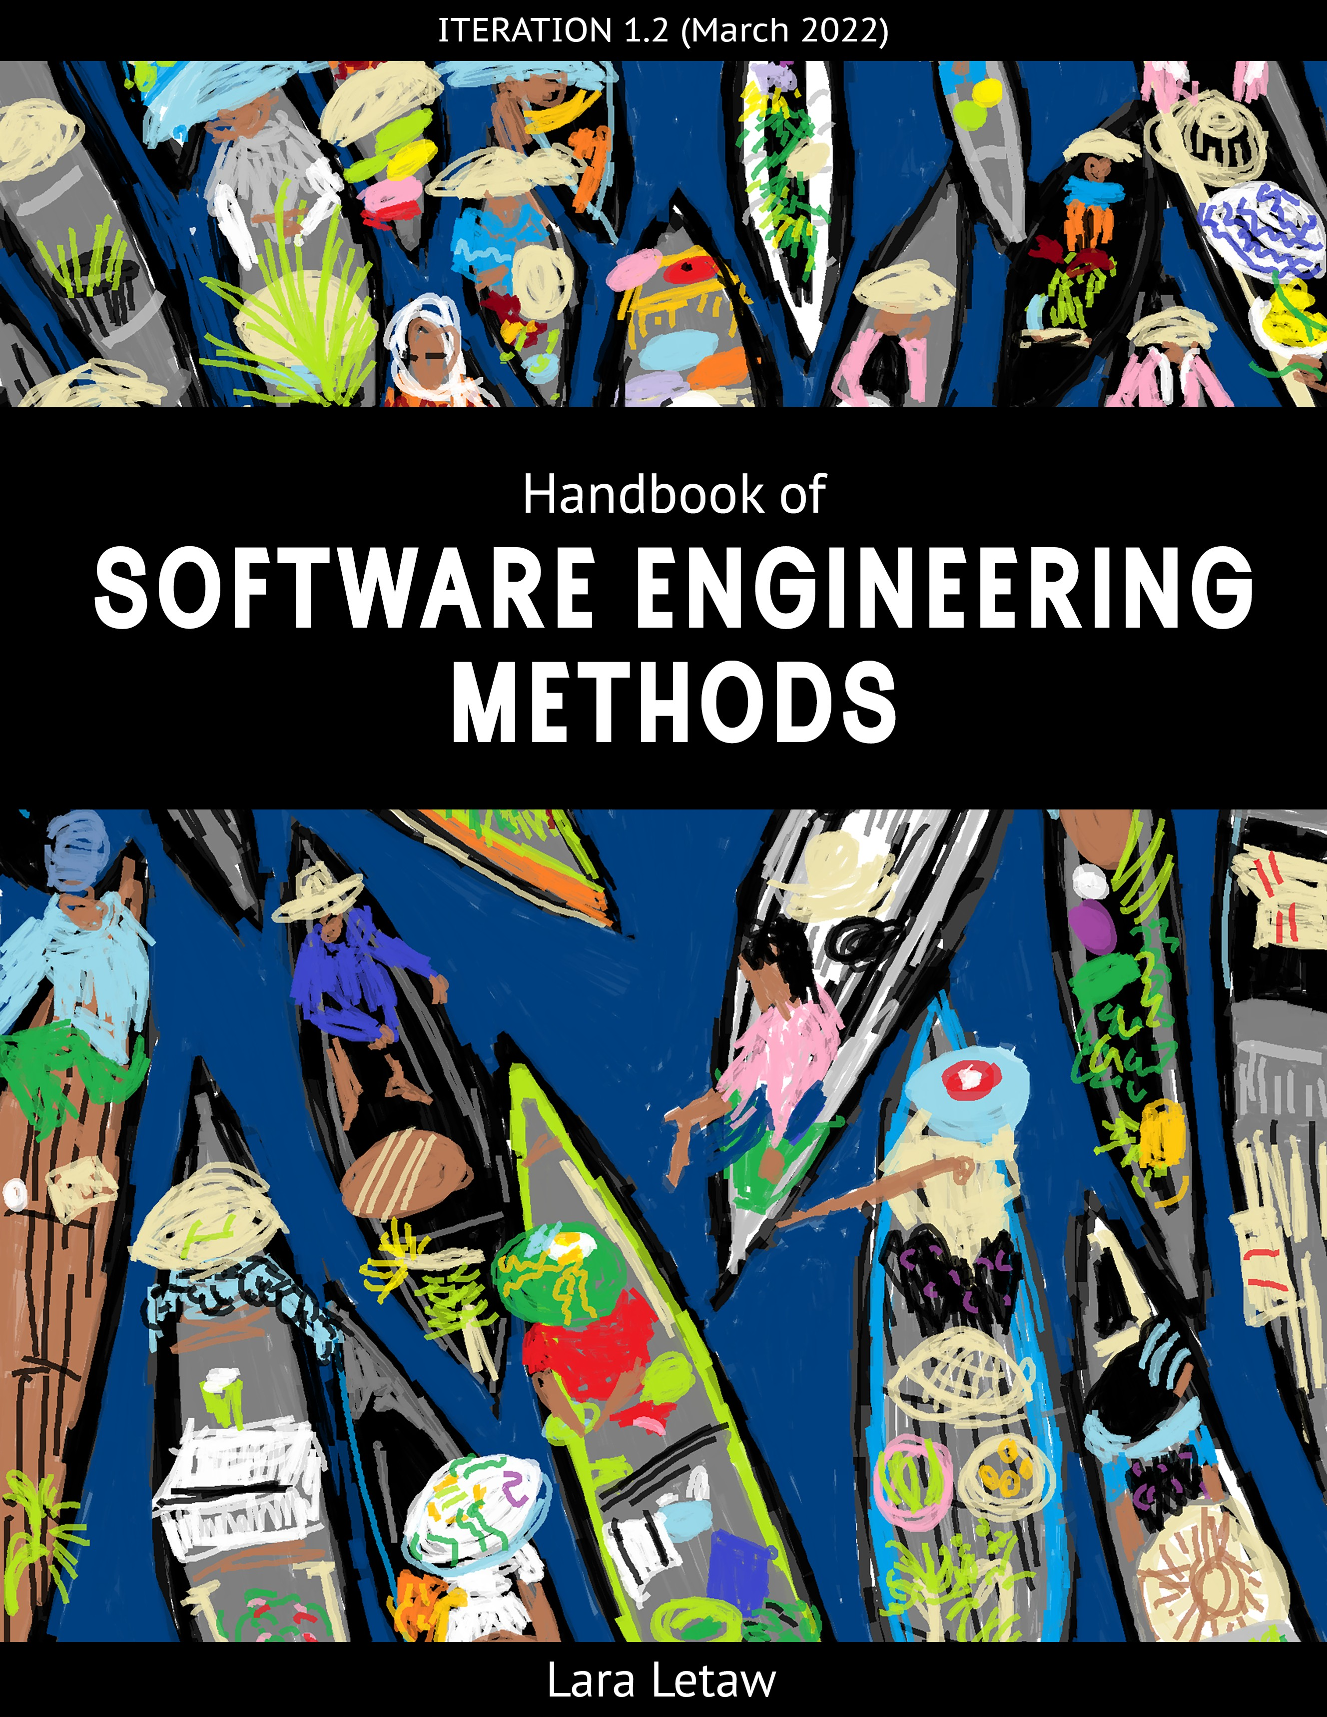
1

Handbook of Software Engineering Methods

Lara Letaw March 28, 2022

Contents

Introduction 7
  - What’s software engineering? 7
  - What’s the philosophy behind this book? 8
    - Software engineering is not black and white 8
    - Studying every detail of software engineering is a waste of time 9
    - Agile isn’t perfect but I really like it (and other people do too) 9
  - What’s this book like? 9
  - What’s the future of this book? 10
  - License 11
  - Acknowledgments 11

Agile 13
  - Software Development Lifecycle (SDLC) 14
    - Why care about Agile, other software process models, and software engi- neering methods? 15
  - Agile, Scrum, and Agile Methods 16
    - Agile 16
    - Scrum 16
3

 | 2.2.3 Agile Methods . . . . . . . . . . . . . . . . . . . . . . . . . . . . . . . . | 18
 | 2.3 Conclusion . . . . . . . . . . . . . . . . . . . . . . . . . . . . . . . . . . . . . . | 18
3 | Project Management & Teamwork | 21
 | 3.1 Why learn about project management? . . . . . . . . . . . . . . . . . . . . . . . . | 22
 | 3.2 Triple Constraint . . . . . . . . . . . . . . . . . . . . . . . . . . . . . . . . . . . | 22
 | 3.3 Managerial Skill Mix . . . . . . . . . . . . . . . . . . . . . . . . . . . . . . . . . | 24
 | 3.4 Interpersonal Skills: Team Communication . . . . . . . . . . . . . . . . . . . . . | 25
 | 3.4.1 Establishing Ground Rules . . . . . . . . . . . . . . . . . . . . . . . . . . | 25
 | 3.4.2 Defining Roles and Responsibilities: RACI Matrix . . . . . . . . . . . . . | 26
 | 3.4.3 Measuring and Building Consensus: Fist of Five Method . . . . . . . . . . | 27
 | 3.5 Technical Skills: Project Definition . . . . . . . . . . . . . . . . . . . . . . . . . . | 28
 | 3.5.1 Project Scope . . . . . . . . . . . . . . . . . . . . . . . . . . . . . . . . . | 28
 | 3.5.2 Balancing Constraints: Project Priority Matrix . . . . . . . . . . . . . . . | 28
 | 3.5.3 Task Prioritization: Eisenhower Matrix . . . . . . . . . . . . . . . . . . . | 29
 | 3.5.4 Finer-Grained Prioritization . . . . . . . . . . . . . . . . . . . . . . . . . | 30
 | 3.5.5 Estimation: Story Points, Ideal Days, and Planning Poker . . . . . . . . . . | 32
 | 3.5.6 Scheduling: Project Network . . . . . . . . . . . . . . . . . . . . . . . . . | 33
 | 3.5.7 Task Management Systems . . . . . . . . . . . . . . . . . . . . . . . . . . | 34
 | 3.6 Conclusion . . . . . . . . . . . . . . . . . . . . . . . . . . . . . . . . . . . . . . | 35
 | 3.7 Additional Resources . . . . . . . . . . . . . . . . . . . . . . . . . . . . . . . . . | 36
4 | Requirements | 39
 | 4.1 Types of Requirements . . . . . . . . . . . . . . . . . . . . . . . . . . . . . . . . | 39
 | 4.2 Why Requirements Matter . . . . . . . . . . . . . . . . . . . . . . . . . . . . . . | 40
 | 4.3 What Makes a Good Requirement . . . . . . . . . . . . . . . . . . . . . . . . . . | 41
 | 4.4 Requirements Elicitation . . . . . . . . . . . . . . . . . . . . . . . . . . . . . . . | 41
 | 4.5 Non-Functional Requirements . . . . . . . . . . . . . . . . . . . . . . . . . . . . | 43
 | 4.5.1 Quality Attributes . . . . . . . . . . . . . . . . . . . . . . . . . . . . . . | 43
 | 4.6 Functional Requirements . . . . . . . . . . . . . . . . . . . . . . . . . . . . . . . | 44
 | 4.6.1 User Stories . . . . . . . . . . . . . . . . . . . . . . . . . . . . . . . . . . | 44
 | 4.6.2 Use Cases . . . . . . . . . . . . . . . . . . . . . . . . . . . . . . . . . . . | 47
 | 4.7 Requirements Specification . . . . . . . . . . . . . . . . . . . . . . . . . . . . . . | 48
 | 4.8 Conclusion . . . . . . . . . . . . . . . . . . . . . . . . . . . . . . . . . . . . . . | 50
 | 4.9 Additional Resources . . . . . . . . . . . . . . . . . . . . . . . . . . . . . . . . . | 50
5 | Unified Modeling Language (UML) Class and Sequence Diagrams  5.1 How Diagrams Help . . . . . . . . . . . . . . . . . . . . . . . . . . . . . . . . . | 51  51
 | 5.2 What Diagrams Must Do Well . . . . . . . . . . . . . . . . . . . . . . . . . . . . | 52
 | 5.3 What is UML? . . . . . . . . . . . . . . . . . . . . . . . . . . . . . . . . . . . . | 52
 | 5.4 Why use UML? . . . . . . . . . . . . . . . . . . . . . . . . . . . . . . . . . . . . | 53
 | 5.5 Why NOT use UML? . . . . . . . . . . . . . . . . . . . . . . . . . . . . . . . . . | 54
 | 5.6 Class Diagrams . . . . . . . . . . . . . . . . . . . . . . . . . . . . . . . . . . . . | 54
 | 5.6.1 UML Class Diagram Notation . . . . . . . . . . . . . . . . . . . . . . . . | 55
 | 5.7 Sequence Diagrams . . . . . . . . . . . . . . . . . . . . . . . . . . . . . . . . . . | 56

CONTENTS 5
5.7.1 UML Sequence Diagram Notation 57
  - Conclusion 58
  - Additional Resources 58
- Monolith vs. Microservices Architectures 59
  - Monolith Architecture 60
  - Microservice Architecture 60
    - “Smart endpoints and dumb pipes” 60
    - “Componentization via services” 61
    - “Organized around business capabilities” 61
    - “Decentralized data management” 63
    - “Decentralized governance” 63
    - “Design for failure” 63
  - Comparison Between Monolith and Microservices 63
    - How does communication happen within a monolith versus between mi- croservices? 63
    - How is a monolith deployed vs. microservices? 64
    - How is a monolith scaled vs. microservices? 64
    - How is a monolith tested vs. microservices? 64
    - How is a monolith upgraded vs. microservices? 64
    - How is the database used in a monolith vs. microservices? 64
  - Conclusion 64
  - Additional Resources 65
- Paper Prototyping 67
  - Showing Interaction 69
  - Showing Your Concept to Others 70
  - Conclusion 71
  - Additional Resources 71
- Cognitive Style Heuristics 73
  - Cognitive Style Facets 74
  - Cognitive Style Personas 75
    - Abi, Pat, and Tim 76
  - The Heuristics 77
    - Heuristic #1 (of 8): Explain the benefits of using new and existing features 77
    - Heuristic #2 (of 8): Explain the costs of using new and existing features 78
    - Heuristic #3 (of 8): Let people gather as much information as they want,
and no more than they want 79
    - Heuristic #4 (of 8): Keep familiar features available 80
    - Heuristic #5 (of 8): Make undo/redo and backtracking available 81
    - Heuristic #6 (of 8): Provide an explicit path through the task 82
    - Heuristic #7 (of 8): Provide ways to try out different approaches 83
    - Heuristic #8 (of 8): Encourage tinkerers to tinker mindfully 84
  - Background 86

 | 8.5 Conclusion . . . . . . . . . . . . . . . . . . . . . . . . . . . . . . . . . . . . . . | 86
 | 8.6 Additional Resources . . . . . . . . . . . . . . . . . . . . . . . . . . . . . . . . . | 87
9 | Code Smells and Refactoring | 89
 | 9.1 Why care about code smells? . . . . . . . . . . . . . . . . . . . . . . . . . . . . . | 90
 | 9.2 Your code stinks, now what? . . . . . . . . . . . . . . . . . . . . . . . . . . . . . | 91
 | 9.3 Comments . . . . . . . . . . . . . . . . . . . . . . . . . . . . . . . . . . . . . . . | 91
 | 9.3.1 Drawbacks of Having Many Comments . . . . . . . . . . . . . . . . . . . | 91
 | 9.3.2 Code Smells about Comments . . . . . . . . . . . . . . . . . . . . . . . . | 92
 | 9.4 Functions . . . . . . . . . . . . . . . . . . . . . . . . . . . . . . . . . . . . . . . | 93
 | 9.4.1 Code Smells about Functions . . . . . . . . . . . . . . . . . . . . . . . . . | 93
 | 9.5 Code . . . . . . . . . . . . . . . . . . . . . . . . . . . . . . . . . . . . . . . . . . | 94
 | 9.5.1 Code Smells about Code in General . . . . . . . . . . . . . . . . . . . . . | 94
 | 9.6 Conclusion . . . . . . . . . . . . . . . . . . . . . . . . . . . . . . . . . . . . . . | 97
 | 9.7 Additional Resources . . . . . . . . . . . . . . . . . . . . . . . . . . . . . . . . . | 97
10 Conclusion |  | 99
Glossary |  | 101
Bibliography |  | 110
Index |  | 117

Chapter 1 Introduction

I won’t tell you how to be a software engineer; You’ll learn that over time by doing it. Instead, this book is about software engineer- ing methods: Ways people achieve specific objectives in software engineering—that can save your project. My hope is that, after read- ing this book (or parts of it), you’ll feel better equipped for software engineering.

What’s software engineering?
Let’s build a definition from the bottom up:

    - Software engineering is not the same as programming

7

method: A pre-established way of achieving a specific outcome.
. . . . . . . . . . . . . . . . . . . . . . . . . . . . . .
sustainability: Degree to which software can continue to function over time (e.g., measured in time and how well the software is func- tioning).
. . . . . . . . . . . . . . . . . . . . . . . . . . . . . .
extensible: Built in such a way to support adding more functionality later.
. . . . . . . . . . . . . . . . . . . . . . . . . . . . . .
triple constraint: In project man- agement, the three limiting fac- tors that govern project execution: time, cost, and scope. Scope includes quality. Cost includes spending money and resources.
. . . . . . . . . . . . . . . . . . . . . . . . . . . . . .
software engineering: The art and science of using different methods to efficiently create extensible, sustainable programs that solve problems people care about.
- Software engineering involves trying to apply methods
- Software engineering involves trying to make programs that have a long lifespan (sustainable)
- Software engineering involves trying to make programs that can be added to (extensible)
- Software engineering involves trying to balance time, cost, and scope (the triple constraint)
- Software engineering often involves teamwork
- Software engineering involves trying to solve problems peo- ple care about
- Software engineering involves both artistry and science.

Our definition:

Software engineering is the art and science of using dif- ferent methods to efficiently create extensible, sustain- able programs that solve problems people care about.

What’s the philosophy behind this book?
My beliefs about software engineering influenced how I wrote this book. Some of my strongest beliefs about software engineering are described below.

Software engineering is not black and white
Throughout the book, I’ve tried to communicate that software engi- neering is the gray area of computer science. “Right” answers can be difficult to find and may not be reproducible in different contexts. Software engineering as a field also keeps changing as research sci- entists gather new findings, engineers develop new technologies, vi- sionaries define new methods, and the outside world changes (e.g., a pandemic happened while I was writing this book and that changed how software engineering teams collaborate). Whereas in program- ming you might ask, “Is this algorithm correct?”, questions in soft- ware engineering are more like, “How does my team know this soft- ware is ready to release?” or, “People keep misinterpreting my code, how do I shift it toward better understandability and maintainabil- ity?”

1.3. WHAT’S THIS BOOK LIKE? 9

Studying every detail of software engineering
is a waste of time Agile: A software process model

I’m not going to tell you everything you need to know about soft- ware engineering because (1) what you need to know can be drasti- cally different depending on context and (2) if I tried to, this book would be thousands of pages and possibly useless. Instead, I’ll in- troduce a set of software engineering methods that are known to be useful across contexts, give guidance on when and why to use them, and point to resources for when you want more information.

Agile isn’t perfect but I really like it (and other people do too)
This book leans so far toward Agile the two are probably in a re- lationship. That’s because Agile development environments have become extremely popular—and because I like Agile: It matches how I think, and has been appropriate for nearly all the projects I’ve worked on. But you’re not me, and Agile isn’t the be-all-end-all, so I’m planning to incorporate more from other software process mod- els in the future.

What’s this book like?
It was written iteratively (“Do something. Now do it again, but bet- ter”) and incrementally (“Now do a little more”). Lots of software is written the same way.
and philosophy for managing and developing software projects. Ag- ile values: Individuals and inter- actions, working software, cus- tomer collaboration, and respond- ing to change.
. . . . . . . . . . . . . . . . . . . . . . . . . . . . . .
software process model: A phi- losophy and/or set of approaches for software development and/or software project management.
. . . . . . . . . . . . . . . . . . . . . . . . . . . . . .
iteration: Verb: Revision. Noun (in Agile): A time-boxed software development cycle.
. . . . . . . . . . . . . . . . . . . . . . . . . . . . . .
increment: In software, a mea- surable increase in functionality.

It has eight major topics: Over here in the margin is where to find definitions (also in the

- Agile: Collaboration-oriented philosophy of creating software
that values doing over comprehensive planning and documen- tation
- Project management & teamwork: Working in an organized way—and with other people
- Requirements: Being clear about what’s expected of the soft- ware
- Unified modeling language (UML) class and sequence dia- grams: A couple types of diagrams useful for communicating how your code works (or should work)
Glossary).
. . . . . . . . . . . . . . . . . . . . . . . . . . . . . .
This is also where to find asides: Comments that are related to the content but don’t fit into its flow or seem worth emphasizing.

This book might get shorter before it gets longer; I’ve tried to keep
- Monolith vs. microservices architectures: Two contrasting high-level ways to organize code
- Paper prototyping: Creating a good user interface design be- fore coding it
- Cognitive style heuristics: Making software work well for different kinds of people who are not like you
- Code smells & refactoring: Making your code nicer to work with
It’s short and meant to be readable:

chapters concise but informative. • Important terms and concepts are bolded
  - Margins contain term definitions and side notes (relevant ad- ditional thoughts)
  - Additional resources are listed at the end of each major chap- ter
My aim is that you be able to quickly (1) determine whether each topic or method is relevant to your situation and (2) get a basic un- derstanding of the topic or method so you can discuss it with others or have a starting point for exploring more.

What’s the future of this book?

For source files, updated versions, or to make sugges- tions: https://github.com/ setextbook

I’ll keep iterating and incrementing. If you have content requests, suggestions, or other feedback, you can create an issue or pull request
on this book’s GitHub repository: https://github.com/setextbook.

Potential future additions:
- Debugging
- Deployment
- DevOps
- Ethics
- More software architectures
- More software process models
- Object-oriented design principles
- Professionalism
- Software used by software engineers
- Testing your code (verification)

  - LICENSE 11
    - More examples, figures, and images * * Yep, I’m the “illustrator” (a gen- erous title).
This book could also become part of your own book / course / blog / etc.—feel free to use the whole thing or pieces of it (non- commercially).

License
Creative Commons Attribution-NonCommercial (CC BY-NC)

Acknowledgments
Thanks to Caius Brindescu, Raffaele de Amicis, Sèanar Letaw, and Tiffany Rockwell for their feedback, advice, and support. Additional thanks to family and friends for their support. Thanks to the many software engineering students and other individuals who gave feed- back, including Richard Brinkley, Maximillian Davensmith, Brian Doyle, and Jack LaBarba. Thanks to the Oregon State University Open Educational Resources (OER) Unit for making the whole ef- fort possible.

Chapter 2 Agile

This book is geared toward Agile, but there are other software Agile: A software process model

process models. Each software process model has a different way of proceeding through the software development lifecycle (SDLC). This chapter starts by describing the SDLC and Agile versus another software process model. That is followed by a discussion of Scrum (an Agile framework) and Agile methods.
This chapter will give you the flavor of Agile and Scrum rather than being a comprehensive guide. For more detailed information about topics introduced here, see the Additional Resource section at the end of the chapter.

13
and philosophy for managing and developing software projects. Ag- ile values: Individuals and inter- actions, working software, cus- tomer collaboration, and respond- ing to change.
. . . . . . . . . . . . . . . . . . . . . . . . . . . . . .
software process model: A phi- losophy and/or set of approaches for software development and/or software project management.

Scrum: An Agile framework “for developing and sustaining com- plex products.” (Schwaber and Sutherland 2020)
. . . . . . . . . . . . . . . . . . . . . . . . . . . . . .
software development lifecycle (SDLC): Phases through which a software’s development proceeds: requirements, design, implemen- tation, testing, maintenance.
. . . . . . . . . . . . . . . . . . . . . . . . . . . . . .
verification: Confirming that software satisfied its requirements (“did we build the software right?”).
. . . . . . . . . . . . . . . . . . . . . . . . . . . . . .
validation: Confirming that soft- ware meets users’ needs (“did we build the right software?”).
. . . . . . . . . . . . . . . . . . . . . . . . . . . . . .
maintenance: Development ac- tivities that improve software but that are unrelated to implement- ing new features (e.g., correcting bugs, improving organization of code, etc.).
. . . . . . . . . . . . . . . . . . . . . . . . . . . . . .
increment: In software, a mea- surable increase in functionality.
. . . . . . . . . . . . . . . . . . . . . . . . . . . . . .
waterfall (software process model): Way of going about software development and man- agement that is characterized by extensive planning, comprehen- sive documentation, and moving linearly through stages of the software development lifecycle (SDLC).

Software Development Lifecycle (SDLC)
The software development lifecycle (SDLC) is the way a software project proceeds through the SDLC stages:
    - Requirements: Defining what the software must do, how well it must do what it will do, and under what limitations or con- straints
    - Design: Defining how the code will be structured and how the user will experience the software
    - Implementation: Coding or otherwise converting the design into a product
    - Testing: Checking that the code was written without fault (verification) and that the software is what the users or client wants (validation)
    - Maintenance: Improving software’s existing functionality There are different ways to travel through the SDLC stages. Pat-
terns of travelling through the stages are called software process

models.
Commonly, people compare the Agile software process model with the Waterfall model. Agile, guided by the Agile Manifesto, moves through the SDLC approximately like this:

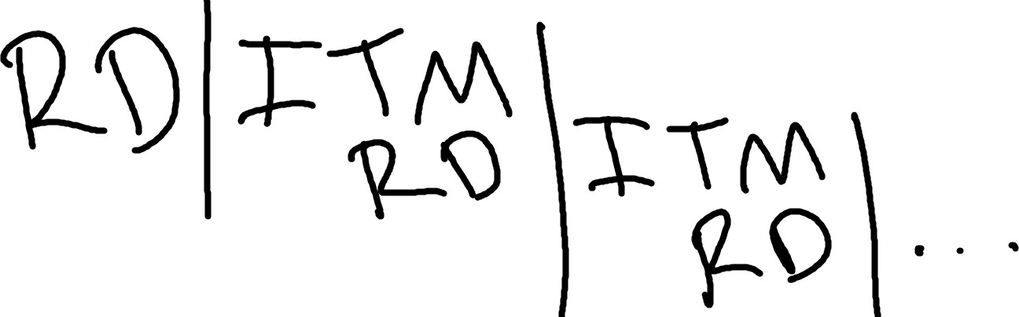

Vertical lines represent development cycle boundaries. Planning (R,D) for the next development cycle starts during the previous cycle. Agile development cycles are relatively short and numerous. Re- leases are frequent and incremental: Each cycle, there’s a little more working functionality. There are multiple frameworks for develop- ing and managing software in an Agile way, such as Scrum, Extreme
Programming (XP), and Kanban.
Waterfall moves through the SDLC approximately like this:

  - SOFTWARE DEVELOPMENT LIFECYCLE (SDLC) 15

Movement in linear; Each stage must be completed before mov- ing to the next, and turning back is not allowed (you can’t swim up a waterfall)—unless the project is starting over. Lots of documenta- tion is produced on the way. There are multiple variants of Waterfall, such as the V-Model, RAD, and the Royce model.

Why care about Agile, other software process models, and software engineering methods?

Some reasons:
      - So you can detect and/or understand what a software de- velopment team is doing. When you’re new to a team, having a general understanding of different software process models can help you ask good questions, identify what you see the team doing, and look competent in front of your team and managers.
      - So you have ideas to choose from when you need to select a software process model or method for a new project. You might need to choose or recommend how your team proceeds.
      - So you have ideas to choose from when a project is in trouble. According to the 2015 Standish Group CHAOS Report (In- ternational 2015), 17 to 22% of software projects fail, with the likelihood of project failure increasing drastically with project size. Sometimes, you can save a project if you have the right methods.
Since this book is Agile-focused, the remainder of the chapter gives you a taste of the Agile software process model, one Agile framework (Scrum), and a few methods that are Agile but not specif- ically Scrum.

The 2015 CHAOS report contains aggregate data about over 25,000 software projects.

Some findings about soft- ware projects:
56% not on budget 60% not on time 44% not on target
43% of “grand” (largest) projects failed
7% of small projects failed

Full report: https://tinyurl. com/chaos-report-2015

Agile, Scrum, and Agile Methods

Agile
The Agile philosophy is summed up by the Agile Manifesto for Software Development:

We are uncovering better ways of developing software by doing it and helping others do it. Through this work we have come to value:
      - Individuals and interactions over processes and tools
      - Working software over comprehensive documentation
      - Customer collaboration over contract negotiation
      - Responding to change over following a plan
That is, while there is value in the items on the right, we value the items on the left more.

Why does this book have a whole chapter about Agile and not one about Waterfall or any other software process model? Because most organizations use Agile methods for software or IT projects. For example, according to a 2017 survey by Hewlett Packard with 601 respondents, here is the distribution of what organizations use as their primary development method:
- 51%: Leaning toward Agile
- 46%: Hybrid
- 16%: Pure Agile
- 7%: Leaning toward Waterfall
- 2%: Pure Waterfall
Why do organizations choose Agile? According to HP:

Percent of respondents agreeing with statement about Agile development (respondents=403 orga- nizations that have primarily adopted Agile):
- 54%: Enhances collaboration between teams that don’t usually work together
- 52%: Increases the level of software quality in organizations
- 49%: Results in increased customer satisfaction
- 43%: Shortens time to market
- 42%: Reduces cost of development

Scrum
Scrum is a set of methods that align with the Agile philosophy. For example, the Scrum Guide (ever-evolving manual for Scrum) (Schwaber and Sutherland 2020) says that, to reflect the “re- sponding to change” value, a software project should be broken into development Sprints that are usually two to four weeks long. Each Sprint has a Sprint Plan. The Sprint Plan can be defined shortly before the Sprint; Teams (and their customers) might only know what they’re doing for two weeks at a time.
Scrum gives teams high-level methods for carrying out a software development project. For example, it says nothing about how to code.

  - AGILE, SCRUM, AND AGILE METHODS 17

In the current version of the Scrum Guide, the methods are divided into three categories: the team, the events, and the artifacts. To give you a quick, convenient introduction to Scrum, the methods are listed below.

The Team
The Scrum Team “consists of one Scrum Master, one Product Owner, and Developers.”
Method (Role) | Definition (Source: The Scrum Guide)
Scrum Master | “accountable for establishing Scrum as defined in the Scrum Guide”
Product Owner | “accountable for maximizing the value of the product resulting from the  work of the Scrum Team”
Developers

“people in the Scrum Team that are committed to creating any aspect of a usable Increment each Sprint”

The Scrum Master’s focus is process, the Product Owner’s focus is the product (software), and the Developers’ focus is creating a product while following Scrum processes.

The Events
Method (Event) | Definition
Sprint | “fixed length events of one month or less ... A new Sprint starts immediately  after the conclusion of the previous Sprint”
Sprint Planning | “initiates the Sprint by laying out the work to be performed”
Daily Scrum | “a 15-minute event for the Developers of the Scrum Team ... focuses on  progress toward the Sprint Goal and produces an actionable plan for the next day of work”
Sprint Review | “to inspect the outcome of the Sprint and determine future adaptations ...  Scrum Team and stakeholders”
Sprint Retrospective

“to plan ways to increase quality and effectiveness Scrum Team”

A Sprint is a development period that occurs in a series of Sprints, which are each laid out during Sprint Planning. Each day, the Developers have a 15 minute meeting about planning the next workday. Sprints end with a Sprint Review (Team and stakeholders) and a Sprint Retrospective (Team only).

The Artifacts
Method (Artifact) | Definition
Product Backlog | “an emergent, ordered list of what is needed to improve the product”
Sprint Backlog | “composed of the Sprint Goal (why), the set of Product Backlog items  selected for the Sprint (what), as well as an actionable plan for delivering the Increment (how)”
Increment

“a concrete stepping stone toward the Product Goal”

The Product Backlog contains a rough list of tasks the Team is planning to do sometime, but the tasks haven’t yet been scheduled and may not be defined in detail. The Sprint Backlog contains tasks the Team has decided to work on and has added details about completing the tasks. An Increment is an achievement toward creating the product (e.g., finishing a feature implementation).
The Scrum Guide (Schwaber and Sutherland 2020) describes the Scrum methods in more detail and defines some of the terms that were unexplained here (e.g., Sprint Goal).

Agile Methods
A few other Agile methods that aren’t officially part of Scrum but are common and can be used with Scrum (or other frameworks, or other software process models):
Method | Description
Scrum board | A way to organize and visualize tasks or work as cards on a board. The board  has columns for different categories and each card is placed within a column. Could be a physical bulletin board with sticky notes or index cards. Is also a common feature of task management software.
Spike | A quick and to-the-point investigation for gathering information to help the  team answer a question or choose a development path.
User story | A short description of a software feature from the perspective of fulfilling a  user need (e.g, using this format: As a <role> I can <capability>, so that  <receive benefit>). Tasks, priorities, time/cost estimates, and acceptance criteria may be associated with a user story.

Conclusion
“Agile” has associated values but no concrete meaning: It’s a philosophy and there’s not just one way to follow it. Agile frameworks, such as Scrum, give more concrete guidance on software development and project management. Scrum is defined by the current version of the Scrum Guide (Schwaber and Sutherland 2020), which changes frequently.

Additional Resources
Kent Beck (2000). Extreme programming explained: embrace change. addison-wesley profes- sional
Hewlett Packard Enterprise (2017). “Agile is the new normal: Adopting Agile project manage- ment”. In: Hewlett Packard Enterprise Development LP
Extreme Programming: A Gentle Introduction (n.d.). http :// www . extremeprogramming . org/. Accessed: 2021-01-01
Martin Fowler (2019a). “Agile Software Guide”. In: url: https://web.archive.org/web/ 20210429215912/https://martinfowler.com/agile.html

  - CONCLUSION 19

Winston W Royce (1987). “Managing the development of large software systems: concepts and techniques”. In: Proceedings of the 9th international conference on Software Engineering, pp. 328–338
Ken Schwaber and Jeff Sutherland (Nov. 2020). “The Scrum Guide”. In: Scrum Alliance
Standish Group International (2015). “The chaos report”. In: United States of America. url: https://web.archive.org/web/20210325103248/https://www.standishgroup. com/sample_research_files/CHAOSReport2015-Final.pdf

Chapter 3
Project Management & Teamwork

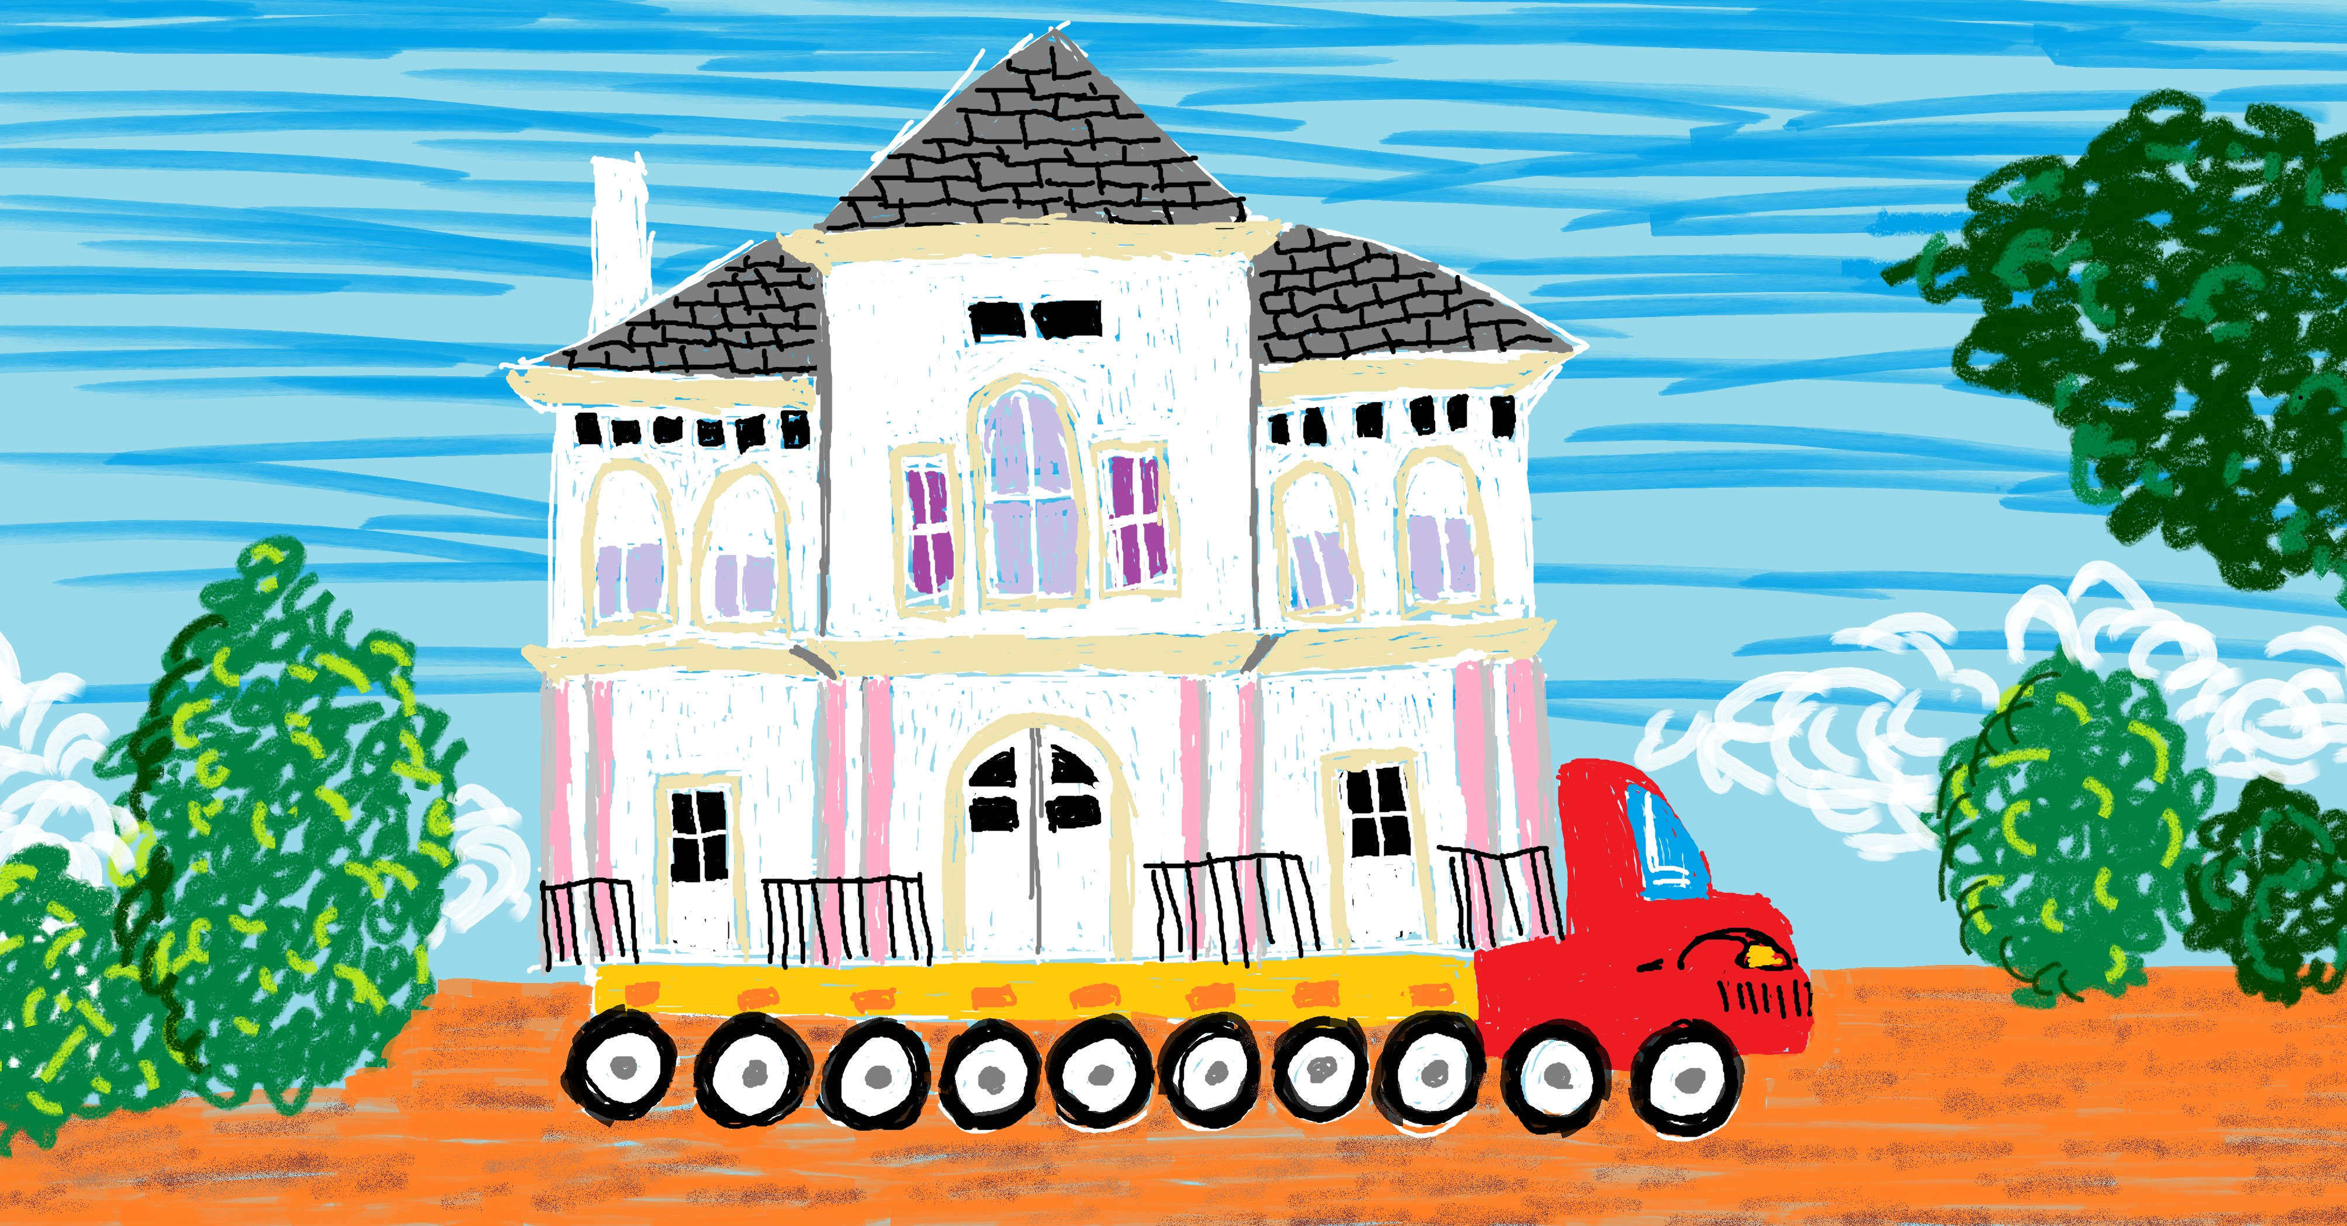
Project management is the process of planning and executing a project while balancing the time, cost, and scope constraints. Time, cost, and scope are known as the triple constraint.
How does one minimize time and money spent on a project while delivering an adequate feature set? Risk management is key. Risk is the estimated probability of a loss given a set of known and un- known factors. Risk can be stated as high, medium, or low, or numer- ically. Ways to mitigate risk include defining and keeping track of your project, communicating with your project team, researching the implications of decisions, developing backup plans, and select-
21

project management: The pro- cess of planning and executing a project while balancing the time, cost, and scope constraints.
. . . . . . . . . . . . . . . . . . . . . . . . . . . . . .
triple constraint: In project man- agement, the three limiting fac- tors that govern project execution: time, cost, and scope. Scope includes quality. Cost includes spending money and resources.

risk: Estimated probability of a negative contingency given known and unknown factors.
. . . . . . . . . . . . . . . . . . . . . . . . . . . . . .
contingency: A future event or circumstance that may occur but depends on known and unknown factors. Can be difficult to predict far ahead of time.
. . . . . . . . . . . . . . . . . . . . . . . . . . . . . .
Agile: A software process model and philosophy for managing and developing software projects. Ag- ile values: Individuals and inter- actions, working software, cus- tomer collaboration, and respond- ing to change.

Other authors in other fields some- times consider quality separate from constraint. In software en- gineering, requirements include quality.
ing suitable tools.
This chapter covers a variety of project management methods, including those related to teamwork. None of them are limited to just one type of software development environment but this chapter, like all of this book, is slanted toward Agile. There are many more methods that aren’t discussed here; instead of hoping to be compre- hensive, this chapter gives you a starter set of methods that are well known and highlight different areas of project management.

Why learn about project management?
Since this book is aimed at people who want to become or are soft- ware engineers, why is there a chapter about project management? Reasons to learn project management:

    - You might become a project manager (e.g., because your em- ployer asks you to fill the role or you’re interested).
    - You might have a project manager. Understanding some basics of project management can help you understand what they’re doing (e.g., using a RACI matrix to define who on the team does what) and what they’re trying to tell you about the project (e.g., implications of the burn down chart analysis).
    - You might need to self-manage (e.g., within an organization that has a flattened hierarchy or within an Agile team).

Triple Constraint
Project management is partially about optimization: How can we use our limited financial and personnel resources to complete our project by the deadline, without going over-budget? These concerns are often summarized as needing to balance three constraints:
    - Time: Duration of the project, intermediate deadlines
    - Cost: Monetary, personnel, and other project resources
    - Scope: What the project is meant to accomplish and the re- quirements of the project, including quality.
This set of three is called the triple constraint.
It can be difficult to balance these three constraints. Common challenges:

  - TRIPLE CONSTRAINT 23

    - You’re meeting with a client and they say, “Oh I forgot to men- tion we want this feature, that won’t be a big deal, right?” (af- fects scope)
    - You realize late in the project that, to implement feature A, you’ll need to implement B, C, and D as well. (affects cost)
    - Your team’s estimates were overly optimistic. (affects the time
constraint)
These situations are so common that you can assume they’re go-
ing to happen and come up with a mitigation plan even before the mitigation plan: What you will

project starts. But many situations are more complicated (more fac- tors with more interrelationships), more unique to your context, and have factors that leak from your professional life to your personal life. Examples:

    - You’re working on a project with a friend, who is an excellent coder but only available for the next three months (time). They also have their own ideas about where they want the project to go (scope). You know your friend will be more enthusias- tic about the project if they have more control, and that means quicker implementation and less work for you (cost). But that’d mean sacrificing some of your own feature priorities (scope).
    - You’re working with a five-person team. Your colleague needs help but all hours must be billed to a project, you’re getting pressured to stay close to the budget, and you bill at a higher rate than your colleague (cost). If your colleague doesn’t get help, they might spend extra hours self-training (cost), might switch to a different project, and there’s a small chance they’ll make the project take longer (time). Scope is fixed: The prod- uct must satisfy all its requirements.

Making strategic project decisions involves adjusting project con- straints. If you want to reduce time and cost spent on a project or increase project scope, you’ll need a corresponding change in one or more other constraints. One way to visualize this:
    - Begin with an equilateral triangle. The three edges represent time, cost, and scope. Time and cost are already as small as possible. Scope is as large as possible, given the time and cost constraints.
    - If you want the project to take less time (shorter time edge), you’ll have to either increase the length of the cost edge, make the scope edge shorter, or do both. Likewise with adjusting the
do if a contingency happens.

The triple constraint triangle (a.k.a. project management tri- angle) is sometimes shown with each vertex labelled instead of each edge. However, that triangle isn’t as useful for imagining the impact of your project decisions.

managerial skill mix (MSM): Three categories of skills used by managers: (1) interpersonal, (2)
technical, (3) administrative/con- ceptual.
. . . . . . . . . . . . . . . . . . . . . . . . . . . . . .
method: A pre-established way of achieving a specific outcome.
other constraints.
    - This model only goes so far. Don’t, for example, get caught up with trying to keep the area or perimeter of the triangle constant.

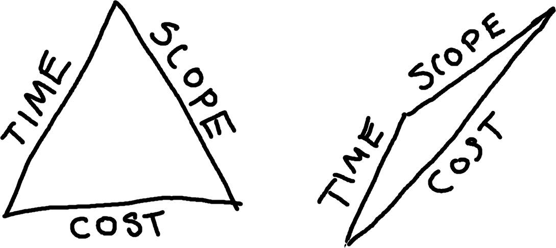

If you want your project to take less time, you might have to tol- erate it costing more or having a reduced scope.

Managerial Skill Mix
What skills are required for managing a project? There are three broad categories comprising the managerial skill mix (MSM):
    - Interpersonal: Communicating effectively with anyone likely to affect the project (e.g., engineers on your team, managers, clients, contractors, IT support, etc.)
    - Technical: Using methods and equipment effectively (e.g., knowledge of appropriate processes, understanding and writ- ing code, etc.)
    - Administrative and conceptual: Understanding the “big pic- ture” vision (conceptual) and being able to move macro-level pieces (e.g., teams, departments, divisions, etc.) toward that vision (administrative).
High-level managers (e.g., CEOs) tend to need a different mix of skills than lower-level managers (e.g., project managers). For exam- ple, a project manager might need strong interpersonal and technical skills while only occasionally considering the big picture of how a project fits into organization’s overall vision. Since this chapter is about project management, we will focus more on interpersonal and technical skills.

Interpersonal Skills: Team Communi- cation
One way to reduce risk is to improve team communication, which can increase the likelihood of project success.
As background for while you read this section, consider Tuck-
man’s five stages of team development: Tuckman’s model of team devel- opment: A five-stage model of

- Forming: Team members become oriented through testing
each other’s boundaries and establishing dependency relation- ships with peers, leaders, and existing team standards.
- Storming: Team members resist group influence, their peers, their peers’ ideas, and tasks.
- Norming: Team develops cohesiveness, new team standards and roles, and team members express personal opinions related to tasks.
- Performing: Team roles become flexible, team dynamics and structure serve the function of the team and task performance.
- Adjourning: Team disbands.
The rest of this section will discuss specific methods a team can use to improve communication. Consider where each might fit in to these stages (there’s not just one answer).
how a team develops over time:
(1) forming, (2) storming, (3) norming, (4) performing, (5) ad- journing.

    - Establishing Ground Rules ground rules: A set of statements

Team ground rules are a preemptive or reactive method for reduc- ing team conflict and dysfunction. Ground rules might already exist when a team forms, others might develop as the team becomes nor- malized, and revisions might happen as the team proceeds with their work and identifies new team concerns or opportunities. To be ef- fective, the ground rules need buy-in from the whole team. What the ground rules should cover or should be varies by team, but here are questions teams can discuss to help:
      - What is our vision for what this team is or what we’re trying to accomplish together? (e.g., clients choose us because we’re honest and transparent)
      - What do we prioritize most? (e.g., delivering a high-quality product ahead of the deadline, input from all team members, honoring diverse end-users, making the big bucks, etc.)
about the team, agreed to by each team member, for avoiding team conflict and dysfunction.
. . . . . . . . . . . . . . . . . . . . . . . . . . . . . .
When deciding on ground rules, your team might choose to incor- porate ground rules or standards already established by others, such as the IEEE Code of Ethics or the Agile Manifesto.
. . . . . . . . . . . . . . . . . . . . . . . . . . . . . .
If your team was to start with a sin- gle ground rule, what would be a good one? Maybe, “We agree to discuss adding more ground rules as needed.”

RACI matrix: In project manage- ment, a chart for defining which roles are responsible (R) and ac- countable (A) for a task or de- liverable and which roles should be consulted (C) or informed (I) about the status of the task or de- liverable.
. . . . . . . . . . . . . . . . . . . . . . . . . . . . . .
minimum viable product (MVP): A low-effort or low- expense effort that results in you being able to better estimate whether people will want to use your product—before the product is fully developed.(Olsen 2015)
. . . . . . . . . . . . . . . . . . . . . . . . . . . . . .
focus group (in usability engi- neering): A moderated discussion between researcher and a small number of potential users (usually 6-12) during which the researcher tries to gather information about the participants’ attitudes, opin- ions, motivations, concerns, and problems related to a specific product or topic.(Odimegwu 2000)
- What methods will we use for day-to-day communication? (e.g., no interrupting, no ’splaining, listen to and acknowledge what other people are saying, ask people if they’re busy before starting a long conversation, etc.)
- What methods will we use to communicate with each other during conflict? (e.g., we’ll get trained on and use non-violent communication)
- What expectations do we have for work habits? (e.g., 1 to 3pm on Tuesday is silent time, be 5 minutes early to meetings, etc.)
- What expectations do we have for responsiveness? (e.g., re- spond within 2 hours during regular work hours and within 24 hours over the weekend, have the team Discord open during regular work hours, etc.)
- What will we do when team members fail expectations? (e.g., we’ll discuss any team problems Friday at 3pm, etc.)
- How will we get to know each other? (e.g., we’ll discuss each other’s cognitive styles, we will not flirt with each other, we will have bring-your-pet-or-child to work days, etc.)
The end product of answering questions like these could be a list of short statements that’s posted somewhere people will see it regularly.
The questions your team asks, and the answers, will vary de- pending on the individuals on the team and on context (e.g., cul- ture). Whatever those questions and answers are, ideally they will feel meaningful and authentic. If your team gets the feeling the ground rules are silly, phony, too aspirational, too inflexible, too authorita- tive, etc., that could invalidate your team’s efforts toward creating the ground rules.

Defining Roles and Responsibilities: RACI Ma- trix
A RACI matrix is a chart for defining who is responsible (R) and ac- countable (A) for a task or deliverable and who should be consulted
- or informed (I).

Basic example defining who should do what during the minimum viable product (MVP) development phase:

 | Frontend Developers | Frontend Designers | Frontend Lead | Backend Developers | Backend Lead | Team Lead
Phase 1: MVP
Focus groups | C | R | R / A | C | C | R / A
Requirements spec. | R | R | A / I | R | A / I | C
Throwaway code design |  |  | I | R | A | I
Implementation | R | C | A | R | A | C
User acceptance testing | R | R | R / A | R | C | C

Interpreting a RACI matrix:
  - Top row: Roles. One person might have multiple roles.
  - First column: Tasks or deliverables, organized into phases (if needed).
  - Letters define what role is responsible for which task or deliv- erable.
  - Responsible (R): Who will do the work
  - Accountable (A): Who will approve the work and make sure it gets done
  - Consulted (C): Who can discuss and offer advice about the work
  - Informed (I): Who to keep up-to-date about the status of the work
A RACI matrix is a method for reducing risk: If your team doesn’t know who needs to do what (or forgets, or can plausibly deny know- ing), that can increase the probability of a negative events and out- comes (e.g., shipping a broken product to customers because nobody
was assigned to quality assurance). fist of five: A method for gauging and building group consensus that

Measuring and Building Consensus: Fist of Five Method
Fist of five is a method for checking and building consensus within a group of people. One person (e.g., team leader) makes a statement or proposes an idea to a group and each person communicates their level or agreement or support by holding up a fist or up to five fingers. It has become associated with Agile (Belling 2020), but I’ve also seen examples of it being used with students of different ages (e.g.,
uses a 6-level voting system (zero to five fingers).

Meanings of single-finger hand gestures vary around the world. For example, in the U.S., putting your thumb up means “good job”, in Australia, Greece, and the Mid- dle East it means “up yours”, in Germany and Hungary it means “one”, and in Japan it means “five”! (Cotton 2013)

release plan: What will be com- pleted for a specific software re- lease and when the release will oc- cur.
. . . . . . . . . . . . . . . . . . . . . . . . . . . . . .
Product Backlog: In Agile Scrum, an ordered list of all that is known to be needed to improve a product.
. . . . . . . . . . . . . . . . . . . . . . . . . . . . . .
iteration plan: In Agile, estab- lishing what will be done during a development cycle.
. . . . . . . . . . . . . . . . . . . . . . . . . . . . . .
Sprint Backlog: In Scrum, the set of activities to be completed dur- ing a Sprint (from Product Back- log), the associated Sprint Goal, and a plan for completing the ac- tivities.
(Fletcher 2002), (Hulshult and Krehbiel 2019)). What each number of fingers means:
- None: Strong reject. Blocks consensus.
- One: Reject. Major issues need resolving now.
- Two: Weak reject. Minor issues need resolving now.
- Three: Weak accept. Minor issues, can resolve later.
- Four: Accept. No issues.
- Five: Strong accept. Willing to lead or champion.
If anyone suggests rejecting the statement or idea by holding up two or fewer fingers, the team can stop, discuss, make changes, and re-vote until there’s sufficient consensus. It’s up to the team or its leader to decide how much consensus is needed.
The fist of five method can reduce risk by (1) bringing problems to light and (2) increasing team motivation, ownership, and invest- ment.

Technical Skills: Project Definition
This section contains methods for helping with the technical side of defining a project, including prioritization, estimation, scheduling, and task management.

Project Scope
In an Agile software development environment, a project’s scope is implied through sets of tasks (e.g, release plan, Product Backlog, it- eration plan, Sprint Backlog). Each iteration might have a goal (e.g., a Sprint Goal) that summarizes what the set of tasks is meant to ac- complish, which is also part of defining scope for Agile projects. The scope is purposely flexible and emerges as the project proceeds.
In other environments, the project scope (a.k.a. statement of work) is a specific document stating the project’s objective, deliver- ables (outputs), milestones, technical requirements, and limitation- s/exclusions.

Balancing Constraints: Project Priority Ma- trix
Earlier, we talked about the three major constraints of project man- agement—time, cost, and scope—and that balancing them isn’t al- ways straightforward. What should the balance be? How do I know

whether I’m achieving balance? How does this fit into how the project is run? One method for more concretely stating the desired balance
is the project priority matrix: project priority matrix: 3x3 grid for documenting how to re- spond when there are potential changes to a project’s time, cost, or scope. Options: Only positive change allowed (constrain), neg-
 | Time | Cost | Scope
Constrain
Enhance
Accept

      - Constrain: The constraint is fixed (can get better but must not get worse)
      - Enhance: Try to improve (e.g., take less time, spend less, have more features)
      - Accept: Can worsen (e.g., more time, more personnel, fewer features) if necessary
For example, if you have a grant from the National Institutes of Health (NIH) to write and test software for a medical device that automatically regulates a person’s pain level, your project priority matrix might look like this:

 | Time | Cost | Scope
Constrain
Enhance
Accept
Scope: Fixed. Your team must do what they said they’d do, and cannot scrimp on quality. If the device only partially works, that would be a disaster—you’ll be testing it on human subjects! Cost: Needs to be tightly controlled because the grant is for a fixed amount and funded by taxpayers. Time: While hopefully the project stays on track and delivers as promised, if needed your team can submit intermediate results to the NIH and (hopefully) use those results to get another grant.
Ideally, the project priority matrix would be defined before the project starts (with the client) and referenced throughout the project as needed. Developing and adhering to the matrix can reduce risk by helping the team or project manager balance constraints in ways that are acceptable to the client.

Task Prioritization: Eisenhower Matrix
Individual tasks, too, need relative prioritization. In an Agile Scrum
environment, this would be the responsibility of the Product Owner
ative change allowed (accept), or positive change sought (enhance).
. . . . . . . . . . . . . . . . . . . . . . . . . . . . . .
“I have two kinds of problems, the urgent and the important. The ur- gent are not important, and the important are never urgent.” – Dwight D. Eisenhower
. . . . . . . . . . . . . . . . . . . . . . . . . . . . . .
Extreme Programming (XP): Agile framework that prioritiz- ing customer satisfaction and communication, short develop- ment cycles, iteration, frequent releases, code review, teamwork, pair programming, required unit testing, and only implementing functionality that’s needed.
. . . . . . . . . . . . . . . . . . . . . . . . . . . . . .
Scrum: An Agile framework “for developing and sustaining com- plex products.” (Schwaber and Sutherland 2020)

and in Agile Extreme Programming (XP) it’s the customer (i.e., someone representing the customer, like the client).
But how are task priorities decided? One high-level method is called the Eisenhower matrix:

 | Urgent | Not Urgent
Important | Do | Decide
Not Important | Delegate | Delete

Eisenhower matrix: 2x2 grid for helping decide whether to do, del- egate, schedule, or eliminate a task based on its urgency and im- portance.

- Do (urgent, important): Needs to be done correctly and now. Example: Documenting your undocumented code so that a new hire can start contributing.
- Decide (not urgent, important): Needs to be done correctly but not immediately. Example: Refactoring your currently- working code. Needs to be done eventually, and done right— maybe the new hire can handle it in a couple months.
- Delegate (urgent, not important): Needs to be done now but mistakes can be absorbed (e.g., tolerated, corrected later, etc.). Example: Someone needs to initialize the task management system so the team can begin defining tasks. If it’s not done right, that’s fine—the developers and managers will adjust the setup as needed. Good learning task for the new hire, who doesn’t have much to do right now.
- Delete (not urgent, not important): Doesn’t need to be done correctly or any time soon. Can be eliminated. Example: Im- plementing a loading screen that looks like a game of pong, but you’re the only one on the team who thinks that’s a cool idea.
Doing a first-pass task prioritization using an Eisenhower matrix can reduce risk by both conserving resources and using them thought- fully (including yourself). It can also help with getting out of the mode of “putting out fires” (concentrating on the urgent tasks), which can result in important but non-urgent tasks getting eternally left at the end of the to-do list (perhaps resulting in project failure).

Finer-Grained Prioritization
What happens when there are multiple important tasks to complete that have the same level of urgency? How does one decide which is more important? Some methods for deciding which task has higher priority when they seem roughly equivalent:

      - For implementation tasks (e.g., coding, architecture, other im- plementation choices, etc.), ask an expert. They might know from past experience which tasks have more unknowns, more risk, dependencies, etc.
      - If it’s an implementation task and you’re meant to be an expert,
you can do a focused research effort called a spike, usabil- spike: A quick and to-the-point

ity testing to gather more information about the task, which in turn can help you prioritize it. To do a spike: (1) Come up with a question, (2) Focus on answering the question, discovering additional questions and sub-questions in the process, (3) Re- peat until you have enough information. A good way to do a spike is to start doing the task and see what obstacles you run into. Example: You need to set up a local server for testing and write a test suite. You have experience writing a test suite but have never set up a server. After doing a spike, you re- alize that some of the tests you’re going to write rely on the local server having a static IP address, which you learned is not the default. Based on your findings, you decide to priori- tize the server setup because (1) the test suite strongly depends on it and (2) the server setup task still has many unknowns and you’re not sure how long it’ll take to eliminate those.
      - Think about dependencies: Who is waiting on you? How many other tasks depend on this task? Compare that to the important of the dependent tasks (or the importance of keep- ing the waiting person happy / productive) and how long it’ll take to complete the task. Example: You estimate it’ll take 15 minutes to complete a task that two other people are wait- ing on. You decide to do that before your 4-hour task. Seems like the obvious choice—but if you’re not aware of which tasks depend on yours or are deep into solo work mode, you might make a sub-optimal choice.
      - If you’re deciding which feature to implement, you can ask the customer or users directly (e.g., through a phone call, focus groups, etc.) or indirectly (e.g., by looking at support tickets, asking the marketing team, detecting an unmet need based on how people use other software, etc.).
      - Other ways to select features: Voting (e.g., within your team) or pairwise comparison (e.g., Is Feature A more valuable than
investigation for gathering infor- mation to help the team answer a question or choose a development path.
. . . . . . . . . . . . . . . . . . . . . . . . . . . . . .
focus group (in usability engi- neering): A moderated discussion between researcher and a small number of potential users (usually 6-12) during which the researcher tries to gather information about the participants’ attitudes, opin- ions, motivations, concerns, and problems related to a specific product or topic.(Odimegwu 2000)
. . . . . . . . . . . . . . . . . . . . . . . . . . . . . .
usability testing: Observing peo- ple while they try to use your soft- ware.(Barnum 2020)
. . . . . . . . . . . . . . . . . . . . . . . . . . . . . .
estimation: Figuring out ahead of time how long a task is likely to take.
. . . . . . . . . . . . . . . . . . . . . . . . . . . . . .
story points: A method for esti- mating an activity based on its size relative to other activities. Scale established by team.

Common scales for story points: 1 to 10, Fibonacci, and powers of two. The latter two are meant to help make sizing a task easier by putting more distance between the numbers in the scale: Deciding between a 4 and an 8 can be easier than deciding between a 4 and a 5.
. . . . . . . . . . . . . . . . . . . . . . . . . . . . . .
ideal days: The number of days it would take to complete the work if the work could be 100% focused on.
. . . . . . . . . . . . . . . . . . . . . . . . . . . . . .
velocity: In Agile, a measure of how much work is being com- pleted.
. . . . . . . . . . . . . . . . . . . . . . . . . . . . . .
planning poker: In Agile, a consensus-based method of as- signing estimates to a task that in- volves individuals on a team each making their own estimate pri- vately, then sharing with the team, discussing, and re-estimating as needed.
. . . . . . . . . . . . . . . . . . . . . . . . . . . . . .
scheduling: Deciding when project activities are to be com- pleted, how long they will take, and what resources are needed to complete them.
Feature B? If so, is Feature C more valuable than Feature A?).

A natural side effect of prioritization is finding how long it’ll take to complete a task, what dependencies exist, who the players are, and what the end user wants: All this knowledge contributes to risk mitigation.

Estimation: Story Points, Ideal Days, and Plan- ning Poker
Intertwined with prioritization is estimation: Figuring out ahead of time how long a task is likely to take. But what does “how long” mean and how do we figure out “how long”?
Two methods, from the Agile community, of stating the size of a task:
- Story points: Assign a number to a task representing its size relative to other tasks. For example, a software installation and a virus scan might both be a 1 if they take roughly the same amount of time and effort, have roughly the same amount of risk, etc. Implementing a major feature might, on the other hand, be an 8. Your team decides how far the scale goes.
- Ideal days: Assign a number of days you think it’d take to complete the task if there were no other tasks, no distractions, etc. For example, if it takes me 5 minutes to remove one square foot of grass from my lawn, and I have 100 square feet to re- move, that is 8 hours and 20 minutes total, so about one ideal day (if your work days are eight or nine hours).
Once story points or ideal days are assigned, a team can make statements like, “This month, we will complete 50 story points”, “10 ideal days”, etc. Work completed (in story points or ideal days) is, in Agile teams, called the velocity. Teams can make initial estimates about velocity then adjust depending on how accurate those estimates end up being.
But how are estimates assigned to a task? Another Agile idea is planning poker. With this method, the team gets together to discuss a set of tasks and each person gets a set of cards with the different possible story points / ideal days / etc. a task can be assigned. One person describes the task, the team asks questions as needed, and then each person privately decides on an estimate by selecting a card (keeping it face-down or hidden). Once everyone is ready, the cards

are revealed. Variations in estimates are expected, and part of the process: differences open a discussion. Someone making a high es- timate might, for example, have thought of good reasons why a task is likely to take a long time. Someone making a low estimate may have identified an efficient idea nobody else thought of. The team discusses and, once ready, can repeat the process until estimates be- come sufficiently consistent.

Scheduling: Project Network
Once a set of tasks has been defined, prioritized, and estimated, those tasks can be scheduled. Scheduling a task is placing it within the timeline and context of a project. The context of a project includes other tasks, personnel, and non-personnel resources (e.g., equipment), and milestones. One method for defining and visualizing a project’s schedule is using a project network. A project network is a directed graph showing a project’s tasks, the sequence in which they’re to be completed, and the dependency relationships between the tasks. The nodes in the digraph represent tasks and the lines with arrows repre- sent dependency or sequence relationships. A project network moves
left to right, where left is earlier in time. project network: Graph showing

For a task to be represented as a node on a project network, it needs to (at a minimum) be distinct from other tasks and its depen- dent tasks (a.k.a., predecessors) must be known. However, a project network becomes more useful if estimates for the tasks are also known.

Constructing a Project Network
Project networks can be created manually or automatically generated by software. If you want to include estimates in the project network, generating the network will likely be less cumbersome, especially since you might want to modify your tasks or estimates once you see how the network looks. If you don’t care about entering estimates and just want to visualize the sequencing and dependency relationships between tasks, drawing the network by hand might be sufficient for your needs.
For automatically generating a project network using software (e.g., MS Project, Lucidchart), you’d use the software’s user interface to enter the task details. For example, in a table:
the order in which a project’s ac- tivities are to be completed.
. . . . . . . . . . . . . . . . . . . . . . . . . . . . . .
This textbook does not cover strategies or methods for opti- mally assigning personnel or other resources to tasks.
. . . . . . . . . . . . . . . . . . . . . . . . . . . . . .
While complex project networks may be less valued in a Agile development environment, they might also be just the method you need for understanding a complex project.
. . . . . . . . . . . . . . . . . . . . . . . . . . . . . .
In Agile, predecessors are also called blockers or impediments, especially in cases when an activ- ity could be started but is wait- ing on another activity (or external event) to occur.

Task ID | Task | Predecessors | Duration
4 | Implement GUI | 1,3 | 50hrs
3 | Test GUI design with users | 2 | 5hrs
2 | Prototype GUI |  | 8hrs
1 | Select GUI framework |  | 2hrs

Note that, even though Task 2 must happen before Task 4, it’s not listed as a predecessor because it’s not an immediate predecessor.
Depending on the software you choose for creating your project network, you might have access to more complex options like specific dates by which individual tasks must be completed.

task management system: Soft- ware for planning and organizing project activities.

project management system: Software for planning, organiz- ing, and otherwise carrying out a project.
. . . . . . . . . . . . . . . . . . . . . . . . . . . . . .
Gantt chart: Horizontal bar chart showing start and end times of ac- tivities within a project schedule, along a timeline.

Task Management Systems
A task management system can be used to organize tasks, their details (e.g., description, acceptance criteria, assignee, status, etc.), and other relevant information (e.g., which iteration or phase the task belongs to). They’re useful organizing and storing informa- tion about tasks, but also for the satisfaction of marking a task as done! Task management systems like Jira, Trello, and Asana are strongly oriented toward team collaboration. Some of these systems are also strongly Agile-oriented, in that they offer Agile-inspired fea- tures (e.g., templates). Common features of task management sys- tems:
      - Create, remove, update, and delete tasks
      - Enter task name, description, notes/comments, and add attach- ments
      - View tasks as a list, as cards on a board, or within a timeline (e.g., Gantt chart)
      - Organize tasks into projects
      - Assign tasks to different team members, with due dates
      - Enter task status (e.g., in progress, done)
      - Get email notifications about tasks
      - Add tags, keywords, and categories
Task management systems don’t universally have a way to gen- erate project networks. For that, you might need a fully-featured project management system (e.g, MS Project). However, you may find that a Gantt chart or roadmap feature meets your needs and is available within your task management system.

  - CONCLUSION 35

Conclusion
Project management and teamwork can reduce the risk of a project failing and make it possible to complete larger projects. Part of good project management is balancing time, scope, and cost.

Additional Resources
Michael K Badawy (1995). Developing managerial skills in engineers and scientists: Succeeding as a technical manager. John Wiley & Sons
Kevin Brennan et al. (2009). A Guide to the Business Analysis Body of Knowledger. Iiba
Karen A Brown, Nancy Lea Hyer, and Richard Ettenson (2013). “The question every project team should answer”. In: MIT Sloan Management Review 55.1, p. 49
Shawn Belling (2020). “Agile Values and Practices”. In: Succeeding with Agile Hybrids. Springer, pp. 47–61
Mike Cohn (2005). Agile estimating and planning. Pearson Education
Gayle Cotton (2013). “Gestures to avoid in cross-cultural business: In other words,‘Keep your fingers to yourself!’” In: The Huffington Post. Avaiable at:< http://www. huffingtonpost. com/gayle-cotton/cross-cultural-gestures_b_3437653. html>(retrieved July 7, 2017)
A Fletcher (2002). “FireStarter youth power curriculum: Participant guidebook”. In: Olympia, WA: Freechild Project
Jarett Hailes (2014). Business Analysis Based on BABOK® Guide Version 2–A Pocket Guide. Van Haren
Brian Hambling and Pauline Van Goethem (2013). “User acceptance testing: a step-by-step guide”. In: BCS
Andrea R Hulshult and Timothy C Krehbiel (2019). “Using Eight Agile Practices in an Online Course to Improve Student Learning and Team Project Quality.” In: Journal of Higher Edu- cation Theory & Practice 19.3
J Mike Jacka and Paulette J Keller (2009). Business process mapping: improving customer satis- faction. John Wiley & Sons
Erik Larson and Clifford Gray (2018). Project management: The managerial process. Irwin/McGraw- Hill
Lucid (n.d.). What is Fist to Five? https://www.lucidmeetings.com/glossary/fist-five.
Accessed: 2021-01-01
Viljan Mahnič and Tomaž Hovelja (2012). “On using planning poker for estimating user stories”.
In: Journal of Systems and Software 85.9, pp. 2086–2095
Debbie Thorne McAlister (2006). “The project management plan: Improving team process and performance”. In: Marketing Education Review 16.1, pp. 97–103
Microsoft (n.d.). The project triangle. https://support.microsoft.com/en-us/office/ the - project - triangle - 8c892e06 - d761 - 4d40 - 8e1f - 17b33fdcf810. Accessed: 2021-01-01

  - ADDITIONAL RESOURCES 37

Barry Overeem (2016). Characteristics of a Great Scrum Team
Andy Stuart (2014). “Ground rules for a high performing team”. In: Paper presented at PMI®Global Congress 2014—North America, Phoenix, AZ. Newtown Square, PA: Project Management Institute. Pp. 328–338
Bruce W Tuckman (1965). “Developmental sequence in small groups.” In: Psychological bulletin
63.6, p. 384
Bruce W Tuckman and Mary Ann C Jensen (1977). “Stages of small-group development revis- ited”. In: Group & Organization Studies 2.4, pp. 419–427
Jasim MohJasim Mohamed Lahdan Fhadel Al Qubaisi et al. (2015). “Leadership, culture and team communication: analysis of project success causality-a UAE case”. In: International Journal of Applied Management Science 7.3, pp. 223–243
Muhammad Usman et al. (2014). “Effort estimation in agile software development: a systematic literature review”. In: Proceedings of the 10th international conference on predictive models in software engineering, pp. 82–91
C Jurie Van Wyngaard, Jan-Harm C Pretorius, and Leon Pretorius (2012). “Theory of the triple constraint—A conceptual review”. In: 2012 IEEE International Conference on Industrial Engineering and Engineering Management. IEEE, pp. 1991–1997
Li-Ren Yang, Chung-Fah Huang, and Kun-Shan Wu (2011). “The association among project man- ager’s leadership style, teamwork and project success”. In: International journal of project management 29.3, pp. 258–267

Chapter 4 Requirements

A software requirement is a rule the software must conform to: requirement: A rule the software

What it must do, how well, and within what constraints or limits.

Types of Requirements
There are two types of requirements:
    - Non-functional requirements specify qualities the software should have (e.g., usable, portable, modular, etc.). They an- swer the questions, “How well should the software perform?” and “What limits or constraints is the software subject to?” This chapter includes a discussion of how quality attributes can be used in specifying non-functional requirements.

39
must conform to: What the soft- ware must to, how well it must do what it does, or the software’s lim- itations or constraints.
. . . . . . . . . . . . . . . . . . . . . . . . . . . . . .
non-functional requirement: Description of how well software is expected to perform.
. . . . . . . . . . . . . . . . . . . . . . . . . . . . . .
functional requirement: De- scription of what functionality the software needs to have.
quality attribute: A characteris- tic of software used to describe how good it is.

User stories and use cases are two different methods for specifying functional requirements. As you will see later, one is more formal than the other.

Requirements keep the develop- ment team on track and working together toward creating what the client (and hopefully the users) want.

Requirements can help protect
    - Functional requirements specify the desired functionality of software (e.g., if I click the Log In button, the Login page ap- pears). They answer the question, “What should the software do?” In this chapter, we’ll talk about specifying functional re- quirements with user stories and use cases.

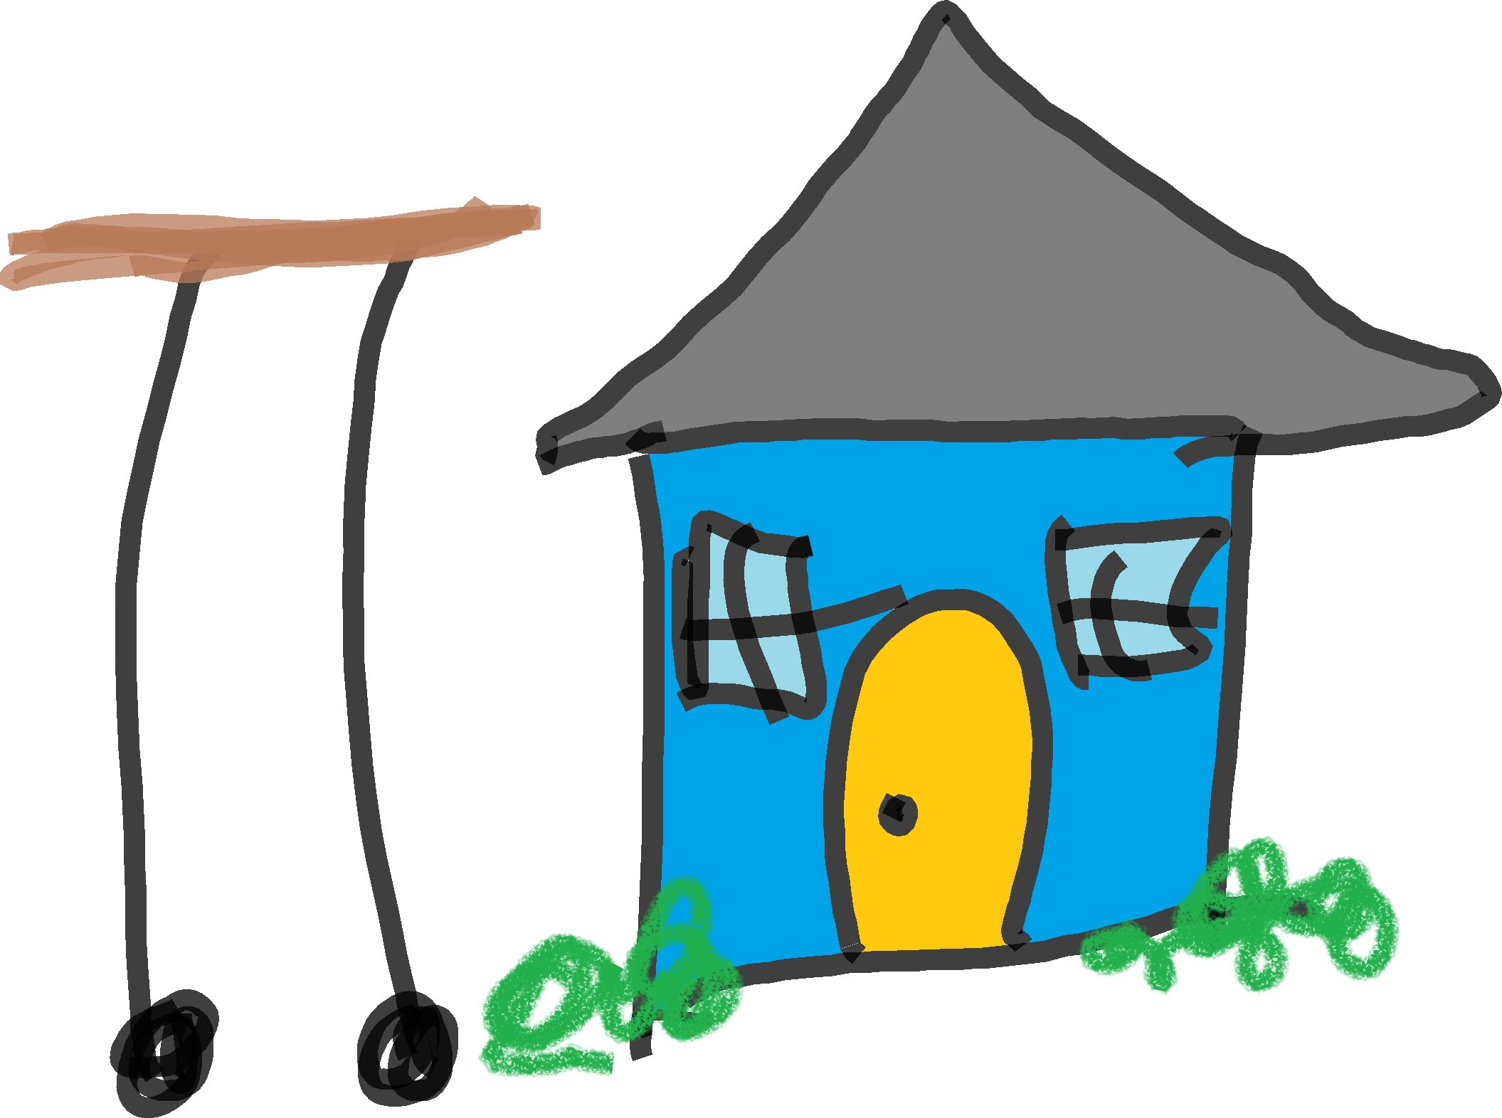

This rolling table fails the non-functional requirement of fitting through an average door and the functional requirement of having four legs.

Why Requirements Matter
The design and implementation of software should, ideally, follow from the requirements. Here are some ways requirements are helpful and reasons they are important:
- When developers aren’t given requirements, they might prior- itize functionality they personally think is important or fun to implement—but what developers want to implement might not make the project successful.
- When multiple developers are working on the same code, re- quirements can help them stay in sync with one another and have the same goal. Without requirements, time, effort, and money can be wasted implementing conflicting code.

projects from drift and failure. • When requirements aren’t specified, it’s easier for project stake-
holders (e.g., clients, partners, investors, consultants, manage- ment, etc.) to influence the project toward satisfying their own (possibly fleeting) wants or needs. This can result in the project drifting away from what it was originally intended to do—and can lead to project failure.
  - Requirements are helpful for communicating about software with stakeholders, keeping track of everything that needs to get done, and helping you and the client decide what really

4.3. WHAT MAKES A GOOD REQUIREMENT 41

needs to get done (clients sometimes don’t know what they
really need). client (a.k.a. customer): One
or more people or organizations who are requesting the software be

What Makes a Good Requirement
Good requirements have the following characteristics: Correct What they say is right.
Consistent They aren’t contradictory of each other.
Unambiguous There is only one way to interpret them.
Complete They cover all that’s important.
Relevant They meet a stakeholder need.
Testable There’s a way to figure out if they’re satisfied.
Traceable It’s possible to figure out where they came from.

Requirements that fail to have these characteristics can lead de- velopers to making features of software nobody wants, wasting time and other resources and potentially jeopardizing the project.

Requirements Elicitation
The process of gathering requirements is called requirements elic- itation. Requirements can come from any stakeholder, including clients, managers, users, governments, developers of software your software will integrate with, your development team, and yourself.

Three of the most important, distinct, and universal (common across projects) categories of stakeholders:
- Clients: The people who request the software and have most of the authority over its requirements (e.g., because they are paying for it).
- Users: The people who will use the software.
- Developers: The people who will make the software, includ- ing those who manage the software engineers.
made and have decision-making authority about the software (e.g., because they are paying for it or otherwise providing resources).

Sloppy requirements can be use- less or worse.
. . . . . . . . . . . . . . . . . . . . . . . . . . . . . .
stakeholder: Anyone who is or will be affected by the soft- ware or its development (e.g., clients, companies, users, devel- opers, managers, politicians, etc.)

requirements elicitation: The process of gathering requirements from project stakeholders.

triple constraint: In project man- agement, the three limiting fac- tors that govern project execution: time, cost, and scope. Scope includes quality. Cost includes spending money and resources.
. . . . . . . . . . . . . . . . . . . . . . . . . . . . . .
focus group (in usability engi- neering): A moderated discussion between researcher and a small number of potential users (usually 6-12) during which the researcher tries to gather information about the participants’ attitudes, opin- ions, motivations, concerns, and problems related to a specific product or topic.(Odimegwu 2000)
. . . . . . . . . . . . . . . . . . . . . . . . . . . . . .
usability testing: Observing peo- ple while they try to use your soft- ware.(Barnum 2020)
. . . . . . . . . . . . . . . . . . . . . . . . . . . . . .
minimum viable product (MVP): A low-effort or low- expense effort that results in you being able to better estimate whether people will want to use your product—before the product is fully developed.(Olsen 2015)

Aspects of these stakeholders that can affect the requirements elicitation processes and the software’s development and ulti- mate success:

- Clients might not have experience or expertise. Developers can help fill the gap between what the client wants and what is technically feasible and reasonable (e.g., given time, cost, and scope, a.k.a. the triple constraint).
- Clients might not have good ideas. They may be incorrect about what users will want or will use. Developers sometimes try to guide clients toward better ideas, but developers can also have bad ideas. Methods such as focus groups, usabil- ity testing, and releasing a minimum viable product (MVP) can help with figuring out whether users will use (and pay for) the software.
- Clients might not know what they want. They might have a rough idea, or they might have an idea that’s at odds with their goals. Developers, through requirements elicitation, can help clients define their goals clearly and reasonable ways for accomplishing those goals.
- Users might not know what they want or will use. They may be unaware of their own needs or wants until there’s a product in front of them that addresses those needs or wants. Even if 10,000 users tell you, “I would definitely use an app that does X”, they might be wrong, they might only use the app once, or they might not be willing to pay for the app. MVP can be a good method for figuring out early whether users will be inter- ested enough in the software to use or pay for it.
- Users might want what’s bad for them. You can probably think of multiple examples.
- Developers have their own tendencies. They may have tech- nologies and ideas they prefer or feel most comfortable with. For better or worse, they bring their own influences to a project.
- Clients, users, and developers are all humans. They com- municate imperfectly.

4.5. NON-FUNCTIONAL REQUIREMENTS 43

Deciding what software to make, and doing so successfully, is a complex process influenced by human factors affecting all involved.
So how does one elicit requirements? By having conversations or otherwise collecting information from stakeholders. The amount of stakeholder communication can vary by project, project type, the software process model being used, and other factors.

Non-Functional Requirements
Non-functional requirements describe how well the software needs to perform.

Examples of non-functional requirements:

- Response time should be a few seconds or less in all operating environments.
- The keylogger must be indetectable to 99.999% of test users.

- The software must be available 24 hours a day, 7 days a week, and must have an uptime of 99.99%.

Notice that each requirement has a quantity associated with it: That makes it testable (a criterion for a good requirement).

Quality Attributes
Quality attributes are characteristics of software used to describe how good it is. They can be used in specifying non-functional require- ments.

Examples of quality attributes:

      - Reliability: How often does function X succeed?
      - Efficiency: How many resources does the software need?
      - Integrity: How frequently does the software have errors that require a restart?
      - Memorability: How many times must users learn a function before they no longer need documentation?
      - Flexibility: How many ways can the software be used?

non-functional requirement: Description of how well software is expected to perform.

quality attribute: A characteris- tic of software used to describe how good it is.

A quality attribute is not the same as a non-functional re- quirement. Rather, quality at- tributes are good for labelling what a non-functional require- ment is about.

functional requirement: De- scription of what functionality the
- Interoperability: How well can the software integrate with other software?
- Reusability: To what extent can the code be used to solve other problems without being modified?
Each quality attribute can be converted to a scale. For example, the lowest value on a reliability scale could be “the function suc- ceeds 0% of the time” and 100% would of course be the opposite pole. Given this scale, we can specify a non-functional requirement by defining a performance threshold:
The function must have high reliability (succeeds >99% of the time).
When you select quality attributes for your software, you are pri- oritizing what qualities matter most to you / your team / the project. Ideally, your team would keep these quality attributes (and the cor- responding non-functional requirements) in mind for the duration of the project; If the software is not meeting the non-functional require- ments, either the software or the threshold of acceptability needs to change.

Functional Requirements

software needs to have. Example of a functional requirement:
When a user clicks the “register” button, their informa- tion is added to the database and the user is shown a “thank you for registering” screen.

User Stories
User stories are a method for specifying functional requirements. They describe a small piece of the software’s functionality in a sim- ple and easy to read sentence. They are written in plain English so that non-technical people (e.g., users, clients, other stakeholders) can

user story: “Short, simple de- scriptions of a feature told from the perspective of the person who desires the new capability, usually a user or customer of the system.” (Cohn n.d.)
understand them.
User stories have a title and are commonly written using this for- mat:
As a (ROLE), I want (SOME FUNCTIONALITY) so
that I get (SOME BENEFIT).

These short sentences can be written on 3x5” index cards and then stuck on a wall or whiteboard. They can also be typed into task and project management systems (e.g., Jira, Asana, etc.).

Examples of what user story cards can look like:

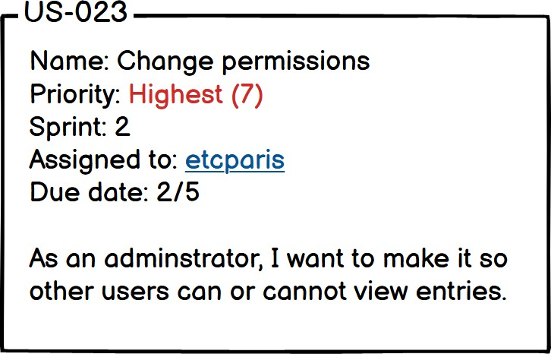

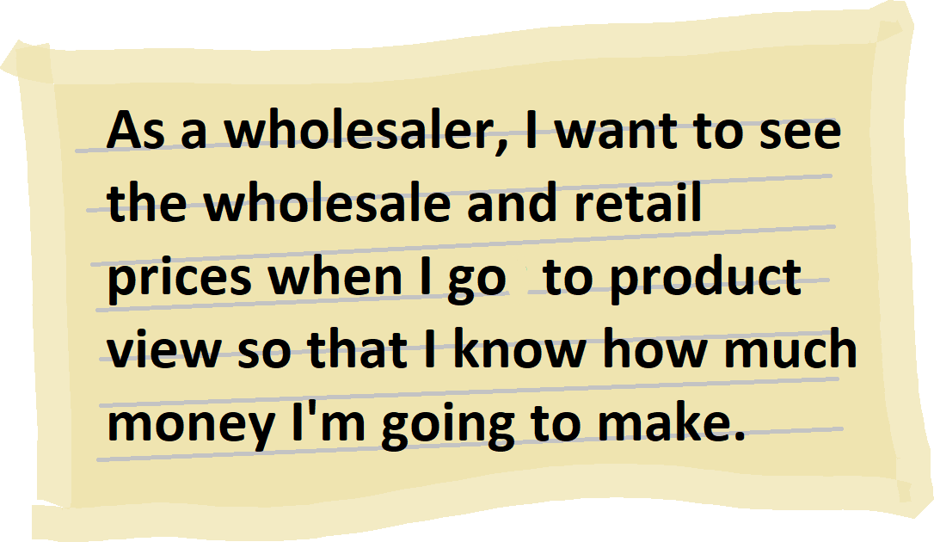
Anyone on the team—or any project stakeholder—might come up with user stories. Once the user stories are initially defined, they can be used to start a conversation with the client and others on the team. Clients can guide you on setting priorities for user stories. This conversation is also a good time to get more details about the user stories, which should be added to the card.

Characteristics of good user stories (INVEST):
More examples of user sto- ries: https://tinyurl.com/ user-story-examples https://twitter.com/ shituserstory

INVEST: Characteristics of good user stories (independent, nego- tiable, valuable, estimable, small, testable) (Wake 2003).

I Independent: Doesn’t depend on other user stories. N Negotiable: Can be changed during development.
V Valuable: Fulfills a user need.
E Estimable: Can be given a time estimate.
- Small: Can fit into a single development period (e.g., a 2- week Sprint)
- Testable: Possible to determine it’s done.

acceptance criterion: A state- ment about functionality that, when satisfied, mean the func- tionality has been satisfactorily implemented.
. . . . . . . . . . . . . . . . . . . . . . . . . . . . . .
Definition of Done (DoD): The set of acceptance criteria which, once satisfied, mean a user story has been satisfactorily implemented.
There is some overlap between INVEST and the general charac- teristics of good requirements mentioned earlier in this chapter.
How do you know when you are done with a user story? This is negotiated with the client and added to the user story as accep- tance criteria. Acceptance criteria say what must be true about the functionality specified by the user story in order for the user story to be considered done (i.e., establishing the Definition of Done for the user story).

Example acceptance criterion:
Given the user is playing a video file and their operating system is Windows, when they do the Ctrl-T keyboard shortcut then they will see the “Go to Time” screen and the video will pause.
There are bolded words in that example because its using a com- mon format (Alliance n.d.) for acceptance criteria:
Given . . . when . . . then . . .
The “and”’s are optional parts of the format. Ideally, acceptance criteria testing can be automated.

Example pseudocode for testing acceptance criteria:
1
def test_go_to_time (): # given
assert os. is Windows () ," Not Windows !" player . open () player . play_video (’ test . mkv ’)
# when user . send_keyboard_shortcut (" Ctrl - T")

# then
assert player . screen . is_showing ( GOTOTIME )
2
3
4
5
6
7
8
9
10
11

    - Use Cases use case: “A contract for the be-

Use cases are a more formal method of specifying functional require- ments. They are structured descriptions of what a system is required to do when a user interacts with it.
Use cases are not specific to a particular software process model (e.g., Agile, Waterfall, Spiral) or environment. Instead, like much of what you will encounter in this book, they are a well-known method software teams can choose to use (and many do), or not.

Example of a use case:

- Name: Generate list of recovered patients
- Actor: Clinician

Flow:
      - Clinican authenticates using smart card
      - Software confirms credentials and access permissions for specific machine
      - Software logs access
      - Software displays patient search
      - Clinician selects “Advanced Patient Search”
      - Software confirms user access permissions for advanced search page
      - Clinician selects ailment and patient status
      - Clinician executes search using “Search” button
      - Software returns results
      - Software logs query

Required Parts of a Use Case
What every valid use case has:
- Name: A short title for the use case that often starts with a verb (e.g., Schedule weekly wellness check). Briefly states the user objective the use case will be describing.
- Actors: The user or users (human / non-human / computer) that are interacting with the software (e.g., Medical staff)
- Flow of events (a.k.a. “basic course of action” or “success scenario”): Sequence of actions describing the interaction be- tween the actor and the software.
havior of the system under discus- sion” (Cockburn 2001)

More examples of use cases:
https://tinyurl.com/ use-case-examples

The correct amount of detail to give a use case is the minimum amount to adequately describe what you’re trying to communi- cate.

requirements specification: Converting stakeholder requests into written requirements.
. . . . . . . . . . . . . . . . . . . . . . . . . . . . . .
Software Requirements Specifi- cation (SRS): A document that contains software requirements.
. . . . . . . . . . . . . . . . . . . . . . . . . . . . . .
Another type of software docu- ment, which sometimes gets con- fused with an SRS, is a Software Design Document (SDD). If the SRS is what the software should do, the SDD is what the software is. However, there is often overlap between the two.
Sometimes, the actor is implied through the flow of events (e.g., Shopper selects the calendar icon). Other times, the actor is stated separately from the flow of events (e.g., Actor: Shopper).

Additional Parts of a Use Case
Sometimes included in use cases:

- Identifier: A unique way of referring to the use case (e.g., UC-002)
- Pre-conditions: What must be true before the flow (e.g., The shopper has added at least one product to their shopping cart.)
- Post-conditions: What must be true after the flow (e.g., The shopper received an order confirmation email.)
- Business relevance: Justification for why the use case exists
- Dependencies: Other use cases the use case relies on. This unique identifier is handy for this part.
- Extensions: Contingencies, alternate routes, and branches to other use cases
- Priorities: The importance of the use case
- Non-functional requirements: How well the software must perform during the flow

Requirements Specification
The process of writing down requirements is called requirements specification. Used as a noun, requirements specification refers to the document that contains the requirements. That document is also called an SRS (Software Requirements Specification). The best way to understand what an SRS looks like is to look at some.

Freely available SRS examples (including some for open source software):

- SRS for apps and a data repository for distributing manu- facturing data: Thomas Hedberg Jr., Moneer Helu, and Mar- cus Newrock (Dec. 2017). Software Requirements Specifica- tion to Distribute Manufacturing Data. https://web.archive. org / web / 20201208070659 / https : / / nvlpubs . nist . gov/nistpubs/ams/NIST.AMS.300-2.pdf

  - REQUIREMENTS SPECIFICATION 49

SRS for data system that assesses conservation practices:
Data System Team (n.d.). System Requirements Specification
for STEWARDS. https://web.archive.org/web/20200923200038/ https://www.nrcs.usda.gov/Internet/FSE_DOCUMENTS/ nrcs143_013173.pdf
    - SRS for an app that splits and merges PDFs: Ploutarchos Spyridonos (Feb. 2010). Software Requirements Specification for PDF Split and Merge, Version 2.1.0. https : / / web . archive . org / web / 20170225043950 / http : / / selab . netlab.uky.edu/%7Eashlee/cs617/project2/PDFSam. pdf
    - SRS for software that processes EEG data: Inria Innovation Lab (n.d.). Software Requirement Specification for CertiViBE, v1.0. https://web.archive.org/web/20190710221933/ http :// openvibe . inria . fr / openvibe / wp - content /
uploads/2018/04/CERT-Software-Requirement-Specification. pdf
    - SRS for library software: Fred Eaker (Nov. 2006). Soft- ware Requirements Specification for Vyasa. https://web. archive . org / web / 20161127184329 / http : / / vyasa .
sourceforge.net/vyasa_software_requirements_specification. pdf

Conclusion
Gathering and writing down requirements for a project can help with keeping the project on track and communicating about the project to others. Doing requirements well can save a project from failing.

Additional Resources
Agile Alliance (n.d.). What is “Given - When - Then?” https:// web. archive. org/ web/ 20201124202211/https://www.agilealliance.org/glossary/gwt
Roger Atkinson (1999). “Project management: cost, time and quality, two best guesses and a phenomenon, its time to accept other success criteria”. eng. In: International journal of project management 17.6, pp. 337–342. issn: 0263-7863
Carol M. Barnum (2020). Usability Testing Essentials: Ready, Set...Test! 2nd ed. Morgan Kauf- mann
Alistair Cockburn (2001). Writing effective use cases. Boston
Mike Cohn (n.d.). User Stories and User Story Examples. https://web.archive.org/web/ 20201124004807/https://www.mountaingoatsoftware.com/agile/user-stories
Martin Fowler (2004). UML distilled : a brief guide to the standard object modeling language.
Boston
Clifford Odimegwu (July 2000). “Methodological Issues in the Use of Focus Group Discussion as a Data Collection Tool”. In: Journal of Social Sciences 4, pp. 207–212. doi: 10.1080/ 09718923.2000.11892269
Dan Olsen (2015). The lean product playbook : how to innovate with minimum viable products and rapid customer feedback. Hoboken: Wiley. isbn: 9781118961025
Rebecca Parsons (June 2003). “Components and the world of chaos”. In: Software, IEEE 20, pp. 83–85. doi: 10.1109/MS.2003.1196326
Bill Wake (Aug. 2003). INVEST in Good Stories, and SMART Tasks. https://xp123.com/ articles/invest-in-good-stories-and-smart-tasks/. Accessed: 2020-12-31

Chapter 5
Unified Modeling Language (UML) Class and Sequence Diagrams

After a discussion of diagrams in general, this chapter covers two common diagram types: UML class and sequence diagrams.
“Nobody, not even the creators of the UML, understand or use all of it.”

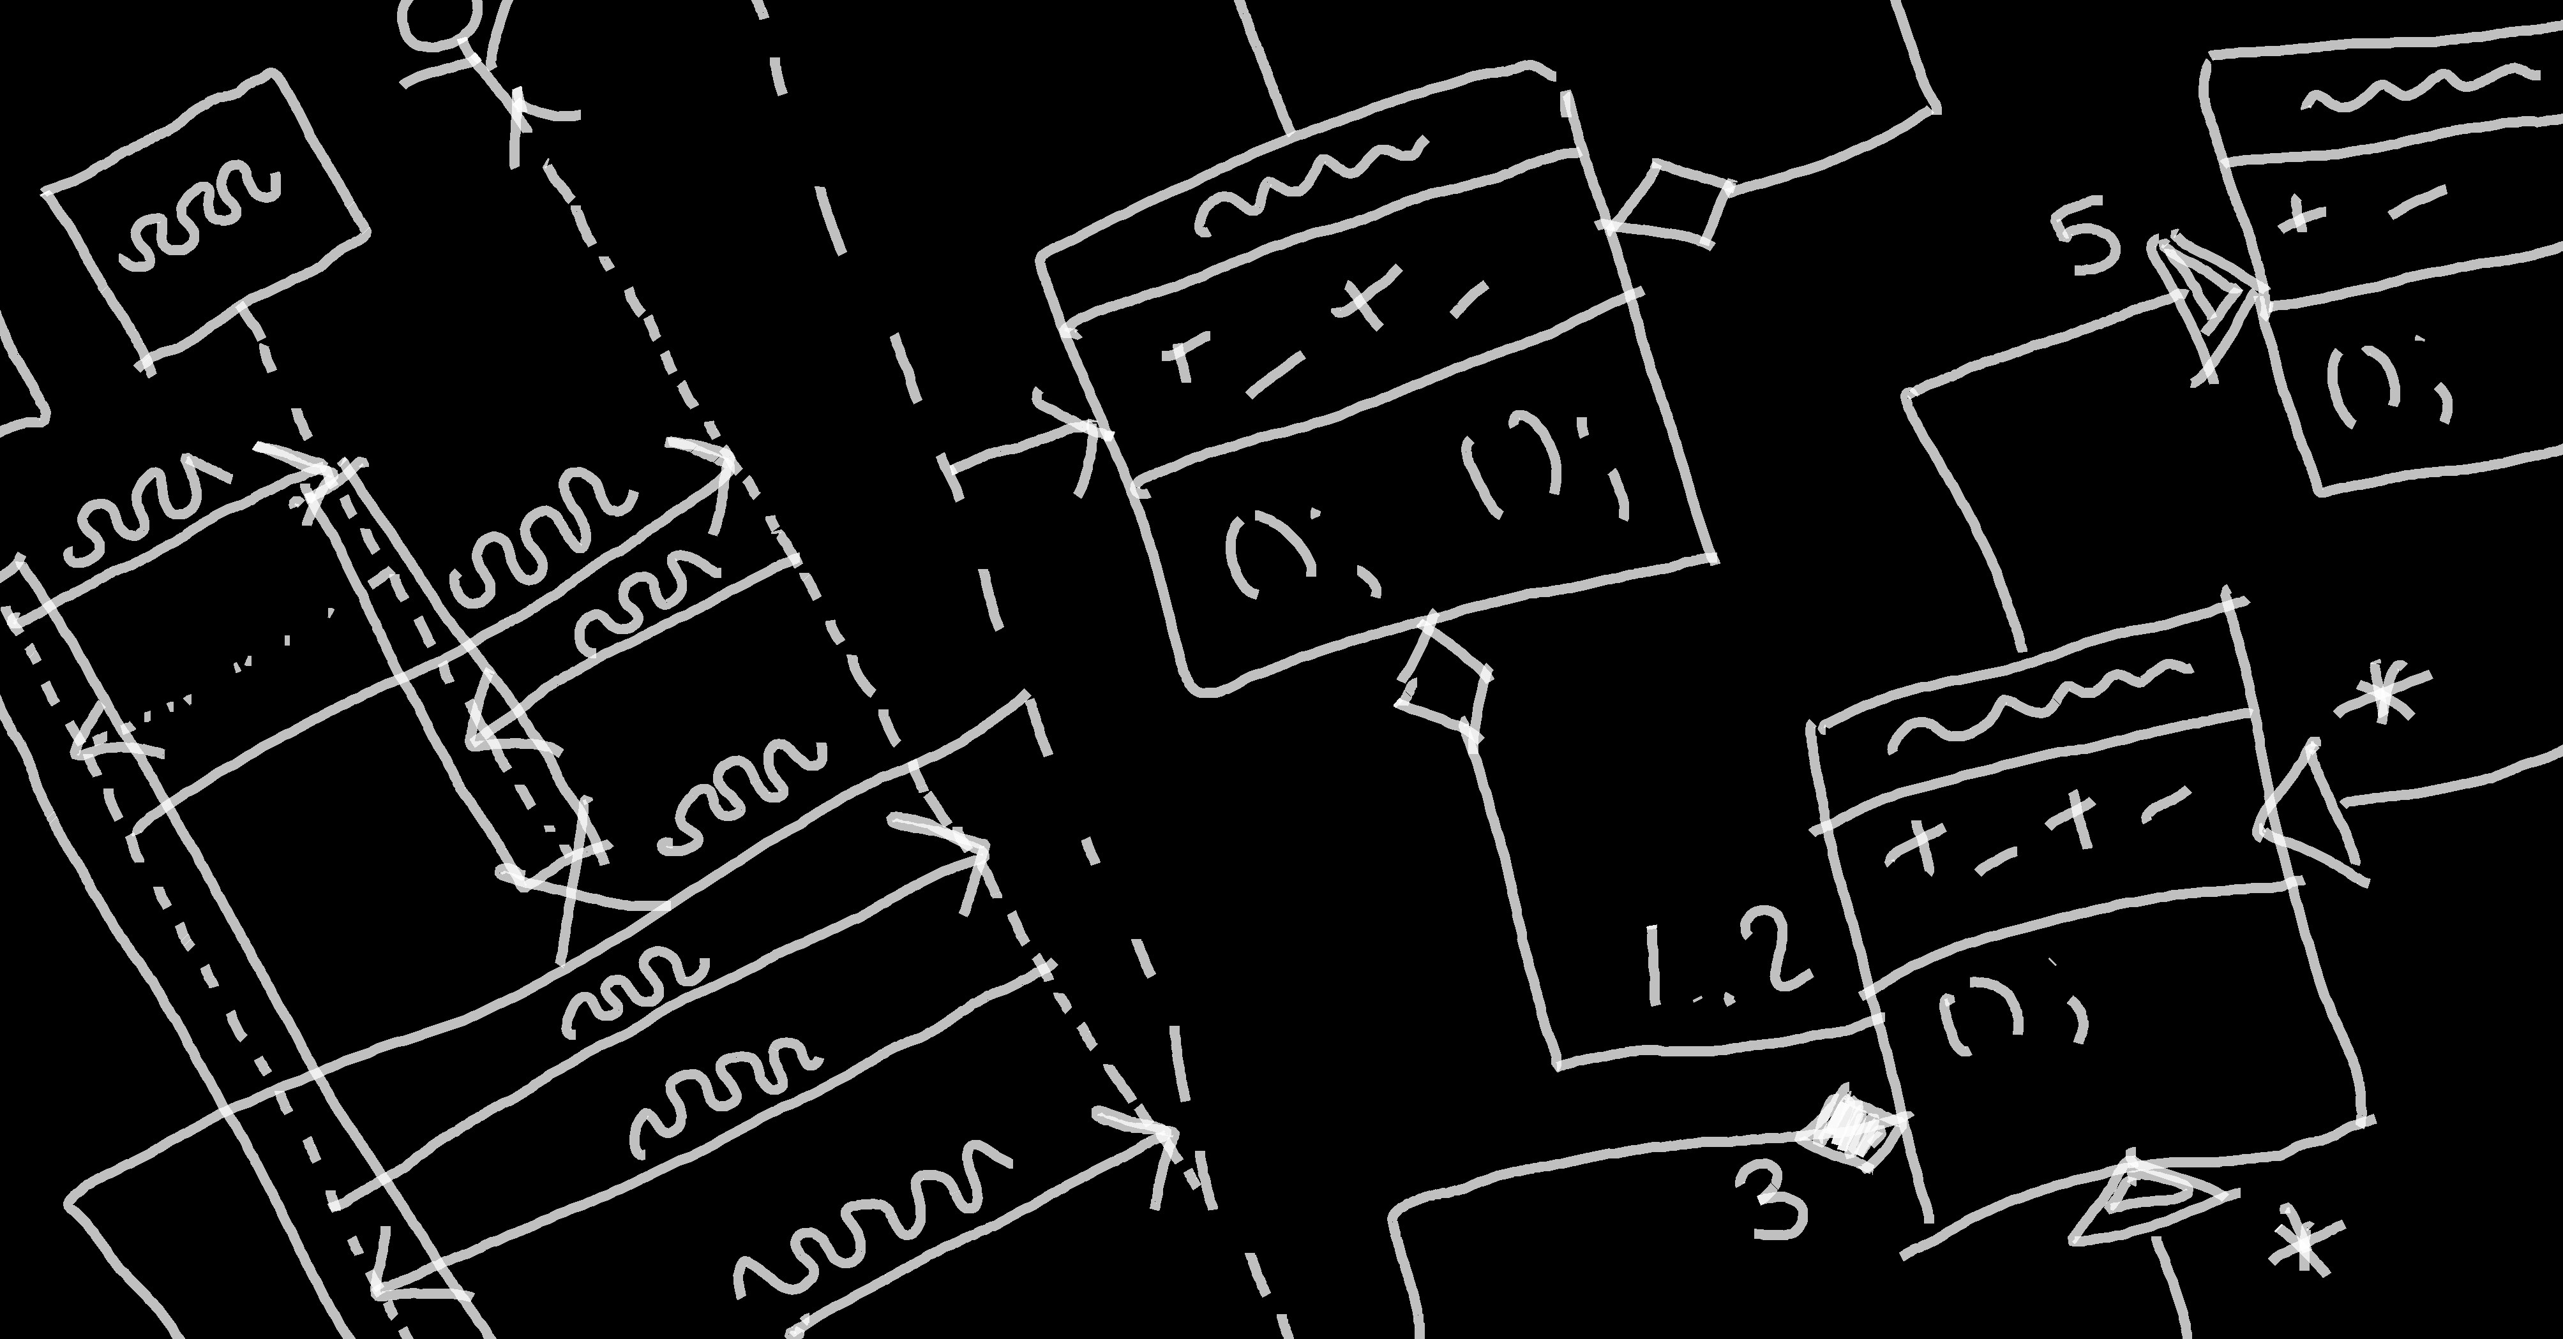
How Diagrams Help
Diagrams can help in at least two major ways:
    - They can help you plan software you will create.

51
Martin Fowler UML Distilled (3rd Ed.)

class diagram: Visualization of how classes are built in relation to other classes in object-oriented software. Includes properties and methods of individual classes and “has a” and “is a” relationships be- tween classes.
. . . . . . . . . . . . . . . . . . . . . . . . . . . . . .
sequence diagram: Interaction diagram showing how different participants (e.g., users, software components, classes, etc.) collab- orate during a single use case.
. . . . . . . . . . . . . . . . . . . . . . . . . . . . . .

Audiences often have short atten- tion spans.
. . . . . . . . . . . . . . . . . . . . . . . . . . . . . .
IDE: Integrated development en- vironment. Software specifically for creating software.

UML: Unified modeling lan- guage: A set of notation and methods for describing and designing software.
Once you’ve created diagrams for planning your software, you can use them to communicate to the development team what will/should be implemented and decide (evaluate) whether your plans are any good (e.g., are clear, are logical, reflect your project’s desired quality attributes, etc.).

    - They can help you describe software you’ve already created.
If your software is already created, diagrams are good for doc- umentation and, as mentioned above, for evaluating how satis- factory your software is. The purpose of including diagrams in documentation is to communicate something about your soft- ware to somebody. There are many different audiences you could be trying to communicate with.

Example audiences for your diagrams: Other developers on the project, your supervisor or manager, developers who might be inter- ested in joining the team, developers who want to integrate with your system, curious end users, and students of software engineering.
Depending on the IDE/tools you’re using, diagrams can be auto- matically generated from your code, which helps make documenta- tion maintenance easier and more likely to happen.

What Diagrams Must Do Well
To be helpful, diagrams must communicate clearly and at an appro- priate level of detail for your intended audience. If your intended audience does not understand your diagram—or misunderstands it— your diagram has failed.

What is UML?
UML (Unified Modeling Language) is a family of graphical nota- tions for describing and designing software through diagrams. It is especially applicable to object-oriented software, but some parts of UML are applicable to many types of software. Different UML no- tations are used for different types of UML diagrams, each of which have a specific purpose. UML was first published in 1994, became a standard of the Object Management Group (OMG) in 1997, and became an ISO standard in 2005. UML is currently on version 2.

5.4. WHY USE UML? 53

Why use UML?
There are multiple benefits of creating diagrams using UML:
- UML gives you (1) notation for designing software so that your implementation will be structured and (2) notation for describing the existing design of software so that you can eval- uate whether the design is any good.
- UML diagramming forces you to think about software design in a structured way. When people try to design software in their minds, they can be sloppy about it—thinking about the aspects of the design they want to think about. UML can en- courage you to face the more tricky parts of software design.
- UML diagramming gives you a view of the software at differ- ent levels of design (e.g., class-level, component-level, package-
level). Some IDEs will automatically
generate some types of UML di-

- UML provides a common language between software pro- fessionals. Because UML is well-known, it gives developers and managers a common vocabulary for communicating about software. That being said, expect to encounter some variation in how UML notation is used—it can be difficult to remember all the details of UML notations; many developers will make mistakes or adapt the notation to their own way of thinking. That is ok to do so long as you provide a legend or explanation of what your notation means.
- UML diagrams give you a way to tell people about your soft- ware’s structure without asking them to look through code. This is nice, for example, when onboarding new developers or communicating with managers.
agrams from your code. This is nice because it’s easy to re- generate your diagram when your code changes. However, the gen- erated diagrams can sometimes have more detail than you want, making them less good for com- municating.

Why NOT use UML?
There are also drawbacks to UML diagramming:

- People tend to vary their UML notation, which can cause confusion. Tips for avoiding that problem: (1) Keep your notation basic and (2) explain more complex notation usage to the people you’re trying to communicate with.
- Trying to get the UML notation details right can take a lot of time. Remember that diagrams are for communicating; If creating the diagram takes longer than explaining the code a dif- ferent way, the diagram isn’t helping.
- UML diagrams can require a lot of maintenance. If your software design changes fre- quently, so must your UML diagrams if you want them to be accurate. Fortunately, some IDEs can generate some UML diagrams from your code.

Class Diagrams
A class diagram describes types of objects in a system and the static relationships that exist among them. Class diagrams also show properties and operations of a class and constraints on how objects are connected. UML uses the term “feature” as a general term that covers properties and operations of a class.

Example class diagram:

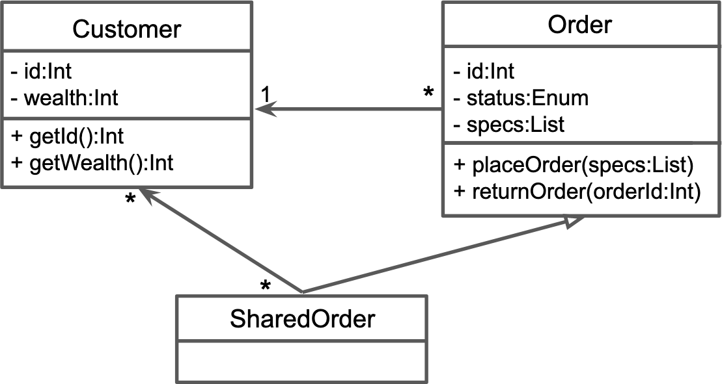

This class diagram shows the relationships between three classes: Customer, Order, and Share- dOrder. An Order has one Customer—but the same Customer can be on multiple Orders. A Share- dOrder is a type of Order that can have multiple Customers. The classes have “attributes” (e.g., id) and “operations” (e.g., getId()).
The next page explains each of the notational elements shown in the example. Class diagram notations gets more complicated than is described here; see publications in Additional Resources.

  - CLASS DIAGRAMS 55

UML Class Diagram Notation
Below is a subset of UML class diagram notation. Some of the other notation tends to be confusing and so more people get it wrong (leading to miscommunication). However, if you’d like to learn about it anyway, see the references section at the end of this chapter.
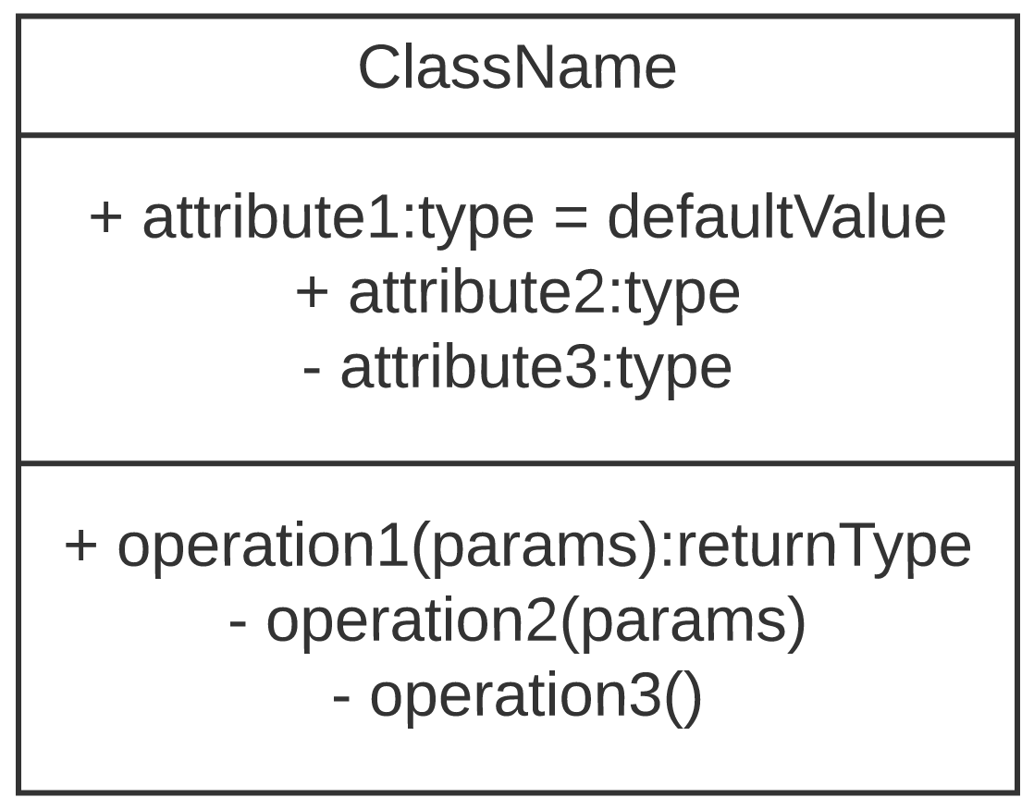
class
A class, potentially with attributes and operations (methods). The + indicates a public method, - is private, and # is protected. The notation includes at- tribute types (e.g., int, Token, etc.), method parameters and return types, and default values for attributes.
note
A note. Notes are for putting com- ments on diagrams.
Graphical Representation Name Description
association Association means that a class con-
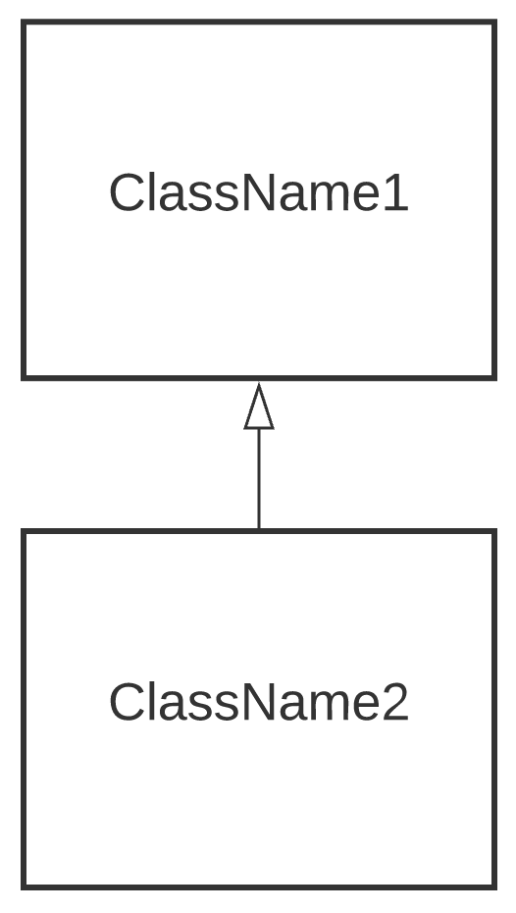tains a reference to an object(s) of the other class in the form of an attribute. If Class1 points to Class2, Class1 has a Class2.
inheritance
Inheritance means that one class is a subclass of another. If Class2 points to Class1, Class2 is a Class1.

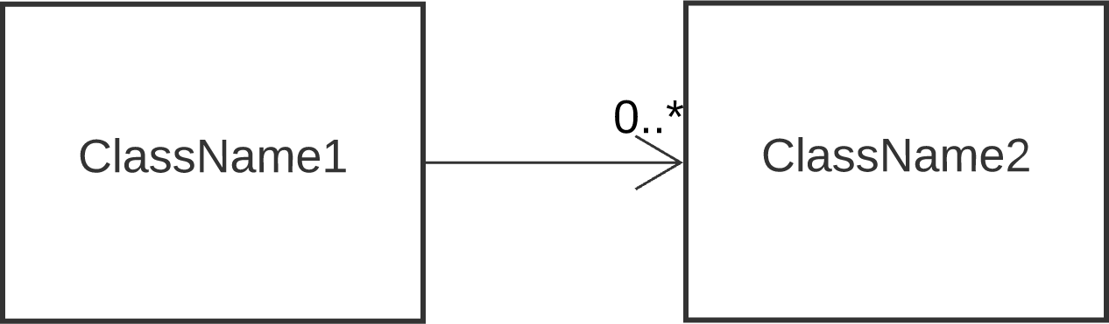
multiplicity Multiplicity constrains the number of
objects. If, for example, Class1 has three objects of type Class2, that’s in- dicated with a 3 near the arrow point- ing to Class2. 0..* (or just *) means zero or more. An integer N (e.g., 1) means exactly N. N..M means N to M (inclusive).

sequence diagram: Interaction diagram showing how different participants (e.g., users, software components, classes, etc.) collab- orate during a single use case.
. . . . . . . . . . . . . . . . . . . . . . . . . . . . . .
interaction diagram: Visualiza- tion of collaboration between dif- ferent parts of software.

When making any diagram, know your audience and what you’re try- ing to communicate. If your audi- ence is a human, they have limited capacity for absorbing tiny details (and probably limited time). Fo- cus on showing them what’s most important in a way they will un- derstand.

Sequence Diagrams
A sequence diagram describes interactions between objects. Usu- ally, the diagram is showing a single use case or scenario. Sequence diagrams are a type of interaction diagram and are not as good for showing object implementation details.
This section shows an example of a sequence diagram and commonly- used sequence diagram notation. To see more obscure notation, check the publications in the Additional Resources section.

Example sequence diagram:
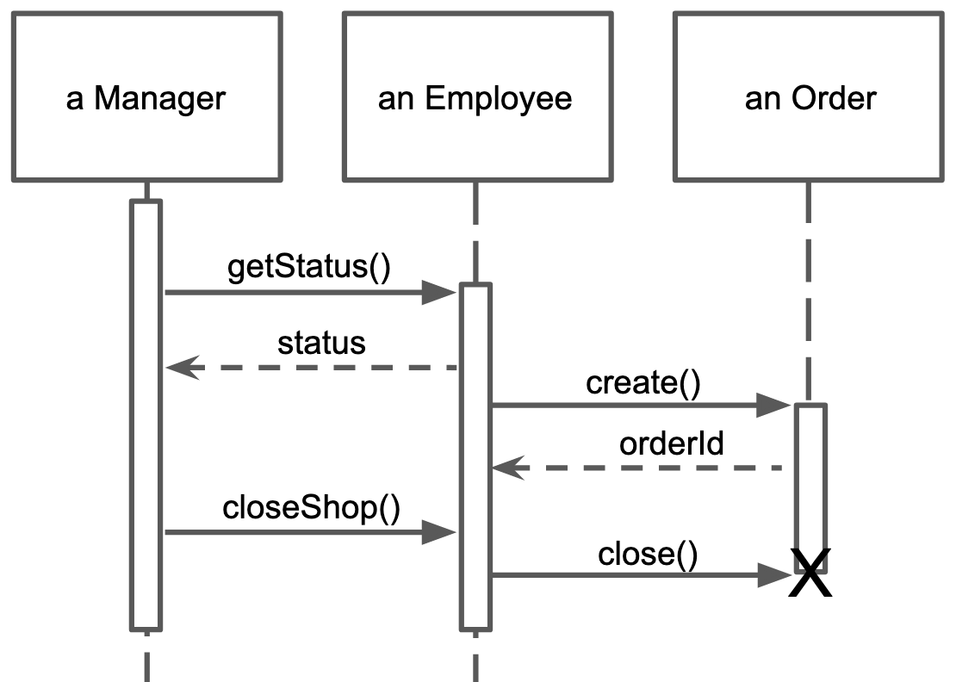

This sequence diagram shows interactions between instances of the Manager, Employee, and Order classes. Manager asks the Em- ployee for a status update, Employee complies, Employee creates an order, Manager asks Employee to close the shop, Employee closes the Order.
In the example, each of the columns (called “participants”) are objects, but this is not always the case. For example, a participant can be a user. Users, if they are human, are sometimes represented as stick figures (without the box). Another possible non-object par- ticipant could be a database (although, in some cases, a database is considered an object). What’s most important when creating dia- grams is not following the rules or conventions, but communicating with your audience.

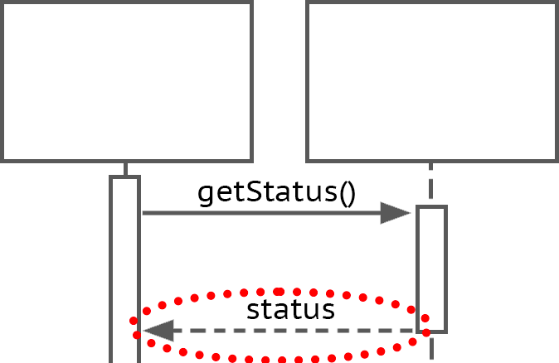
  - SEQUENCE DIAGRAMS 57

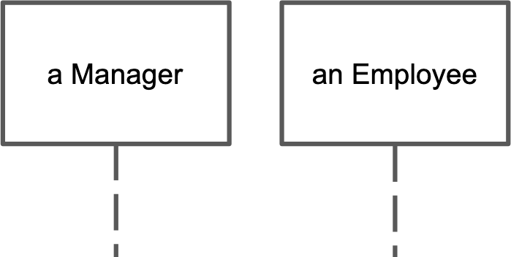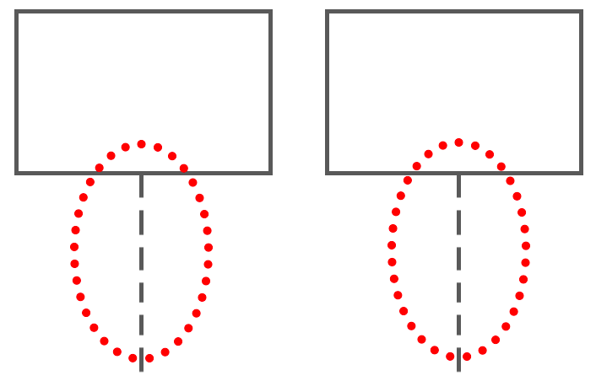UML Sequence Diagram Notation
lifeline
Vertical dashed line representing the lifespan of the participant. Top is be- ginning of life, bottom is end. Life ends when the participant is deleted.
participant
The “columns” of a sequence dia- gram. Often objects. Name of the par- ticipant goes in the box.
Graphical Representation Name Description

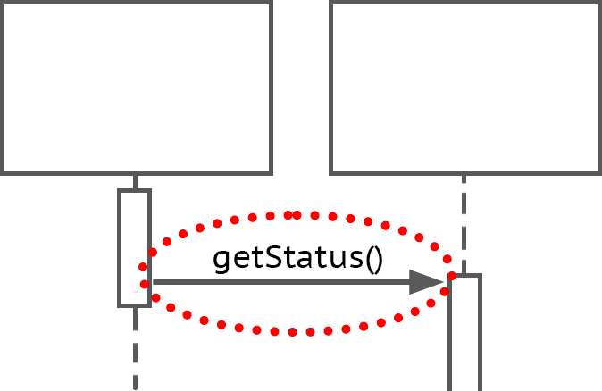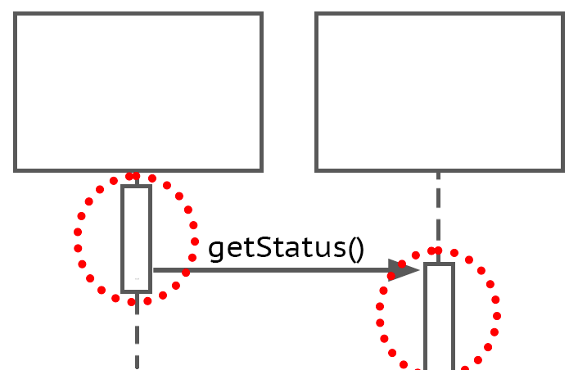
activation
Box on lifeline indicating when the participant is active. Indicates method is on call stack.
message
Interaction from one participant to an- other. Solid line with arrow. Often a method call.
return Dashed line with arrow indicating method return. Use only when it helps communicate something impor- tant about the interaction.

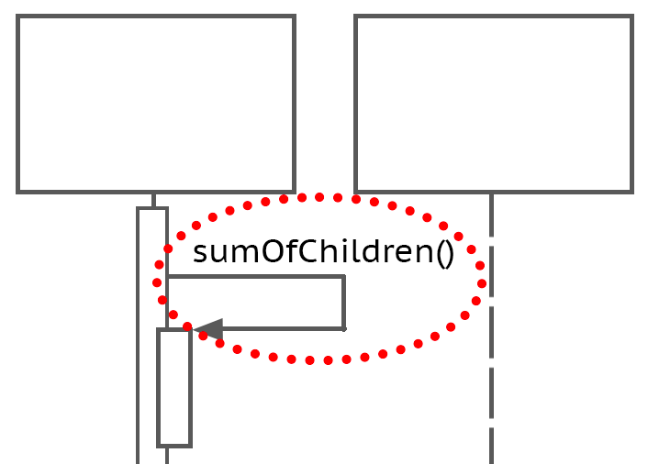deletion End of participant’s life. Indicated by
self-call
Method calling self. Solid line with arrow pointing back to participant’s own lifeline.
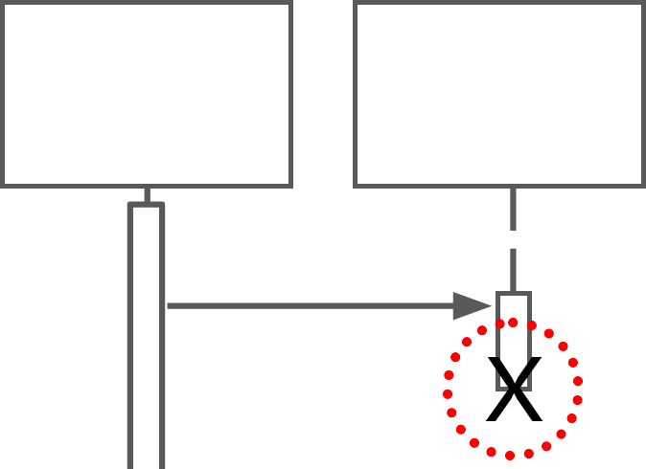
“X” on lifeline.

Conclusion
UML diagrams can be helpful for communicating how your code works. Class diagrams and se- quence diagrams are two common-used types of UML diagrams. Each type of diagram emphasizes some part of the code design while leaving out other parts. This is because UML diagrams are for communicating with humans—not computers.

Additional Resources
Russ Miles and Kim Hamilton (2006). Learning UML 2.0: a pragmatic introduction to UML. O’Reilly Media, Inc.
Martin Fowler, Kendall Scott, et al. (2003). UML distilled: a brief guide to the standard object

Chapter 6
Monolith vs. Microservices Architectures

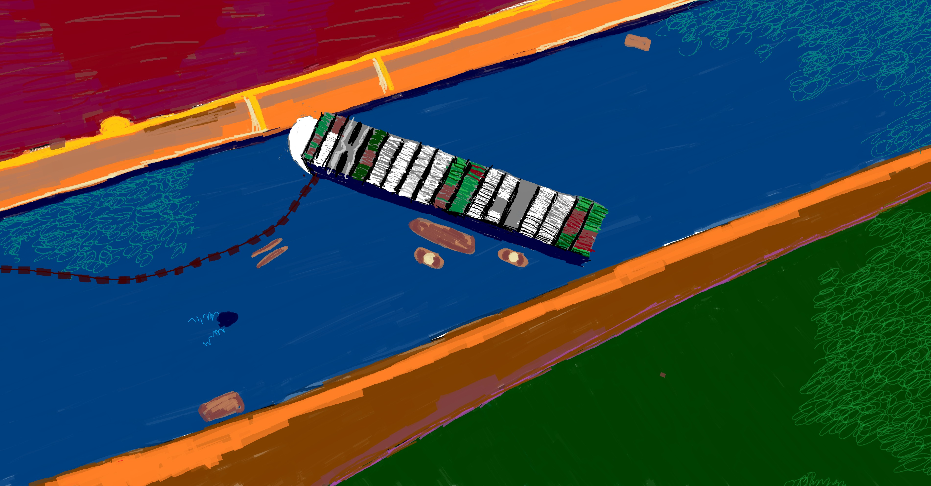
High-level architecture is the software’s all-encompassing code design. When described with the diagram, a high-level architecture usually looks like a few to dozens of interconnected shapes with short labels, an abstraction that usually represents the entire codebase. In this chapter, we’ll use “architecture” interchangeably with “high- level architecture” (in other contexts, architecture can refer to code design at lower levels).
If you’re developing new software, you might get to choose the high-level architecture, or it may already be baked into a framework you’ve chosen. For example, many web application frameworks use

59

software architecture: Code de- sign. Can be shown at different levels of abstraction and detail.
. . . . . . . . . . . . . . . . . . . . . . . . . . . . . .
high-level architecture: Abstract representation of overall code de- sign; covers all parts of the soft- ware.

monolith architecture: Overall code design characterized by be- ing in one or few pieces; cannot be easily divided into components that run separately and are inde- pendently useful.
. . . . . . . . . . . . . . . . . . . . . . . . . . . . . .
microservices architecture: Overall code design characterized by multiple independent com- ponents that each run in their own process and communicate between one another without direct access.
. . . . . . . . . . . . . . . . . . . . . . . . . . . . . .
abstraction: Representation that is purposely missing details to fo- cus attention on purpose of the ob- ject / idea / etc. being represented.

“Dumb pipes” does not imply sim-
the Model-View-Controller (MVC) architecture or variants. In the latter case, you have to learn MVC and how to work within it; The design decision is made for you.
Since my aim is to help you make choices about software, I won’t be covering every high-level architecture. Instead, I’ll concentrate on two distinct high-level architectures: monolith and microser- vices. Talking about the ways they’re different will lead us through concepts applicable to architectures in general.

Monolith Architecture
Monolith software is one or few pieces and cannot easily be divided into multiple independent components that run separately and are individually useful. What about when the client side, the server side, and the database are all separate, can that be a monolith? Yes. If the client-side part of the software will not start or is not useful without the database or server-side part of the software, that’s a monolith.
If you’re trying to think of an example of a monolith and noth- ing is coming to mind, that’s probably because this architecture is so common; it can arise without having to plan. Your first computer program was probably a small monolith. If you keep adding more code / files / classes / components, the software becomes a bigger monolith—unless you make a different design decision.

Microservice Architecture
Microservices are multiple pieces of software, each of which runs in a separate process and can be individually useful. This sec- tion describes core characteristics of software that uses the microser- vice architecture. Additional commentary from Lewis and Fowler at (Fowler and J. Lewis 2019).

“Smart endpoints and dumb pipes”

ple message contents. The communication pipe within microservice architectures is sim-
ple and the services themselves take care of translating and otherwise
processing messages. For example, microservices commonly com- municate through a REST API, which allow these kinds of messages: GET, POST (create), PUT (update), or DELETE. The contents of the messages can be complex but it’s the job of the services to deal with that.

  - MICROSERVICE ARCHITECTURE 61

“Componentization via services”
In a microservice architecture, components are services. The Lewis and Fowler definition of a component is, “a unit of software that is independently replaceable and upgradeable”. A service provides functionality while running in its own process. In a monolith, it’s more common to have more tightly coupled code and components that run in the same process.

Advantages of splitting components into services:

      - Independence: Each individual service can be updated, tested, launched, and stopped without requiring the same from other parts of the software. In contrast, with some monolithic soft- ware, for example, all tests must be run each time a developer commits to a change, which can make for a long wait. If a service fails, any software depending on it will be without that service but the rest of the software needn’t be affected.
      - Standardized component communication: Service commu- nication pipes can be simple and the same each time. This can make for less thinking, fewer mistakes, and less violation of encapsulation when connecting two components—just use the pipe.

Disadvantages of splitting components into services:

      - More expensive communication: Whereas in a monolith com- munication between components can be direct calls (fast, light- weight), with microservices requests often happen over a net- work, need to include metadata to explain the request, and, be- cause the pipes are “dumb”, responses can contain extra data the requester didn’t ask for (slower, heavier).
      - Potentially less secure communication: Communication over

component: Within a codebase, a unit of the code containing related functionality. Ideally, is both re- placeable and reusable.
. . . . . . . . . . . . . . . . . . . . . . . . . . . . . .
service: A unit of software that re- ceived and fulfills requests.
. . . . . . . . . . . . . . . . . . . . . . . . . . . . . .
Even though it provides a service, a library is not a service if you’re including its code in your code.
. . . . . . . . . . . . . . . . . . . . . . . . . . . . . .
coupling: The degree to which one unit of code is dependent on another.
. . . . . . . . . . . . . . . . . . . . . . . . . . . . . .
encapsulation: In object-oriented programming, (1) combining data and the methods that act upon that data into one unit of code or (2) preventing external direct access to data within a unit of code.

a network can be more prone to interception and alteration. client-server architecture: Over-
all code design characterized by

“Organized around business capabilities”
You may have heard of the client-server high-level architecture, which usually consists of multiple instances of client-side software that communicate with server-side software, which communicates
one component (the server) re- sponding to requests and provid- ing resources while other compo- nents (clients) request those re- sources.

business capability: “the poten- tial of a business resource (or groups of resources) to produce customer value by acting on their environment via a process using other tangible and intangible re- sources” (Michell 2011)
. . . . . . . . . . . . . . . . . . . . . . . . . . . . . .
In each of these examples, what are the business resources produc- ing customer value? What is the value to the customer? How are the business resources acting on their environment? What other re- sources are the business resources using?
. . . . . . . . . . . . . . . . . . . . . . . . . . . . . .
eventual consistency: Character- istic of software systems where different parts of the system can have less up-to-date information (e.g., state, data) than other parts but the inconsistencies are tempo- rary.
. . . . . . . . . . . . . . . . . . . . . . . . . . . . . .
tech stack: The set of program- ming languages, frameworks, and other technologies chosen or needed for implementing a piece of software.
with a database. That architecture is organized around technology. Another way to put that: Someone unfamiliar with the differences between client-side software, server-side software, and a database would not get much out of seeing a diagram of this architecture.
In contrast, microservices are organized around business capa- bilities. This term has multiple definitions. Michell’s integrated def- inition fits what we’re talking about: “the potential of a business re- source (or groups of resources) to produce customer value by acting on their environment via a process using other tangible and intangi- ble resources” (Michell 2011).

Examples of business capabilities:
- The manufacturer can slice a 20ft by 40ft rectangle of wheat dough into 0.5cm strips in 1.2 seconds, which will later be- come packaged noodles someone can buy for lunch in a gro- cery store.
- A loan officer can lead a customer through the process of se- curing a loan, enabling the customer to start a small business.
- A pet food distributor can regularly ship nutritionally-balanced cat food to stores around the country.
- The software can convert a video so it works better on mobile devices.

One implication of being focused on business capabilties is that each microservice has its own tech stack (including its own database).

  - COMPARISON BETWEEN MONOLITH AND MICROSERVICES 63

“Decentralized data management”
In a microservice architecture, each service typically has its own database instead of sharing a centralized database. This helps keep the microservices independent, which has many benefits including failure containment. A disadvantage is that interoperating microservices can end up with copies of the same data that are inconsisent (e.g., because one database has not yet received the update). The term for this is eventual consistency, which means that, with time, each microservice will have the most up-to-date information but meanwhile there could be a mismatch (perhaps one that will annoy or mislead human users).

“Decentralized governance”
Microservices need only be compatible at their interfaces (communication pipe), leaving flexibil- ity in how each is implemented. For example, each service can be written in a different language, reducing the weight of tech stack decisions and decreasing the need to compromise on those de- cisions: For each service, teams can choose the optimal programming language, framework, ar- chitecture, etc. If, later, the team needs to change to different technologies, only the one service is affected. On the other hand, in a monolith, teams might only need to maintain a small set of technologies (e.g., if there’s only one framework, only one framework will need updates installed) and might not need as broad of expertise (e.g., having working knowledge of five programming lan- guages). Also, when code is more-or-less part of the same codebase, it might be easier to maintain the same standards across the code.

“Design for failure”
When services running in different processes on different machines and potentially being written with different technologies by different teams with different standards, that can change how de- velopers think. Instead of keeping the whole ship afloat, thinking can shift toward what to do if a service fails. With that comes monitoring, logging, and design decisions about what to do when a service fails—including what to tell the user. In contrast, with a monolith, more thought might be put into how to revert quickly if a deployment fails (because failure might mean no part of the monolith works). Monoliths can also be designed for failure but that’s not as natural a tendency as with microservices.

Comparison Between Monolith and Microservices
This section recaps and expands upon differences between monolith and microservice architectures.

How does communication happen within a monolith versus between microservices?
In a monolith, communication (e.g., between classes and components) can happen in many ways, including through direct calls and over a network. With microservices, communication typically happens over a network such as through HTTP requests/responses, through “dumb”, standardized

communication pipes. While microservices communication pipes are less complex, that means the endpoints need to be smarter. Also, communication over a network can be less reliable.

How is a monolith deployed vs. microservices?
Monolithic software often needs to be deployed all at once. Microservices can be independently deployed, and can potentially be stopped without stopping connected services.

How is a monolith scaled vs. microservices?
If your monolithic software needs more resources to be able to support how much it’s being used, it can be copied onto multiple machines. Each machine must have enough space, memory, pro- cessing speed, etc. to support the entire monolith.
If your microservices software needs more resources, you have more options. For example, the
services that are used more can be replicated more times.

How is a monolith tested vs. microservices?
In microservice software, each service can be independently tested. In a monolith, the way you test is influenced by dependencies within the code, which could reach broadly across the software (and make for slow tests).

How is a monolith upgraded vs. microservices?
Each microservice can be written in a different language (e.g., one in Python, another in Java, another in C++, etc.), and can run in different contexts (e.g., machines with different operating systems, libraries, versions of libraries, etc.). In theory, this means they can be independently upgraded.
With a monolith, upgrading may require more care; each component must be compatible with the new context (but this is also sometimes true with microservices).

How is the database used in a monolith vs. microservices?
Monolithic software might have just one database, potentially a very large one. This can create a bottleneck if multiple parts of the software need to access the database in parallel and can make for slow database backing up and restoring, among other drawbacks. However, if you only have one database, that’s just one place for managing database access accounts and one database to maintain
/ back up / restore / etc. In contrast, each microservice typically has its own data storage.

Conclusion
The microservices architecture has advantage of being modular, where each service can be independently- managed. Communication mechanisms between modules can be standardized. However, creating

6.5. ADDITIONAL RESOURCES 65

a monolith can require less planning ahead of time and modules within a monolith can commu- nicate directly, which can be more reliable, less expensive, and provide better consistency than communicating to many pieces of software through a network.

Additional Resources
Martin Fowler (May 2011). TolerantReader. https://martinfowler.com/bliki/TolerantReader. html
Martin Fowler (July 2015). Microservice Trade-Offs. https://martinfowler.com/articles/ microservice-trade-offs.html
Martin Fowler and J Lewis (Aug. 2019). Microservices Guide. https://martinfowler.com/ microservices/
IBM (n.d.). HTTP Responses. https :// www . ibm . com / docs / en / cics - ts /5.3? topic = protocol-http-responses. Accessed: 2021-01-01
IBM Cloud Education (Apr. 2021a). ESB (Enterprise Service Bus). https://www.ibm.com/ cloud/learn/esb
IBM Cloud Education (Apr. 2021b). REST APIs. https://www.ibm.com/cloud/learn/rest- apis
Vaughan Michell (2011). “A focussed approach to business capability”. In: First International Symposium on Business Modelling and Software Design–BMSD, pp. 105–113
Mozilla Developer Network (n.d.). HTTP Messages. https://developer.mozilla.org/en- US/docs/Web/HTTP/Messages. Accessed: 2021-01-01
Sam Newman (2015). Building microservices: designing fine-grained systems. O’Reilly Media, Inc.

Chapter 7
Paper Prototyping

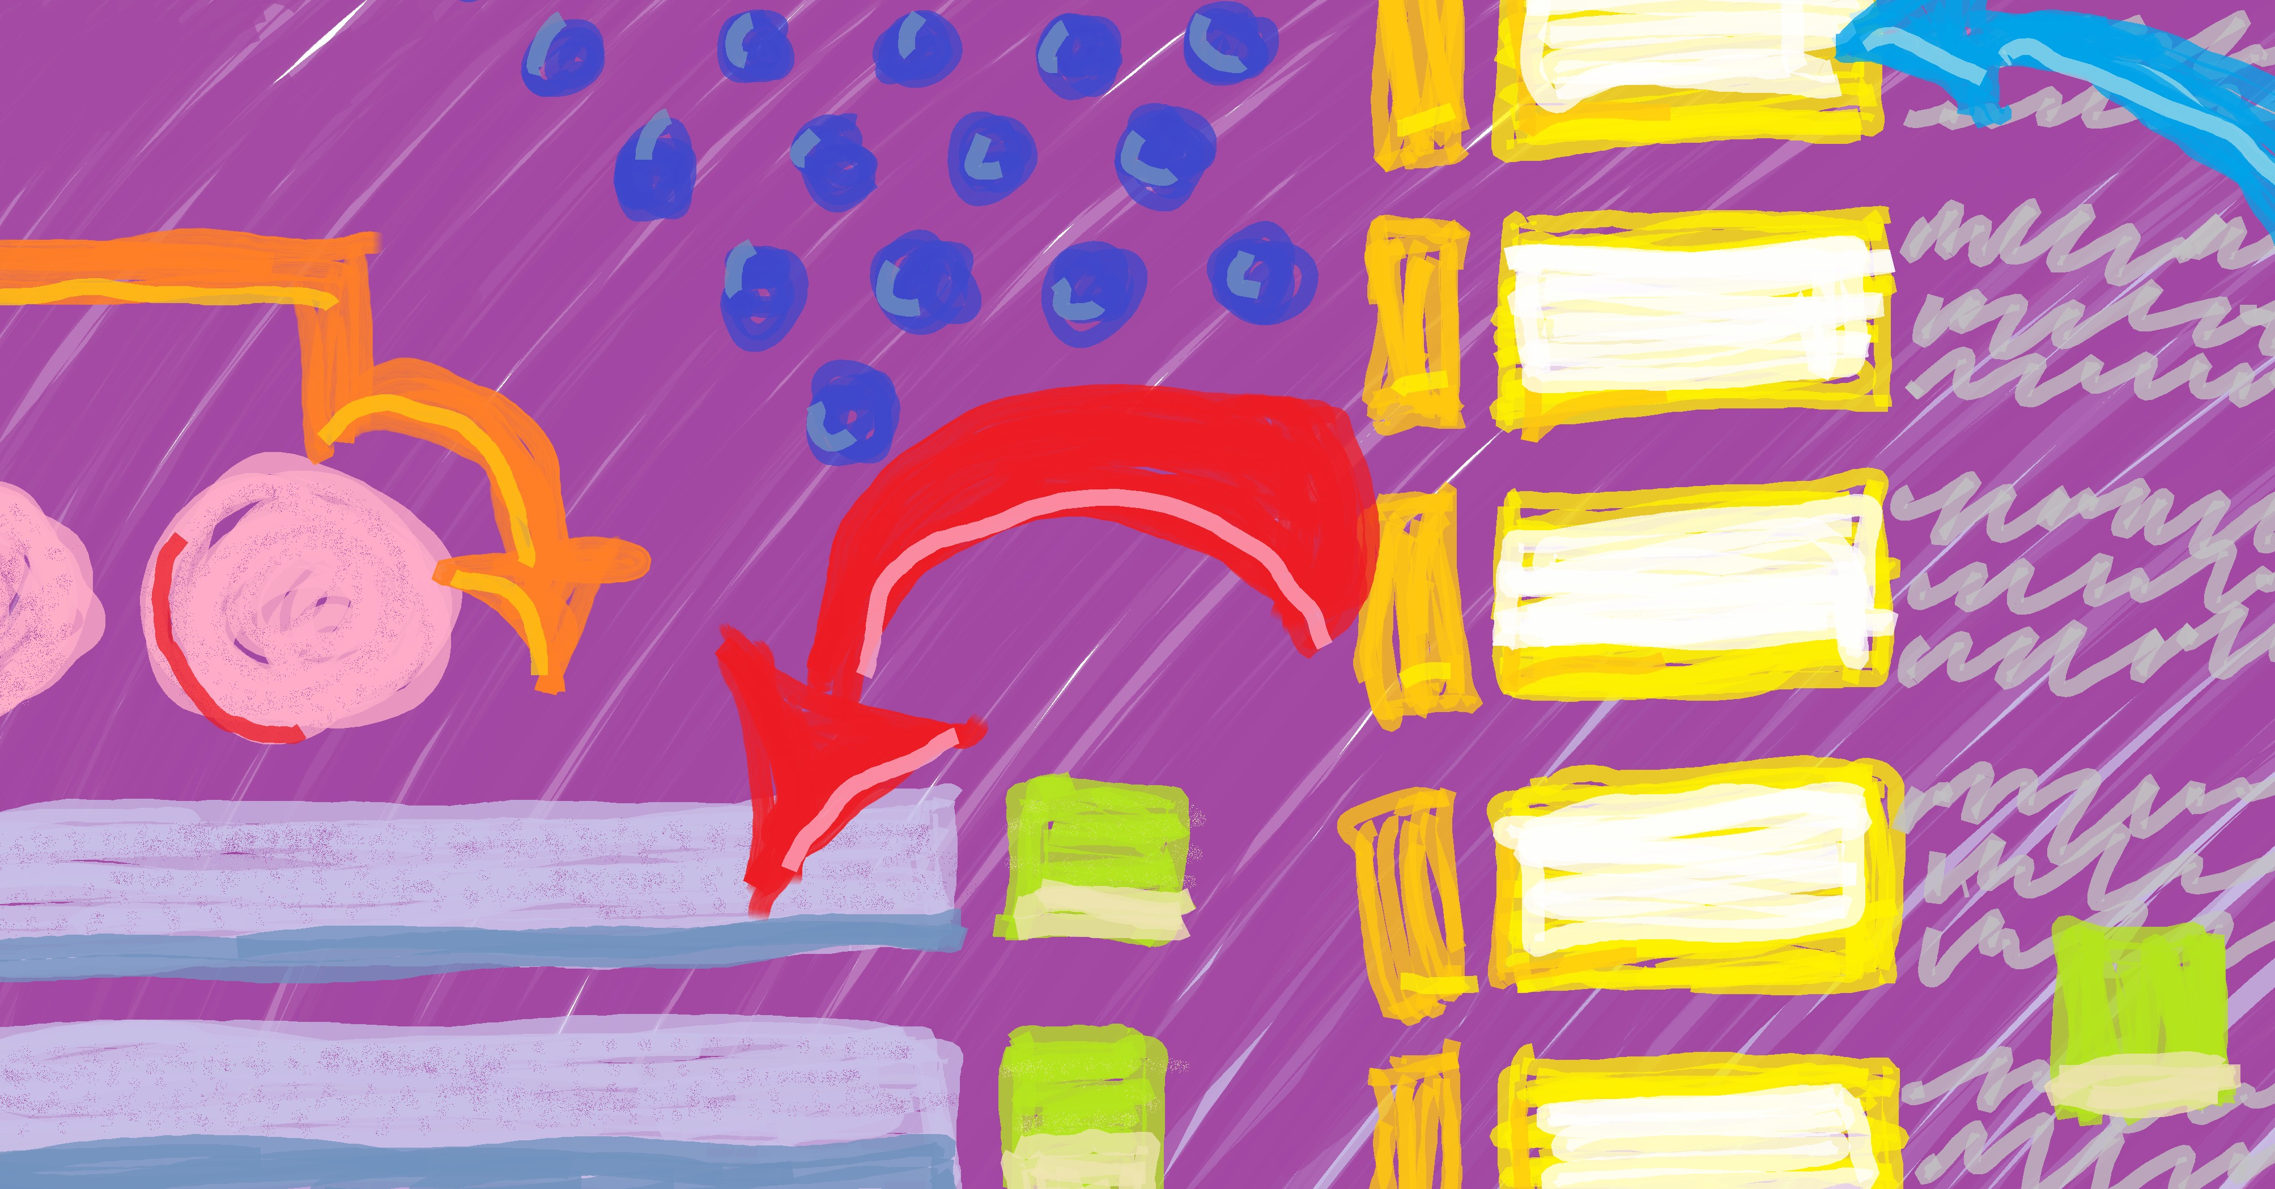
User interface (UI) design often involves prototyping: Iteratively creating depictions of what you think the UI should look like, and how users should interact with it, based on the software’s require- ments. Prototyping gives you a way to try out a UI design and find problems early. Changing a drawing (digital or physical) is easier and faster than changing its code implementation.
There are multiple levels—or “fidelities”—of UI design proto- types (low-fidelity, medium-fidelity, and high-fidelity). If you look around, you’ll find disagreement on the definitions. Definitions I use:
- Low-fidelity: A rough sketch that is often drawn by hand, drawn using an app and stylus, or made using software specif-

67
user interface (UI): What a user interacts with to operate a sys- tem (e.g., a graphical user inter- face, a command-line interface, a virtual or augmented reality inter- face, etc.).

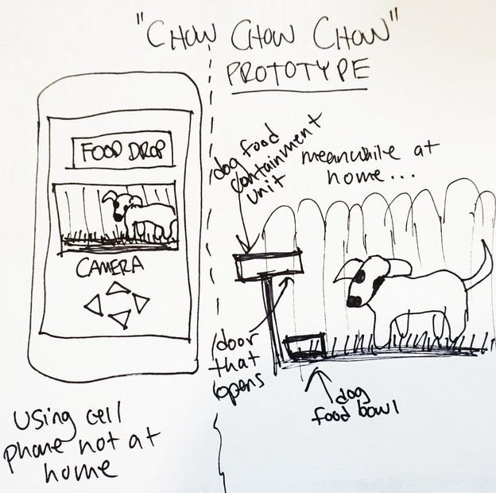
ically for creating low-fidelity prototypes. At this fidelity, you can gather feedback on higher-level features and have the flexibility to make large, low-cost changes.

graphical user interface (GUI): A user interface with interactive graphics, in contrast to a text- based user interface.
. . . . . . . . . . . . . . . . . . . . . . . . . . . . . .
low-fidelity prototype: A rough sketch of a user interface design (especially a GUI). Can be hand- drawn or digital.
. . . . . . . . . . . . . . . . . . . . . . . . . . . . . .
medium-fidelity prototype: A careful and detailed illustration of a user interface design (especially a GUI). Can be hand-drawn, but digital is more common.

- Medium-fidelity: A detailed illustration often created using a professional drawing or presentation tool (e.g., Visio, Pow- erPoint, etc.), or perhaps a careful and detailed hand-drawing. At this fidelity, to keep costs low, you can gather feedback on small changes to defined and accepted features that you plan to keep but might change the look of.
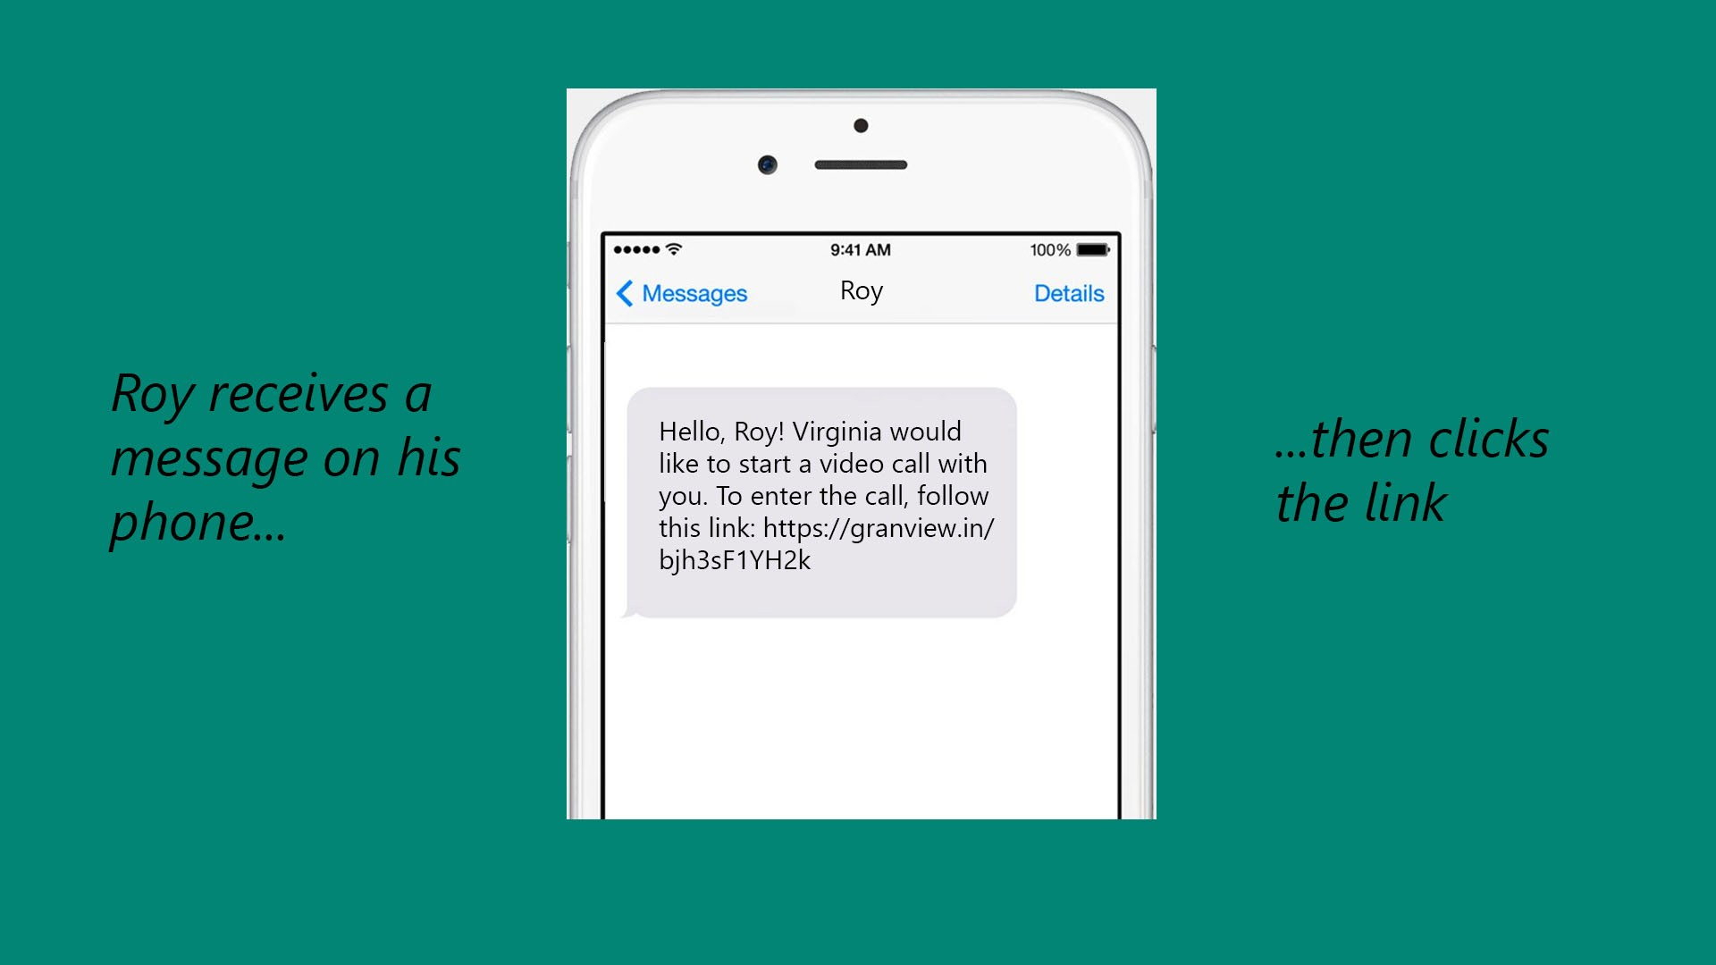
- High-fidelity: A polished, detailed illustration that looks like a finished UI. These designs might be created in a full-featured

7.1. SHOWING INTERACTION 69

graphics editor (e.g., Photoshop, Illustrator, etc.) or a GUI builder. At this fidelity, to keep costs low, you can gather feed- back about detailed tweaks to specific features to make very
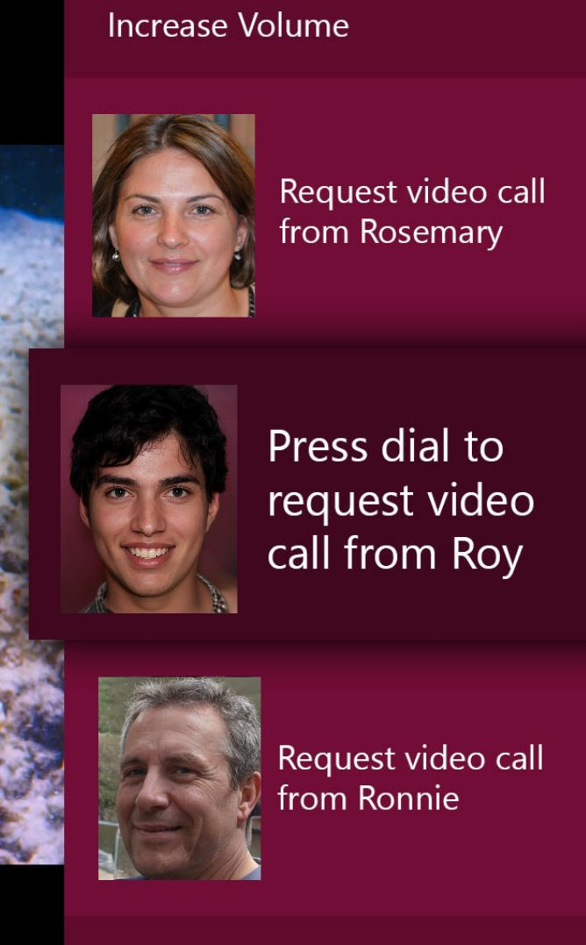
focused and incremental improvements. high-fidelity prototype: A pol- ished illustration that looks like a finished, publishable user inter- face design (especially a GUI). Al- most always digital.
. . . . . . . . . . . . . . . . . . . . . . . . . . . . . .
paper prototype: A hand-drawn sketch used to communicate a po- tential user interface design to be implemented, especially a graph- ical user interface design (Snyder 2003).

A quick and low-cost way to begin prototyping (and begin get- ting feedback on your UI design) is to create a low-fidelity paper prototype.
A paper prototype is a hand-drawn sketch of a UI design that’s based on the software’s requirements. It does not need to be pretty or artistic. It can be simple and reduce the UI to only the most im- portant elements (i.e., it is often low-fidelity).

Showing Interaction
A paper prototype needn’t be static or limited to one sheet of paper. With some craftiness and creativity, paper prototypes can commu-
nicate elements of interaction design by indicating what users can interaction design: An approach

interact with (e.g., a slider), how they can interact (e.g., by dragging), and what happens when they interact (e.g., an overlay appears, show- ing the elevations of each mountain in the photo). To show interac- tion design through a paper prototype, you can, for example, cut out small paper shapes you can easily move around (e.g., a small rect- angle showing the submenu items that appear when a user clicks), place arrows and annotations on your prototype, and even add strings
to technology design that involves helping users understand what’s happening with the technology, what just happened, and what they can do (Norman 2013).

think-aloud protocol: A method for gathering feedback about the usability of a design that in- volves a test user speaking their thoughts as they interact with the design (C. Lewis, Rieman, and Blustein 1993). More in- formation: https://tinyurl. com/think-aloud-protocol
to show how UI elements may move. I’ve even seen people use brass brads for spinnable elements. But keep in mind that, if your client doesn’t like your design, you might have saved time and communi- cated your concept just as well with a less elaborate paper prototype.

Showing Your Concept to Others
Once you have a paper prototype, you can use it to harvest feedback. Here’s one way: If each of your screen designs is on one piece of paper, give your user the entry screen drawing, then either give them an objective (e.g., submit data report) or let them explore on their own. Watch as they tap buttons or otherwise interact. Be ready to place other drawings on top of the one they have to indicate what would happen in the real software (e.g., if they tap the gear icon, give them a sketch of the settings screen). If you’re fast and brought extra supplies, you can construct new designs on-the-fly or (if they’re interested) let your user participate.
You can ask your user to provide feedback about the design after they’re done using it or as they go, using a think-aloud protocol: Ask your user to tell you what they’re doing, what they’re trying to do, what questions they have at that moment, what they don’t like, etc.

7.3. CONCLUSION 71

Conclusion
Paper prototyping can help reduce project costs by giving a way to detect user interface design flaws before they are implemented. It can also help teams communicate about the software with each other, clients, and users.

Additional Resources
Clayton Lewis, John Rieman, and Amended J. Blustein (1993). Task-Centered User Interface Design: A practical introduction. A shareware book published by the authors. url: https:
//web.archive.org/web/20201126014548/http://www.hcibib.org/tcuid/tcuid. pdf
Don Norman (2013). The Design of Everyday Things: Revised and Expanded Edition. eng. Rev. and expanded ed. Boulder: Basic Books. isbn: 9780465050659
Carolyn Snyder (2003). Paper Prototyping: The Fast and Easy Way to Design and Refine User Interfaces. eng. The Morgan Kaufmann series in interactive technologies. Kidlington: El- sevier Science & Technology. isbn: 9781558608702. url: https://web.archive.org/ web/20140628171628/http://www.paperprototyping.com/

Chapter 8
Cognitive Style Heuristics

The Cognitive Style Heuristics (CSH) are eight principles of inter- Cognitive Style Heuristics

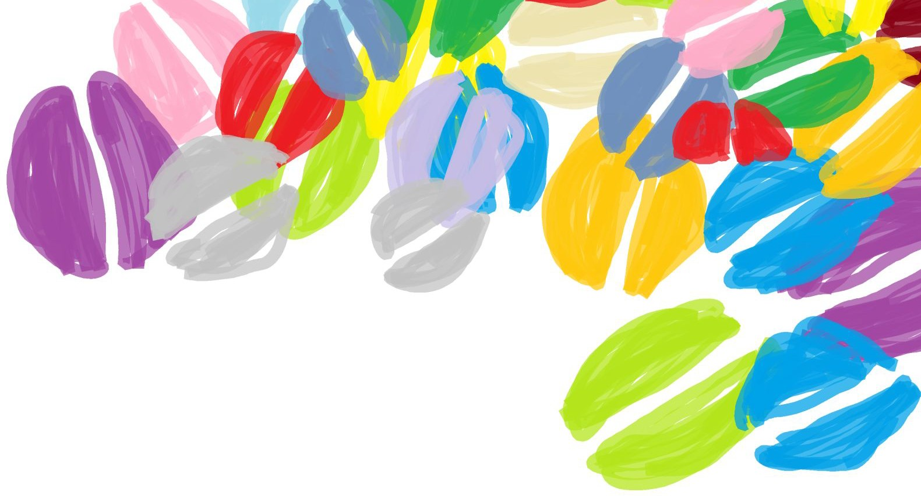
action design used to improve software usability. They are framed around how different people use software in different ways. The CSH were created by a research team headed by Margaret Burnett, one of the world’s leading experts in usability research and inclusive soft- ware design.
The CSH were created with new users in mind: People who have never seen, interacted with, or received previous direction on the soft- ware. They can also improve usability for more seasoned users who have figured out how to use the software to complete their tasks but may still be unhappy with the software.

73
(CSH): Eight principles of in- teraction design for finding and fixing usability bugs in software. They are based around different cognitive styles different people use when they problem-solve in software.
. . . . . . . . . . . . . . . . . . . . . . . . . . . . . .
interaction design: An approach to technology design that involves helping users understand what’s happening with the technology, what just happened, and what they can do (Norman 2013).

inclusive software design: A type of software user interface design with the goal of increas- ing usability for traditionally under-served user populations while also increasing usability for mainstream users.
. . . . . . . . . . . . . . . . . . . . . . . . . . . . . .
cognitive style facets (CSFs): Five aspects of users that af- fect how they solve problems in software: Motivations, informa- tion processing style, computer self-efficacy, attitude toward risk, learning style
. . . . . . . . . . . . . . . . . . . . . . . . . . . . . .
motivation CSF: Why someone is using the software (task comple- tion vs. interest)
. . . . . . . . . . . . . . . . . . . . . . . . . . . . . .
information processing style CSF: How a person looks through or absorbs information in software (comprehensively vs. selectively)
. . . . . . . . . . . . . . . . . . . . . . . . . . . . . .
computer self-efficacy CSF: A person’s confidence in their ability to use computers or software (low vs. high)

Cognitive Style Facets
At the core of the Cognitive Style Heuristics are the cognitive style facets, five aspects of human cognition that affect how users problem- solve in software:

    - Motivations for using software (task completion vs. tech in- terest). A person who is feeling task-motivated might choose to use software because they have something specific they need to accomplish, and might focus on that task immediately when they open the software and the whole time they’re using it. A person who is feeling interested in the software itself might seek out the new and exciting features and spend a lot of time exploring them.
    - Information processing style (comprehensive vs. selective). A person processing comprehensively might want to under- stand details, implications, or to get a sense of overall structure before taking action in software. A person processing selec- tively might take action as soon as they detect what seems like the beginning of a promising path.
    - Computer self-efficacy (low vs. high). A person who is feel- ing low computer self-efficacy might think it’s their fault when they make a mistake or encounter a problem in the software. A person feeling high computer self-efficacy might feel the soft- ware is poorly made if they make a mistake or encounter a problem in the software.
    - Attitude toward risk (risk-tolerant vs. risk-averse). A person who is feeling risk-averse might avoid taking actions that have unknown consequences or seem dangerous or irreversible. A person who is feeling risk-tolerant might take actions even if they know those actions could lead to bad consequences.
    - Learning style (tinkering vs. by process). When someone is tinkering, they might click a button just because it’s clickable then learn from what happens. When someone is learning by process, they might seek a logical first step, and want to pro- ceed smoothly from start to finish.

As you probably noticed, each of the cognitive style facets has two polar cognitive style facet values (or cognitive styles). Each

8.2. COGNITIVE STYLE PERSONAS 75

pair of facet values creates a spectrum. When each of us uses soft- ware, the way we feel and behave corresponds to somewhere on each of those spectra. Our individual facet values may be similar each time we use software, but they can also vary by context and change over time. For example, many people feel cognitively impatient when reading paragraphs of text (“text walls”) on websites and might pro- cess them more selectively, whereas they might want to catch every word of a new novel by their favorite author (comprehensive process-
ing). attitude toward risk CSF: How
willing a person is to take chances

Cognitive Style Personas
The CSH are stated from the perspective of improving usability for the three cognitive style personas: Abi, Pat, and Tim. A persona is fictional person that is created to represent a group of users within a target audience. Personas are used to help marketing teams keep im- portant subsets of their target audience in mind, and in software UI design for the same reason. Personas are typically documents that in- clude a photo, name, age, gender, other background information, and information about how the made-up person interacts with product or software.
The cognitive style personas have a similar purpose but are dis- tinct from traditional personas in multiple ways:
- There are three and only three (Abi, Pat, and Tim).
- Abi, Pat, and Tim each have a different set of cognitive styles. The cognitive styles are fixed.
- Abi, Pat, and Tim are each multi-personas: They each have multiple photos of different people who appear to be of differ- ent ages, races, genders, etc.
- Abi, Pat, and Tim were specifically created for evaluating soft- ware (not marketing).
- Abi, Pat, and Tim represent different positions on the cognitive style facet spectrum: Abi and Tim are on the ends and Pat is in the middle.
The idea of the cognitive style personas is that creating software that works well for Abi and Tim (the two ends of the cognitive style facet value spectrum) will result in software that’s better for them and everyone in between.
in software (risk-tolerant vs. risk- averse)
. . . . . . . . . . . . . . . . . . . . . . . . . . . . . .
learning style CSF: How a person prefers to move through software (tinkering vs. by process)
. . . . . . . . . . . . . . . . . . . . . . . . . . . . . .
cognitive style facet value (A.K.A., cognitive style): A position on the spectrum of a cognitive style facet
. . . . . . . . . . . . . . . . . . . . . . . . . . . . . .
persona: A fictional character that represents a subset of users in a target audience. Personas are used in marketing and UI design to help with focusing on particu- lar groups of users and customers (Pruitt 2010; B. Martin 2012).
. . . . . . . . . . . . . . . . . . . . . . . . . . . . . .
cognitive style personas: Three specialized personas (Abi, Pat, and Tim) used for making soft- ware UI designs more usable to people with different cognitive styles.

8.2.1 Abi, Pat, and Tim
Abi (Abigail/Abishek)
Motivation: Uses technology to accomplish their tasks.
Computer self-efficacy: Lower self-confidence than their peers about doing unfamiliar com- puting tasks. Blames themselves for problems.
Attitude toward risk: Risk-averse about using unfamiliar technologies that might require a lot of time
Information processing style: Comprehensive
Learning style: Process-orientated learning
Pat (Patricia/Patrick)
Motivation: Learns new technologies when they need to
Computer self-efficacy: Medium confidence doing unfamiliar computing tasks. If a prob- lem can’t be fixed, they will keep trying
Attitude toward risk: Risk-averse and doesn’t want to expend time when they might not receive benefits
Information processing style: Comprehensive
Learning style: Likes to explore and purposefully tinker
Tim (Timara/Timothy)
Motivation: Likes learning all the available functionality on all their devices
Computer self-efficacy: High confidence in technical abilities. If a problem can’t be fixed, blame goes to software vendor.
Attitude toward risk: Doesn’t mind taking risk using features of technology
Information processing style: Selective
Learning style: Likes tinkering and exploring

The Heuristics
Adapted from (Burnett, Sarma, Hilderbrand, Steine-Hanson, Mendez, Perdriau, et al. 2021).

Note: The designs shown below were modelled after examples found in published software.

Heuristic #1 (of 8): Explain the benefits of using new and existing fea- tures
      - Abi and Pat are task-motivated so might lose interest if they don’t see how a feature relates to their task.
      - Abi is risk-averse so might avoid features with too many unknowns.
      - Tim is risk-tolerant and motivated by tech interest so might take a chance on features then be disappointed at how mundane they are.
To support users’ motivations and attitudes toward risk, provide Abi and Pat ways to decide whether a feature relates to their task and provide Tim ways to decide whether a feature is new and unique.

Example 1: Each featured extension has a brief description that says what the extension does and why somebody would use it.

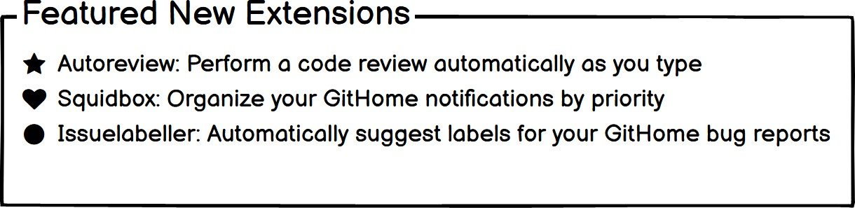

Example 2: Announcement briefly describes a new feature and how to use it.

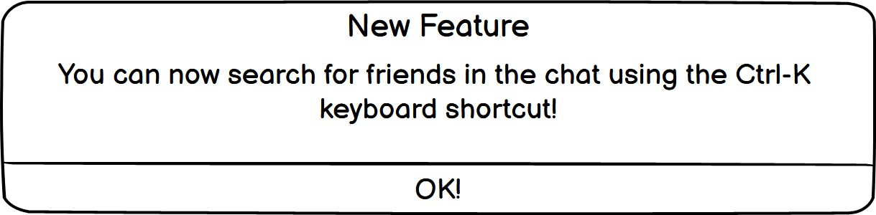

Example 3: Tooltip says why someone might use the search.

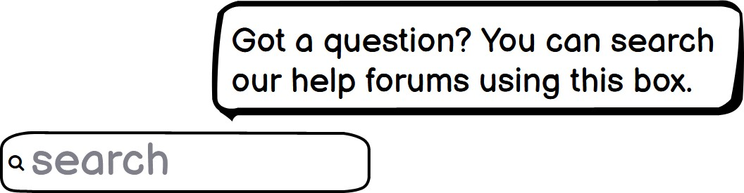

Example 4: Each tile explains a feature and the benefit of using the feature.

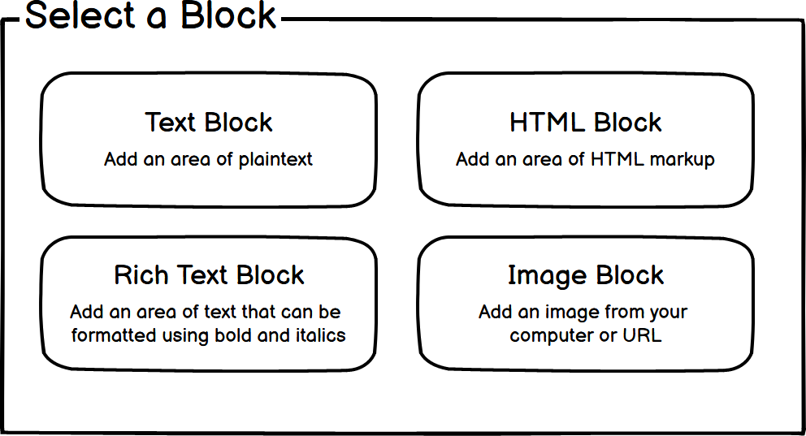

Heuristic #2 (of 8): Explain the costs of using new and existing features
      - Abi and Pat are risk-averse, so they may want to avoid features with high effort costs if the benefits of using these features are unclear.
      - Tim is risk-tolerant, so may begin using features that require extra effort and time, and that are unrelated to the task at hand.
To support their attitudes toward risk, allow Abi and Pat to decide whether or not a feature will require too much effort to use. To help Tim stay on track with their task, allow them to understand that a feature may take extra effort, and thus more time.

Example 1: Placing “Advanced Options” at the bottom of the menu indicates to the user that “advanced” features may take more effort.

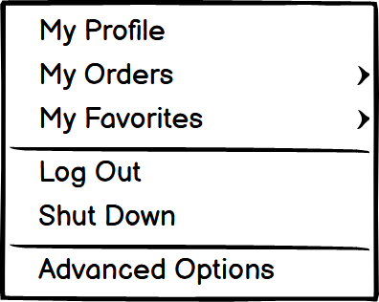

Example 2: The dialog indicates that “cor launcher” will be needed to “associate files with Coral” and that the user will need write permissions for the installation folder.

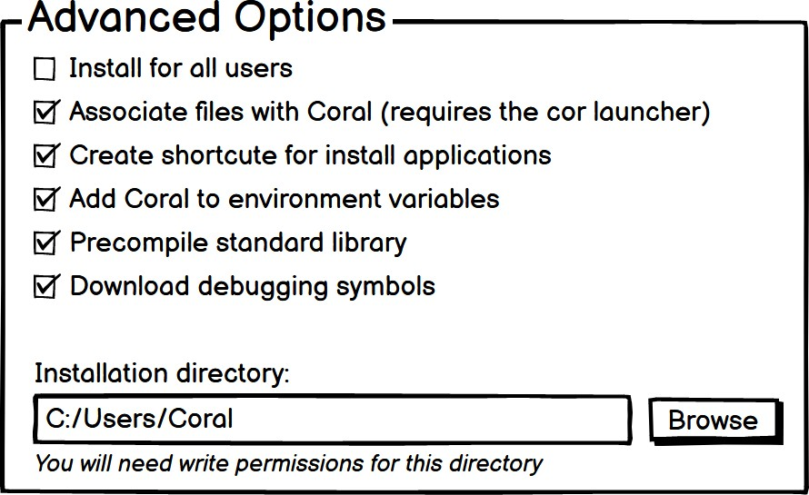

Heuristic #3 (of 8): Let people gather as much information as they want, and no more than they want
      - Abi and Pat gather and read relevant information comprehensively before acting.
      - Tim likes to delve into the first option and pursue it, backtracking if need be.
To support their information processing styles, allow Abi and Pat to easily obtain as much informa- tion they want, but don’t require them to spend excessive time or effort gathering that information. Allow Tim to get to directly useful information immediately so that they can act upon it without wading through a lot of information they don’t want.

Example 1: Users can choose to view code documentation while still viewing their code.

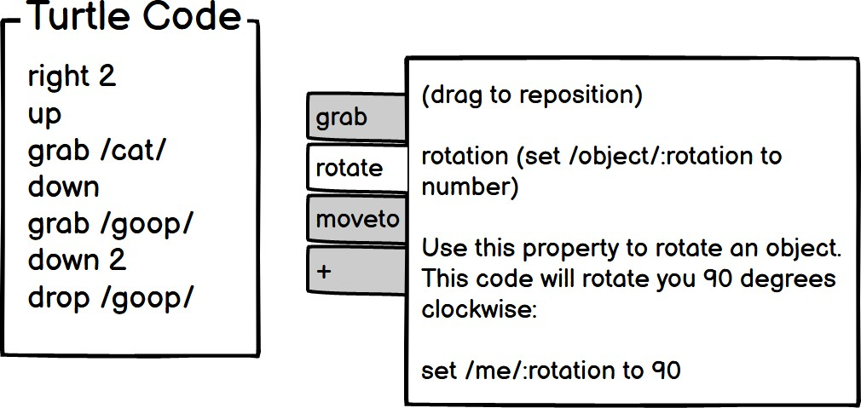

Example 2: Users can quickly see the contents of the webpage and jump to the section they’re interested in.
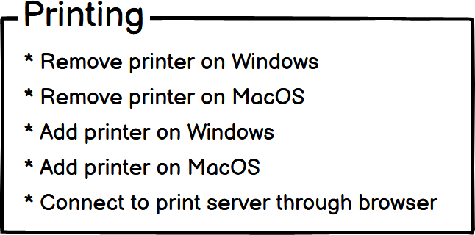

Heuristic #4 (of 8): Keep familiar features available
      - Abi has lower computer self-efficacy and is more risk-averse than Tim, so if a problem arises when they are trying to use an unfamiliar feature, Abi blames themself and stops using the tech rather than potentially wasting their time trying to get the unfamiliar feature working.
      - Pat has medium self-efficacy with technology, so if a problem arises when they are trying to use an unfamiliar feature, Pat will try alternative ways of succeeding for a while. However, Pat is also risk-averse so prefers to perform tasks using familiar features, because they’re more predictable about what Pat will get from them and how much time they’ll take.
      - Tim has higher computer self-efficacy and is more risk-tolerant than Abi, so if a problem arises when they are trying to use an unfamiliar feature, they’ll blame the tech, and may spend a lot of extra time trying to work around a problem in numerous ways.
To support their computer self-efficacies and attitudes toward risk, and to encourage Abi, Pat, and Tim to keep using the tech without wasting their time, enable them to interact with it using the same features they’ve used in the past.

Example 1: Although the “following” page is gone, the new update looks similar to the previ- ous version so that users are still familiar with the app.

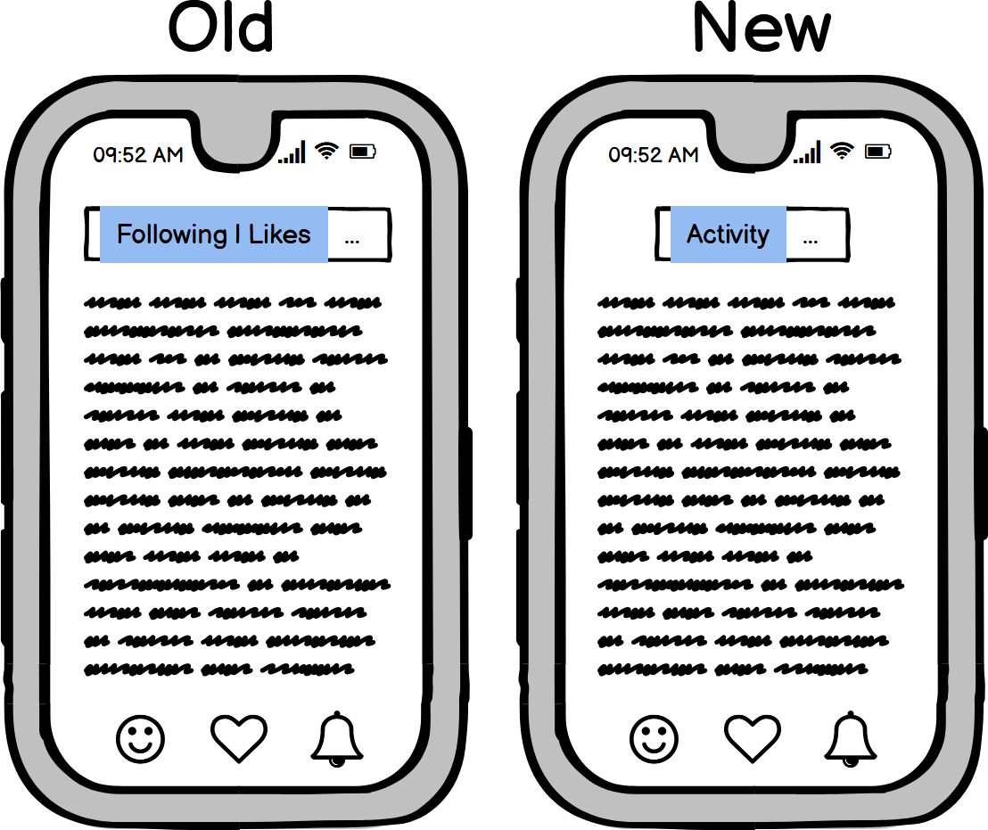

Example 2: The smartphone and tablet versions of this app offer the same features which makes switching between the two easy.
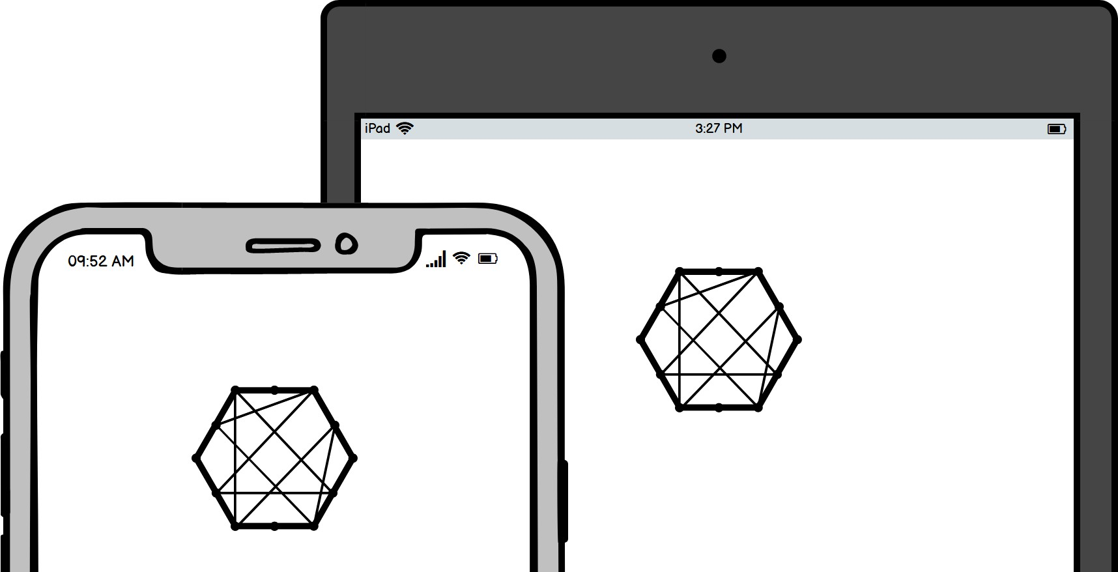

Heuristic #5 (of 8): Make undo/redo and backtracking available
      - Abi and Pat are risk-averse, so they prefer not to take actions in technology that might not be easy to reverse.
      - Tim is risk-tolerant, so is willing to take actions in technology that might be incorrect and need to be reversed.
To support their attitudes toward risk, provide undo/redo and backtracking to allow Abi and Pat to feel comfortable proceeding with actions whose consequences may not be clear, so that that they know they can easily reverse these actions, and so that Tim can recover from mistakes.

Example 1: Browser back/forward buttons allow users to backtrack through their browsing history.

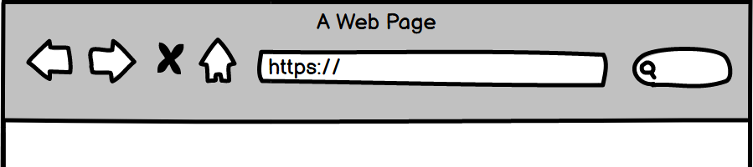

Example 2: An undo button allow users to make and recover from mistakes. Also, version control systems allow users to revert to any previously-committed code state.

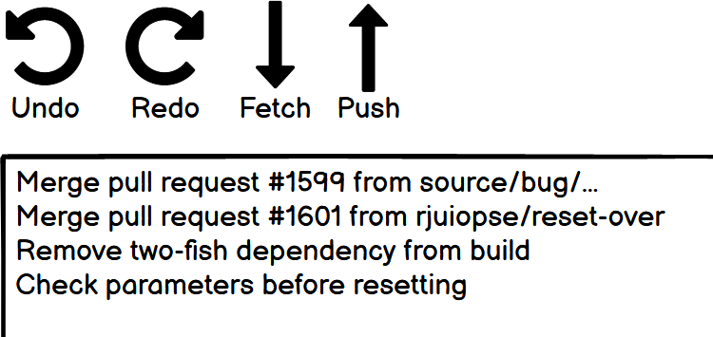

Heuristic #6 (of 8): Provide an explicit path through the task
      - Abi is a process-oriented learner, so prefers to proceed through tasks step-by-step.
      - Tim and Pat learn by tinkering, and therefore prefer not to be constrained by rigid, pre- determined processes.
To support their learning styles, explicitly provide Abi a clear process to go through the task, and provide Tim and Pat a way to bypass step-by-step processes and tutorials if those are not required for learning the technology.

Example 1: Users can choose their entry point, and each path is explained.

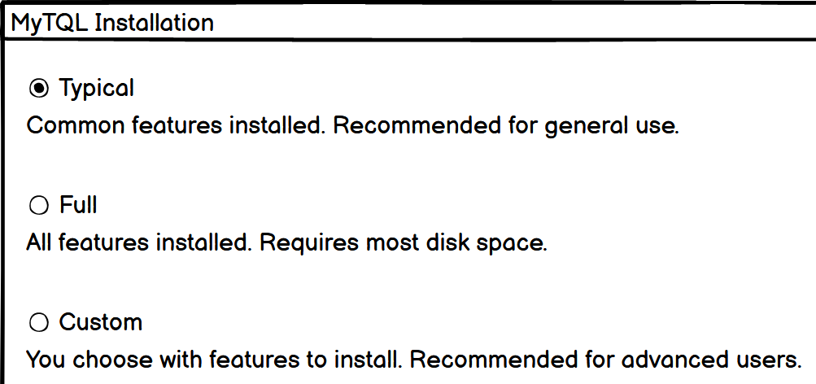

Example 2: Users get to choose either the path of learning more about the new feature or going back to what they were doing.

Heuristic #7 (of 8): Provide ways to try out different approaches
      - Abi has lower computer self-efficacy than Tim, so if a problem arises when they are trying to use technology, Abi blames themself and stops using the tech.
      - Pat has medium self-efficacy with technology, so if a problem arises when they are trying to use technology, Pat will try alternative ways of succeeding for a while.
      - Tim has higher computer self-efficacy than Abi, so if a problem arises when they are trying to use technology, they’ll blame the tech, and then will try numerous workarounds to get around the problem.
To support their computer self-efficacies, point Abi toward a different approach when they feel unable to proceed with the current one. This will also point Tim and Pat to multiple ways they can try to solve the problem.

Example 1: If users don’t find what they need on the “Choose a Question” drop-down menu, they can try the chat.

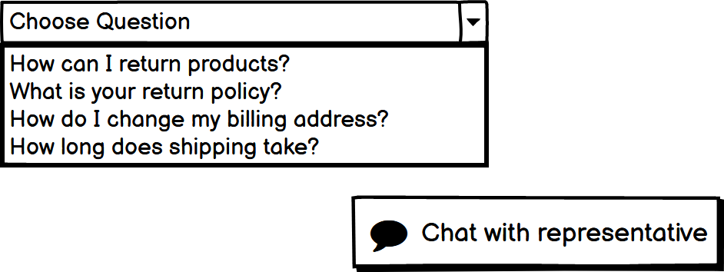

Example 2: If users encounter a problem using the SecureChat UI, they can attempt the same operations using the command line interface.

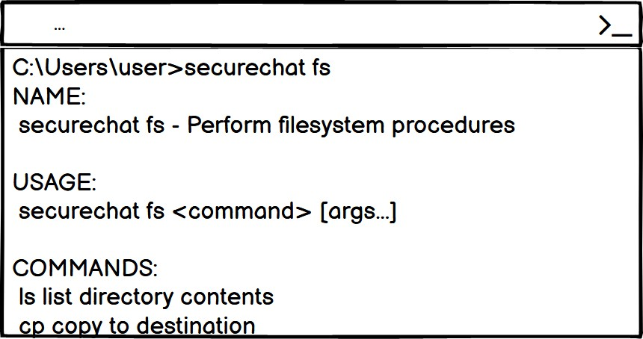

Heuristic #8 (of 8): Encourage tinkerers to tinker mindfully
      - Tim learns by tinkering, but sometimes tinkers addictively and gets distracted from their task.
      - Pat learns by trying out new features but does so mindfully, reflecting on each step.
To support their learning styles, encourage Tim not to over-tinker (e.g., by adding an extra click), so that they make fewer mistakes, have time to absorb important information, and stay on-task.

Example 1: This design encourages users to tinker mindfully by showing they will notify them before impactful actions are executed, like emailing 237 people.

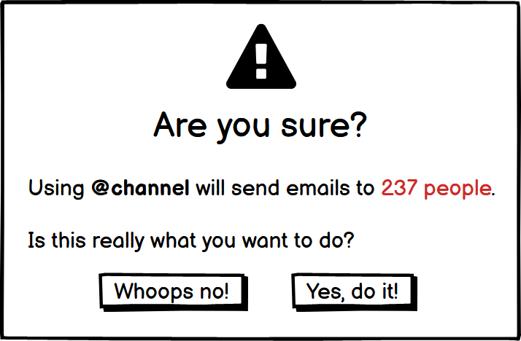

Example 2: This design encourages users to try out new “slash” commands by showing all the commands when a user types “/”, and explaining what each does and how to use it.

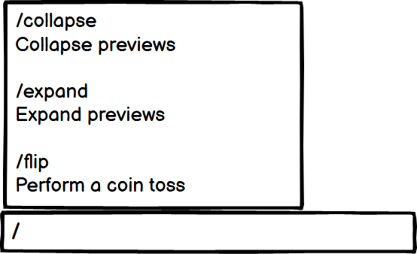

heuristic evaluation: A usabil- ity inspection method where eval- uators independently check that a design reflects a set of heuristics, then compare results (Nielsen and Molich 1990).
. . . . . . . . . . . . . . . . . . . . . . . . . . . . . .
The cognitive style personas are simplified versions of the Gender- Mag personas. You can find the the GenderMag personas, and a full description of their research origins, at GenderMag.org
. . . . . . . . . . . . . . . . . . . . . . . . . . . . . .
GenderMag Method: A method for finding and fixing gender- inclusivity bugs in software that uses a specialized cognitive walk- through and the customizable Abi, Pat, and Tim personas (Burnett, Stumpf, et al. 2016)
. . . . . . . . . . . . . . . . . . . . . . . . . . . . . .
cognitive walkthrough: A us- ability inspection method that in- volves stepping through a user in- terface as a user, stopping to ask specific questions about the user’s experience (Nielsen and Mack 1994).

Background
The Cognitive Style Heuristics are meant to be used in a heuris- tic evaluation, a process where software designers or evaluators go through heuristics one-by-one like a checklist, deciding whether the design does or does not reflect the heuristic. The evaluation is done independently by two or more people, who then compare findings.
The Cognitive Style Heuristics are derived from the GenderMag Heuristics (Burnett, Sarma, Hilderbrand, Steine-Hanson, Mendez, and Perdriau 2018) and the GenderMag Method (Burnett, Stumpf, et al. 2016). The GenderMag Method is a process for finding and fixing gender-inclusivity bugs in software. Instead of heuristic eval- uation, it uses a cognitive walkthrough. It uses the same personas: Abi, Pat, and Tim. However, in addition to their cognitive styles, each GenderMag persona has additional sections, such as one with customizable background information.
What do cognitive styles have to do with gender? Software tends to be biased against the cognitive styles often favored by women. De- signing with cognitive styles in mind can make software less gender- biased (Vorvoreanu et al. 2019).
In addition, “designing software so that it works for diverse pop- ulations matters to software companies’ profitability, to equity in the workplace and at home, and to anyone in a situation that changes the way they think, such as when under deadline pressure.”(Mendez et al. 2019)

Conclusion
The Cognitive Style Heuristics are a set a eight software usability heuristics for evaluating and improving the usability of UIs across users with different cognitive styles.

8.6. ADDITIONAL RESOURCES 87

Additional Resources
Margaret Burnett, Simone Stumpf, et al. (Oct. 2016). “GenderMag: A Method for Evaluating Software’s Gender Inclusiveness”. In: Interacting with Computers 28.6, pp. 760–787. issn: 0953-5438. doi: 10.1093/iwc/iwv046. eprint: https://academic.oup.com/iwc/ article- pdf/28/6/760/7919992/iwv046.pdf. url: https://doi.org/10.1093/ iwc/iwv046
Charles G Hill et al. (2017). “Gender-Inclusiveness Personas vs. Stereotyping: Can we have it both ways?” In: Proceedings of the 2017 chi conference on human factors in computing systems, pp. 6658–6671
GenderMag.org (n.d.). http://gendermag.org. Accessed: 2020-12-27
Margaret Burnett, Anita Sarma, Claudia Hilderbrand, Zoe Steine-Hanson, Christopher Mendez, and Christopher Perdriau (July 2018). The GenderMag Heuristics (Beta Version). https:
//gendermag.org/flyers_handouts.php
Bella Martin (2012). Universal methods of design : 100 ways to research complex problems, develop innovative ideas, and design effective solutions. Digital ed. Beverly, MA: Rockport Publishers. isbn: 9781610581998
Christopher Mendez et al. (2019). “From GenderMag to InclusiveMag: An Inclusive Design Meta-Method”. eng. In:
Jakob Nielsen and Rolf Molich (1990). “Heuristic Evaluation of User Interfaces”. In: IN: PRO- CEEDINGS OF THE CHI'90 CONFERENCE, SEATTLE. S, pp. 249–256
Jakob Nielsen and Robert L. Mack (1994). Usability inspection methods. New York
Don Norman (2013). The Design of Everyday Things: Revised and Expanded Edition. eng. Rev. and expanded ed. Boulder: Basic Books. isbn: 9780465050659
John Pruitt (2010). The essential persona lifecycle : your guide to building and using personas. San Francisco, Calif. : Oxford: Morgan Kaufmann ; Elsevier Science [distributor]. isbn: 9780123814180
Mihaela Vorvoreanu et al. (2019). “From Gender Biases to Gender-Inclusive Design: An Em- pirical Investigation”. In: Proceedings of the 2019 CHI Conference on Human Factors in Computing Systems. CHI ’19. Glasgow, Scotland Uk: Association for Computing Machin- ery, pp. 1–14. isbn: 9781450359702. doi: 10.1145/3290605.3300283. url: https:
//doi.org/10.1145/3290605.3300283

Chapter 9
Code Smells and Refactoring

Code smells are aspects of code that indicate the code needs to
be reorganized—signs your software is decaying. Your code might code smell: Aspect of code that

need attention if you’re having thoughts like these:
- “I would never show this code during an interview.”
- “I’m going to start over and re-write this code from scratch.”
- “Every time I look at this code, I have to re-figure-out what it does.”
- “I don’t think these code comments match what the code is doing...”
- “Why is this code repeated in three different places?”
- “I want to switch out this component, but that’ll break X, Y, and Z in this other place and I don’t want to deal with that.”

89
indicates the code is of poor qual- ity (e.g., has detriments to read- ability and maintainability).
. . . . . . . . . . . . . . . . . . . . . . . . . . . . . .
code decay (AKA software rot): Reduction of code quality over time. Can result in decreased maintainability, more bugs, and ir- retrievable failure.

If you want to learn more about any of the code smells and refac- torings described in this chapter, or want to know MORE ways your code can smell, (R. C. Martin 2013) and (Shvets 2021) are two good resources.

If you think it’s more fun to write code than organize code, you may need to be strict with yourself about using good programming practices.
Types of codes smells we’ll cover (including how to fix them):

- Code smells about comments
- Code smells about functions
- General code smells (e.g., about the code within functions)

Why care about code smells?
Reasons to pay attention to and fix code smells:

    - Smelly code can be harder for you and others to maintain because the code is unclear. When code is hard to maintain, developers tend to work around it or re-create the same func- tionality elsewhere.
    - Smelly code leads to smellier code. When you let your code become disorganized, you are giving yourself and others the message that smelly code is acceptable. Disorganized code also tends to give us an excuse to be lazy coders. A web de- velopment example: If you’ve used CSS, you may have en- countered frustrating situations where the style you’re trying to apply is not working—somewhere in the code (e.g., other CSS, HTML, or JS), your style is being overridden. Instead of tracking down the competing code or markup, you use the “!important” property which forces the style to be applied. The codebase is a mess anyway, so who cares? Your future self.
    - Smelly code builds up technical debt. If the code is working, there’s never a reason to change it, right? Wrong. Each time you write sloppy code, you are contributing to your project’s technical debt. Maybe it works now but, as sloppy software grows, it will get more difficult to deal with. That can mean your company needing to hire more developers to keep produc- tivity up. Instead, productivity can go down because now the old developers are struggling to teach the new developers and everyone is continuing to write sloppy code. Ultimately, the software may have to be redeveloped entirely (which doesn’t always solve the problem). Or, the project could fail.

9.2. YOUR CODE STINKS, NOW WHAT? 91

Your code stinks, now what?
If you’re in a position to (e.g., your manager allows it), strongly consider refactoring. Refactoring is when you improve your code without changing what the code does. Refactoring is how you fight
against technical debt. refactoring: Improving code de-

The remainder of this chapter is about code smells and how to clean them up. This is not an exhaustive list. You can find a lot more by looking through the resources listed at the end of this chapter.

Comments
When we first learned to code, many of us didn’t write comments: solving problems is fun and coding can be addictive, no time for bor- ing comments! Then, we got more experience, started coding with others, were formally trained on coding, or attempted to pick up an old project, and we saw why comments are useful—and then some of us jumped to the other extreme: too many comments. We explained functions with paragraphs of prose, or even commented each line. It’s tedious, but it’s the right thing to do, right? Unfortunately (and fortunately), too many comments can be as bad as none.

Drawbacks of Having Many Comments
      - Comments get out of date quickly. If we update the code, then procrastinate on the comments, what we leave can be mislead- ing (to others and our future selves). Also, more comments means greater likelihood some will be neglected, giving us the smelly situation of some accurate and some inaccurate com- ments. In that case, why would we trust any of the comments?
      - Writing comments for straightforward code can distract from the important comments. If the code was difficult to write, is long, is unique, is complex, or has a “gotcha”, that code is more important to call attention to with comments.
      - Writing lots of comments could indicate the code needs to be simplified. Ideally, most of the the code you write will be self-explanatory so that comments are infrequently needed.
sign without changing what the code does.
. . . . . . . . . . . . . . . . . . . . . . . . . . . . . .
technical debt: Time and re- sources you (or someone else) will need to spend on modifying your software in the future because of the poor decisions you’re making in the present.

Don’t fall into the trap of adding excessive comments to your code before an interview! Some prospective employers specifi- cally look for over-commented code (or can’t help but see it) as a indicator of poor programming habits.

Code Smells about Comments
Below is a concise list of common code smells about comments and what to do about them (how to refactor).
      - Obsolete Comment (no longer describes the code). Remove or update.

1
# SMELLY """
Uses the Two Fish block cipher with 256 bit key size
"""
Three Fish (512 , data )
2
3

4
5

As a challenge to myself, I kept the code example boxes narrow and tried to make the “good” code fit.
. . . . . . . . . . . . . . . . . . . . . . . . . . . . . .
Commenting out code often comes with poor assumptions (e.g., you’ll need the code later, others will understand why you commented it out, the surround- ing code will continue having the same purpose, etc.)
- Commented-Out Code (somebody thought they’d need that code later, but the commented out block is now getting out of date and in the way).
Remove. If you’re feeling risk-averse, save a backup or use a version-control system.
1
# SMELLY
def update World State (): """
update Time () # might need later update Players ()
update Points () """
for p in players : p. update State ()
2
3
4
5
6
7
8
9

- Redundant Comment (states what would already be imme- diately apparent to a programmer of any level).
Remove. Less is more.

1
# SMELLY
get Length () # gets the length
2

  - Long Comment (multiple sentences, complicated, goes into a lot of detail)
Simplify the code to make it more self-explanatory, shorten or remove comment.

1
# SMELLY """
This is the first function I made in this module , and it takes the user ’ s Unicode
2
3

  - FUNCTIONS 93

4
text input , converts it into ASCII , then that creates a visualization of a typewriter typing the input . Problem is , as
you might imagine , sometimes there ’ s no good conversion to ASCII and so some meaning is lost .
"""

Functions
A natural way to code is to start writing a function and then, as the program gets more complicated, keep adding to it. For example, if your program’s GUI only has a start and a stop button, the function for populating the screen with UI elements need only draw those two buttons. Then, when you add a menu and a settings button, you could update the function to draw those elements, too. Then you add user accounts and decide that function is a fine place to check if the user is logged in, their level of inactivity, show a pop-up about cool new features... and your function balloons. Understanding the small de- tails of how the function works can even make one feel proud—until the code becomes unmaintainable and bug-ridden.

If you’re only writing a short pro- gram, does coding style matter? Treating code as disposable is a self-fulfilling prophecy.

    - Code Smells about Functions Software made of 3 to 4-line func-

Follow these refactoring suggestions to increase code readability, maintainability, and modularity.

      - Long Function (more than 10 lines or so)
Break into multiple functions. Aim for five lines or fewer.

      - Function with Many Jobs (doing more than what its name suggests, doing things that aren’t closely related, doing many things)
Break into multiple functions.
tions is amazing to behold!

1
# BEFORE
def update GUI (): update Time () update Time Display () update Scores () update Score Display () refresh Window ()
2
3
4
5
6
7
8

9
# AFTER
def update State (): update Time () update Scores ()
def update GUI (): update Time Display () update Score Display () refresh Window ()
10
11
12
13
14
15
16
17

Zero function parameters is even

- Function with Many Parameters (more than four, some say more than three)
As appropriate, pass an object that combines the parameters,

better than four! make calls within the function to get the parameter data, break into multiple functions, or find another way of reducing the number of parameters.

1
# BEFORE
init Outdoor Place ( flora List , fauna List , temperature , wind Speed , cloudiness , rockiness , bird Noises , grass Length )

# AFTER
init Outdoor Place ( world 1 data )
2

3
4
5

Code smells should not be refac- tored blindly. Always consider how your changes might affect the rest of your software; living with smells is sometimes the wiser choice.

Code
Code gets messy fast if you’re not paying attention. One reason is because many of us weren’t trained to be neat with code when we first learned it. To write tidy code, you may have to frequently stop and think about its design, or be strict with yourself about refactoring regularly. Over time, you might adopt better habits.

Code Smells about Code in General
      - Duplicate Code (same code in multiple places)
Consolidate into one place, but watch out for creating unwanted dependencies.

1
# BEFORE
def update Level Of Alarm ( npc ):
if ( npc . is Walking () && npc . is Alive () && npc . is Friendly ())
set Level Of Alarm (0)
2
3

4

  - CODE 95

5
else
set Level Of Alarm ( 500) react ( npc )

def react ( npc ):
if ( npc . is Walking () && npc . is Alive () && npc . is Friendly ())
keep Walking ()
else
run Away ()

# AFTER
def react ( npc ):
if ( npc . is Harmless ()) set Level Of Alarm (0) keep Walking ()
else
set Level Of Alarm ( 500) run Away ()

def set Level Of Alarm ( level ): alarm Level = level

def is Harmless ( npc ):
return ( npc . is Walking () && npc . is Alive () && npc . is Friendly ())
6
7
8
9
10

11
12
13
14
15
16
17
18
19
20
21
22
23
24
25
26
27
28

- Long Lines (more than 100 characters or so)
Shorten by breaking into multiple lines, converting to a func- tion call, defining new variables, etc.
1
# BEFORE
if ( rectangle . coordinate [ 1 ][ 0 ] - rectangle . coordinate [ 2 ][ 0 ] > 500 && rectangle . coordinate [ 2 ][ 1 ] - rectangle . coordinate [ 3 ][ 1 ] > 500 && rectangle . is Square ()):

# AFTER
if ( rectangle . is Square () && rectangle . width > 500) :
2

3
4
5

- Inconsistent Conventions (formatting code differently in dif- ferent places, or untidily)
Follow whatever style conventions the code is already using. If it’s a new project, plan to be self-consistent or follow accepted conventions for the language you’re using.
1
# BEFORE
if ( whale . is Singing ) {
2
Thresholds like “100 characters” or “5 lines” are somewhat arbi- trary. Generally, shorter is better, but not even that rule can be ap- plied everywhere. For example, syntactic sugar is the term for con- cise and elegant code syntax, usu- ally built into the programming language. It can make your code shorter, but what’s the point if no- body can understand it!
. . . . . . . . . . . . . . . . . . . . . . . . . . . . . .
When adding to another person’s code, it’s best to follow their coding style conventions even if you prefer a different way. However, if their code style is sloppy and inconsistent, consider whether there’s a polite way to fix the problem.

3
activate Audio Recording Device ();
} else {
recording_device_off_confirmation_check ();
}

if ( starfish . blocking Camera )
{
Air Cannon . Spray ( camera . coordinates );
}

# AFTER
if ( Whale . is Singing ) { activate Audio Recording Device ();
} else {
confirm Recording Device Off ();
}

if ( Starfish . is Blocking Camera ) { Air Cannon . spray ( Camera . coordinates );
}
4
5
6
7
8
9
10
11
12
13
14
15
16
17
18
19
20
21
22

Wouldn’t it be nice if code read

- Vague Naming (does not communicate what the function, vari- able, etc. is for)
Rename it, even if the name is long. Long names can some- times replace comments.

like a book? 1
# BEFORE a = 100
b = 2

# AFTER
retail_price = 100
wholesale_multiplier = 2
2
3
4
5
6
7

  - CONCLUSION 97

Conclusion
Cleaning up your code can help make your software sustainable and extensible and can make your teammates happier too.

Additional Resources
Martin Fowler (2019b). Refactoring : improving the design of existing code. Boston Robert C. Martin (2013). Clean Code
Alexander Shvets (2021). Refactoring Guru. Accessed: 2021-01-05. url: https://refactoring. guru/

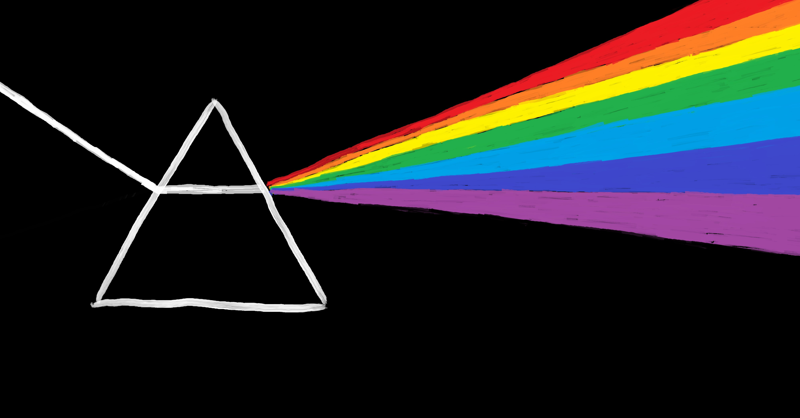

Chapter 10 Conclusion

I hope you’re now better equipped for your next software project. Updated versions of this book will be available at https://github.com/setextbook

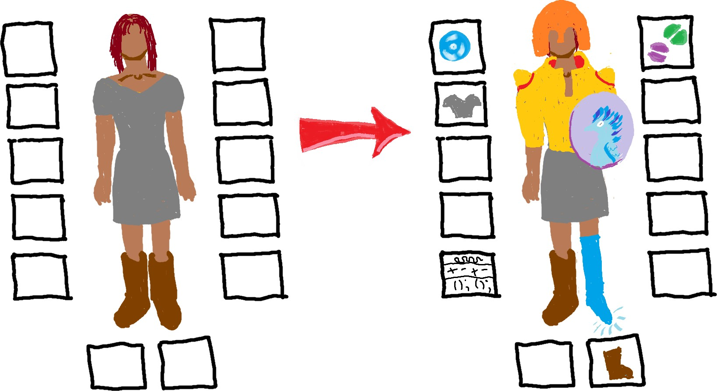

99

100 CHAPTER 10. CONCLUSION

Glossary

A
acceptance criterion: A statement about functionality that, when satisfied, mean the functionality has been satisfactorily implemented.

Agile: A software process model and philosophy for managing and developing software projects. Agile values: Individuals and interactions, working software, customer collaboration, and respond- ing to change.

attitude toward risk CSF: How willing a person is to take chances in software (risk-tolerant vs. risk-averse)

B
business capability: “the potential of a business resource (or groups of resources) to produce customer value by acting on their environment via a process using other tangible and intangible resources” (Michell 2011)

101

C
class diagram: Visualization of how classes are built in relation to other classes in object-oriented software. Includes properties and methods of individual classes and “has a” and “is a” relationships between classes.

client (a.k.a. customer): One or more people or organizations who are requesting the software be made and have decision-making authority about the software (e.g., because they are paying for it or otherwise providing resources).

client-server architecture: Overall code design characterized by one component (the server) re- sponding to requests and providing resources while other components (clients) request those re- sources.

code decay (AKA software rot): Reduction of code quality over time. Can result in decreased maintainability, more bugs, and irretrievable failure.

code smell: Aspect of code that indicates the code is of poor quality (e.g., has detriments to read- ability and maintainability).

cognitive style facets (CSFs): Five aspects of users that affect how they solve problems in soft- ware: Motivations, information processing style, computer self-efficacy, attitude toward risk, learn- ing style

cognitive style facet value (A.K.A., cognitive style): A position on the spectrum of a cognitive style facet

Cognitive Style Heuristics (CSH): Eight principles of interaction design for finding and fixing usability bugs in software. They are based around different cognitive styles different people use when they problem-solve in software.

cognitive style personas: Three specialized personas (Abi, Pat, and Tim) used for making software UI designs more usable to people with different cognitive styles.

cognitive walkthrough: A usability inspection method that involves stepping through a user in- terface as a user, stopping to ask specific questions about the user’s experience (Nielsen and Mack 1994).

component: Within a codebase, a unit of the code containing related functionality. Ideally, is both replaceable and reusable.

computer self-efficacy CSF: A person’s confidence in their ability to use computers or software (low vs. high)

contingency: A future event or circumstance that may occur but depends on known and unknown

factors. Can be difficult to predict far ahead of time.

coupling: The degree to which one unit of code is dependent on another.

D
Definition of Done (DoD): The set of acceptance criteria which, once satisfied, mean a user story has been satisfactorily implemented.

E
Eisenhower matrix: 2x2 grid for helping decide whether to do, delegate, schedule, or eliminate a task based on its urgency and importance.

encapsulation: In object-oriented programming, (1) combining data and the methods that act upon that data into one unit of code or (2) preventing external direct access to data within a unit of code.

estimation: Figuring out ahead of time how long a task is likely to take.

eventual consistency: Characteristic of software systems where different parts of the system can have less up-to-date information (e.g., state, data) than other parts but the inconsistencies are tem- porary.

extensible: Built in such a way to support adding more functionality later.

Extreme Programming (XP): Agile framework that prioritizing customer satisfaction and com- munication, short development cycles, iteration, frequent releases, code review, teamwork, pair programming, required unit testing, and only implementing functionality that’s needed.

F
fist of five: A method for gauging and building group consensus that uses a 6-level voting system (zero to five fingers).

focus group (in usability engineering): A moderated discussion between researcher and a small number of potential users (usually 6-12) during which the researcher tries to gather information about the participants’ attitudes, opinions, motivations, concerns, and problems related to a spe- cific product or topic.(Odimegwu 2000)

functional requirement: Description of what functionality the software needs to have.

G
Gantt chart: Horizontal bar chart showing start and end times of activities within a project sched- ule, along a timeline.

GenderMag Method: A method for finding and fixing gender-inclusivity bugs in software that uses a specialized cognitive walkthrough and the customizable Abi, Pat, and Tim personas (Bur- nett, Stumpf, et al. 2016)

graphical user interface (GUI): A user interface with interactive graphics, in contrast to a text- based user interface.

ground rules: A set of statements about the team, agreed to by each team member, for avoiding team conflict and dysfunction.

H
heuristic evaluation: A usability inspection method where evaluators independently check that a design reflects a set of heuristics, then compare results (Nielsen and Molich 1990).

high-fidelity prototype: A polished illustration that looks like a finished, publishable user inter- face design (especially a GUI). Almost always digital.

high-level architecture: Abstract representation of overall code design; covers all parts of the software.

I
IDE: Integrated development environment. Software specifically for creating software.

ideal days: The number of days it would take to complete the work if the work could be 100% focused on.

inclusive software design: A type of software user interface design with the goal of increasing usability for traditionally under-served user populations while also increasing usability for main- stream users.

increment: In software, a measurable increase in functionality.

interaction design: An approach to technology design that involves helping users understand what’s happening with the technology, what just happened, and what they can do (Norman 2013).

interaction diagram: Visualization of collaboration between different parts of software.

INVEST: Characteristics of good user stories (independent, negotiable, valuable, estimable, small, testable) (Wake 2003).

iteration: Verb: Revision. Noun (in Agile): A time-boxed software development cycle.

iteration plan: In Agile, establishing what will be done during a development cycle.

L
learning style CSF: How a person prefers to move through software (tinkering vs. by process)

low-fidelity prototype: A rough sketch of a user interface design (especially a GUI). Can be hand- drawn or digital.

M
maintenance: Development activities that improve software but that are unrelated to implementing new features (e.g., correcting bugs, improving organization of code, etc.).

managerial skill mix (MSM): Three categories of skills used by managers: (1) interpersonal, (2) technical, (3) administrative/conceptual.

medium-fidelity prototype: A careful and detailed illustration of a user interface design (espe- cially a GUI). Can be hand-drawn, but digital is more common.

method: A pre-established way of achieving a specific outcome.

microservices architecture: Overall code design characterized by multiple independent compo- nents that each run in their own process and communicate between one another without direct access.

mitigation plan: What you will do if a contingency happens.

monolith architecture: Overall code design characterized by being in one or few pieces; cannot be easily divided into components that run separately and are independently useful.

motivation CSF: Why someone is using the software (task completion vs. interest)

minimum viable product (MVP): A low-effort or low-expense effort that results in you being able to better estimate whether people will want to use your product—before the product is fully developed.(Olsen 2015)

N
non-functional requirement: Description of how well software is expected to perform.

P
paper prototype: A hand-drawn sketch used to communicate a potential user interface design to be implemented, especially a graphical user interface design (Snyder 2003).

persona: A fictional character that represents a subset of users in a target audience. Personas are used in marketing and UI design to help with focusing on particular groups of users and customers (Pruitt 2010; B. Martin 2012).

planning poker: In Agile, a consensus-based method of assigning estimates to a task that involves individuals on a team each making their own estimate privately, then sharing with the team, dis- cussing, and re-estimating as needed.

Product Backlog: In Agile Scrum, an ordered list of all that is known to be needed to improve a product.

project management: The process of planning and executing a project while balancing the time, cost, and scope constraints.

project management system: Software for planning, organizing, and otherwise carrying out a project.

project network: Graph showing the order in which a project’s activities are to be completed.

project priority matrix: 3x3 grid for documenting how to respond when there are potential changes to a project’s time, cost, or scope. Options: Only positive change allowed (constrain), negative change allowed (accept), or positive change sought (enhance).

Q
quality attribute: A characteristic of software used to describe how good it is.

R
RACI matrix: In project management, a chart for defining which roles are responsible (R) and accountable (A) for a task or deliverable and which roles should be consulted (C) or informed (I) about the status of the task or deliverable.

refactoring: Improving code design without changing what the code does.

release plan: What will be completed for a specific software release and when the release will occur.

requirement: A rule the software must conform to: What the software must to, how well it must do what it does, or the software’s limitations or constraints.

requirements elicitation: The process of gathering requirements from project stakeholders. requirements specification: Converting stakeholder requests into written requirements. risk: Estimated probability of a negative contingency given known and unknown factors.

S
sequence diagram: Interaction diagram showing how different participants (e.g., users, software components, classes, etc.) collaborate during a single use case.

service: A unit of software that received and fulfills requests.

scheduling: Deciding when project activities are to be completed, how long they will take, and what resources are needed to complete them.

Scrum: An Agile framework “for developing and sustaining complex products.” (Schwaber and Sutherland 2020)

software development lifecycle (SDLC): Phases through which a software’s development pro- ceeds: requirements, design, implementation, testing, maintenance.

software architecture: Code design. Can be shown at different levels of abstraction and detail.

software engineering: The art and science of using different methods to efficiently create extensi- ble, sustainable programs that solve problems people care about.

software process model: A philosophy and/or set of approaches for software development and/or software project management.

spike: A quick and to-the-point investigation for gathering information to help the team answer a question or choose a development path.

Sprint Backlog: In Scrum, the set of activities to be completed during a Sprint (from Product Backlog), the associated Sprint Goal, and a plan for completing the activities.

Software Requirements Specification (SRS): A document that contains software requirements.

stakeholder: Anyone who is or will be affected by the software or its development (e.g., clients, companies, users, developers, managers, politicians, etc.)

story points: A method for estimating an activity based on its size relative to other activities. Scale established by team.

sustainability: Degree to which software can continue to function over time (e.g., measured in time and how well the software is functioning).

T
task management system: Software for planning and organizing project activities.

technical debt: Time and resources you (or someone else) will need to spend on modifying your software in the future because of the poor decisions you’re making in the present.

tech stack: The set of programming languages, frameworks, and other technologies chosen or needed for implementing a piece of software.

think-aloud protocol: A method for gathering feedback about the usability of a design that in- volves a test user speaking their thoughts as they interact with the design (C. Lewis, Rieman, and Blustein 1993). More information: https://tinyurl.com/think-aloud-protocol
triple constraint: In project management, the three limiting factors that govern project execution: time, cost, and scope. Scope includes quality. Cost includes spending money and resources.

Tuckman’s model of team development: A five-stage model of how a team develops over time:
(1) forming, (2) storming, (3) norming, (4) performing, (5) adjourning.

U
user acceptance testing (UAT): Formally testing software with end-users to check not only whether it performs as expected but also whether end-users will use it. Typically performed before the soft- ware is released.

UML: Unified modeling language: A set of notation and methods for describing and designing software.

usability testing: Observing people while they try to use your software.(Barnum 2020)

use case: “A contract for the behavior of the system under discussion” (Cockburn 2001)
user interface (UI): What a user interacts with to operate a system (e.g., a graphical user interface, a command-line interface, a virtual or augmented reality interface, etc.).
user story: “Short, simple descriptions of a feature told from the perspective of the person who desires the new capability, usually a user or customer of the system.” (Cohn n.d.)

V
validation: Confirming that software meets users’ needs (“did we build the right software?”).
velocity: In Agile, a measure of how much work is being completed.
verification: Confirming that software satisfied its requirements (“did we build the software right?”).

W
waterfall (software process model): Way of going about software development and management that is characterized by extensive planning, comprehensive documentation, and moving linearly through stages of the software development lifecycle (SDLC).

Bibliography

Alliance, Agile (n.d.). What is “Given - When - Then?” https :// web . archive . org / web / 20201124202211/https://www.agilealliance.org/glossary/gwt.
Atkinson, Roger (1999). “Project management: cost, time and quality, two best guesses and a phe- nomenon, its time to accept other success criteria”. eng. In: International journal of project management 17.6, pp. 337–342. issn: 0263-7863.
Badawy, Michael K (1995). Developing managerial skills in engineers and scientists: Succeeding as a technical manager. John Wiley & Sons.
Barnum, Carol M. (2020). Usability Testing Essentials: Ready, Set...Test! 2nd ed. Morgan Kauf- mann.
Beck, Kent (2000). Extreme programming explained: embrace change. addison-wesley profes- sional.
Belling, Shawn (2020). “Agile Values and Practices”. In: Succeeding with Agile Hybrids. Springer, pp. 47–61.
Brennan, Kevin et al. (2009). A Guide to the Business Analysis Body of Knowledger. Iiba.
Brown, Karen A, Nancy Lea Hyer, and Richard Ettenson (2013). “The question every project team should answer”. In: MIT Sloan Management Review 55.1, p. 49.
Burnett, Margaret, Anita Sarma, Claudia Hilderbrand, Zoe Steine-Hanson, Christopher Mendez, and Christopher Perdriau (July 2018). The GenderMag Heuristics (Beta Version). https:// gendermag.org/flyers_handouts.php.

111

Burnett, Margaret, Anita Sarma, Claudia Hilderbrand, Zoe Steine-Hanson, Christopher Mendez, Christopher Perdriau, et al. (Mar. 2021). Cognitive Style Heuristics (from the GenderMag Project. url: %5Curl%7Bhttps://web.archive.org/web/20210804014933/http://gendermag. org/Docs/Cognitive-Style-Heuristics-from-the-GenderMag-Project-2021-03- 07-1537.pdf%7D.
Burnett, Margaret, Simone Stumpf, et al. (Oct. 2016). “GenderMag: A Method for Evaluating Soft- ware’s Gender Inclusiveness”. In: Interacting with Computers 28.6, pp. 760–787. issn: 0953- 5438. doi: 10.1093/iwc/iwv046. eprint: https://academic.oup.com/iwc/article- pdf/28/6/760/7919992/iwv046.pdf. url: https://doi.org/10.1093/iwc/iwv046.
Cockburn, Alistair (2001). Writing effective use cases. Boston.
Cohn, Mike (2005). Agile estimating and planning. Pearson Education.
— (n.d.). User Stories and User Story Examples. https://web.archive.org/web/20201124004807/ https://www.mountaingoatsoftware.com/agile/user-stories.
Cotton, Gayle (2013). “Gestures to avoid in cross-cultural business: In other words,‘Keep your fin- gers to yourself!’” In: The Huffington Post. Avaiable at:< http://www. huffingtonpost. com/gayle- cotton/cross-cultural-gestures_b_3437653. html>(retrieved July 7, 2017).
Eaker, Fred (Nov. 2006). Software Requirements Specification for Vyasa. https://web.archive. org / web / 20161127184329 / http : / / vyasa . sourceforge . net / vyasa _ software _ requirements_specification.pdf.
Education, IBM Cloud (Apr. 2021a). ESB (Enterprise Service Bus). https :// www . ibm . com / cloud/learn/esb.
— (Apr. 2021b). REST APIs. https://www.ibm.com/cloud/learn/rest-apis.
Enterprise, Hewlett Packard (2017). “Agile is the new normal: Adopting Agile project manage- ment”. In: Hewlett Packard Enterprise Development LP.
Extreme Programming: A Gentle Introduction (n.d.). http://www.extremeprogramming.org/.
Accessed: 2021-01-01.
Fletcher, A (2002). “FireStarter youth power curriculum: Participant guidebook”. In: Olympia, WA: Freechild Project.
Fowler, Martin (2004). UML distilled : a brief guide to the standard object modeling language.
Boston.
- (May 2011). TolerantReader. https://martinfowler.com/bliki/TolerantReader.html.
- (July 2015). Microservice Trade-Offs. https://martinfowler.com/articles/microservice- trade-offs.html.
- (2019a). “Agile Software Guide”. In: url: https://web.archive.org/web/20210429215912/ https://martinfowler.com/agile.html.
- (2019b). Refactoring : improving the design of existing code. Boston.
Fowler, Martin and J Lewis (Aug. 2019). Microservices Guide. https://martinfowler.com/ microservices/.
Fowler, Martin, Kendall Scott, et al. (2003). UML distilled: a brief guide to the standard object. GenderMag.org (n.d.). http://gendermag.org. Accessed: 2020-12-27.
Hailes, Jarett (2014). Business Analysis Based on BABOK® Guide Version 2–A Pocket Guide. Van
Haren.
Hambling, Brian and Pauline Van Goethem (2013). “User acceptance testing: a step-by-step guide”.
In: BCS.

Hill, Charles G et al. (2017). “Gender-Inclusiveness Personas vs. Stereotyping: Can we have it both ways?” In: Proceedings of the 2017 chi conference on human factors in computing systems, pp. 6658–6671.
Hulshult, Andrea R and Timothy C Krehbiel (2019). “Using Eight Agile Practices in an Online Course to Improve Student Learning and Team Project Quality.” In: Journal of Higher Educa- tion Theory & Practice 19.3.
IBM (n.d.). HTTP Responses. https : / / www . ibm . com / docs / en / cics - ts / 5 . 3 ? topic = protocol-http-responses. Accessed: 2021-01-01.
International, Standish Group (2015). “The chaos report”. In: United States of America. url: https:
/ / web . archive . org / web / 20210325103248 / https : / / www . standishgroup . com / sample_research_files/CHAOSReport2015-Final.pdf.
Jacka, J Mike and Paulette J Keller (2009). Business process mapping: improving customer satis- faction. John Wiley & Sons.
Jr., Thomas Hedberg, Moneer Helu, and Marcus Newrock (Dec. 2017). Software Requirements Specification to Distribute Manufacturing Data. https://web.archive.org/web/20201208070659/ https://nvlpubs.nist.gov/nistpubs/ams/NIST.AMS.300-2.pdf.
Lab, Inria Innovation (n.d.). Software Requirement Specification for CertiViBE, v1.0. https:// web.archive.org/web/20190710221933/http://openvibe.inria.fr/openvibe/wp- content/uploads/2018/04/CERT-Software-Requirement-Specification.pdf.
Larson, Erik and Clifford Gray (2018). Project management: The managerial process. Irwin/McGraw- Hill.
Lewis, Clayton, John Rieman, and Amended J. Blustein (1993). Task-Centered User Interface De- sign: A practical introduction. A shareware book published by the authors. url: https :// web.archive.org/web/20201126014548/http://www.hcibib.org/tcuid/tcuid.pdf.
Lucid (n.d.). What is Fist to Five? https://www.lucidmeetings.com/glossary/fist-five.
Accessed: 2021-01-01.
Mahnič, Viljan and Tomaž Hovelja (2012). “On using planning poker for estimating user stories”.
In: Journal of Systems and Software 85.9, pp. 2086–2095.
Martin, Bella (2012). Universal methods of design : 100 ways to research complex problems, de- velop innovative ideas, and design effective solutions. Digital ed. Beverly, MA: Rockport Pub- lishers. isbn: 9781610581998.
Martin, Robert C. (2013). Clean Code.
McAlister, Debbie Thorne (2006). “The project management plan: Improving team process and performance”. In: Marketing Education Review 16.1, pp. 97–103.
Mendez, Christopher et al. (2019). “From GenderMag to InclusiveMag: An Inclusive Design Meta- Method”. eng. In:
Michell, Vaughan (2011). “A focussed approach to business capability”. In: First International Symposium on Business Modelling and Software Design–BMSD, pp. 105–113.
Microsoft (n.d.). The project triangle. https://support.microsoft.com/en-us/office/the- project-triangle-8c892e06-d761-4d40-8e1f-17b33fdcf810. Accessed: 2021-01-01.
Miles, Russ and Kim Hamilton (2006). Learning UML 2.0: a pragmatic introduction to UML. O’Reilly Media, Inc.
Network, Mozilla Developer (n.d.). HTTP Messages. https://developer.mozilla.org/en- US/docs/Web/HTTP/Messages. Accessed: 2021-01-01.

Newman, Sam (2015). Building microservices: designing fine-grained systems. O’Reilly Media, Inc.
Nielsen, Jakob and Robert L. Mack (1994). Usability inspection methods. New York.
Nielsen, Jakob and Rolf Molich (1990). “Heuristic Evaluation of User Interfaces”. In: IN: PRO- CEEDINGS OF THE CHI'90 CONFERENCE, SEATTLE. S, pp. 249–256.
Norman, Don (2013). The Design of Everyday Things: Revised and Expanded Edition. eng. Rev. and expanded ed. Boulder: Basic Books. isbn: 9780465050659.
Odimegwu, Clifford (July 2000). “Methodological Issues in the Use of Focus Group Discussion as a Data Collection Tool”. In: Journal of Social Sciences 4, pp. 207–212. doi: 10 . 1080 / 09718923.2000.11892269.
Olsen, Dan (2015). The lean product playbook : how to innovate with minimum viable products and rapid customer feedback. Hoboken: Wiley. isbn: 9781118961025.
Overeem, Barry (2016). Characteristics of a Great Scrum Team.
Parsons, Rebecca (June 2003). “Components and the world of chaos”. In: Software, IEEE 20, pp. 83–85. doi: 10.1109/MS.2003.1196326.
Pruitt, John (2010). The essential persona lifecycle : your guide to building and using personas. San
Francisco, Calif. : Oxford: Morgan Kaufmann ; Elsevier Science [distributor]. isbn: 9780123814180.
Qubaisi, Jasim MohJasim Mohamed Lahdan Fhadel Al et al. (2015). “Leadership, culture and team communication: analysis of project success causality-a UAE case”. In: International Journal of Applied Management Science 7.3, pp. 223–243.
Royce, Winston W (1987). “Managing the development of large software systems: concepts and techniques”. In: Proceedings of the 9th international conference on Software Engineering, pp. 328– 338.
Schwaber, Ken and Jeff Sutherland (Nov. 2020). “The Scrum Guide”. In: Scrum Alliance.
Shvets, Alexander (2021). Refactoring Guru. Accessed: 2021-01-05. url: https://refactoring. guru/.
Snyder, Carolyn (2003). Paper Prototyping: The Fast and Easy Way to Design and Refine User Interfaces. eng. The Morgan Kaufmann series in interactive technologies. Kidlington: Elsevier Science & Technology. isbn: 9781558608702. url: https : / / web . archive . org / web / 20140628171628/http://www.paperprototyping.com/.
Spyridonos, Ploutarchos (Feb. 2010). Software Requirements Specification for PDF Split and Merge, Version 2.1.0. https : / / web . archive . org / web / 20170225043950 / http : / / selab . netlab.uky.edu/%7Eashlee/cs617/project2/PDFSam.pdf.
Stuart, Andy (2014). “Ground rules for a high performing team”. In: Paper presented at PMI®Global Congress 2014—North America, Phoenix, AZ. Newtown Square, PA: Project Management In- stitute. Pp. 328–338.
Team, Data System (n.d.). System Requirements Specification for STEWARDS. https :// web . archive.org/web/20200923200038/https://www.nrcs.usda.gov/Internet/FSE_ DOCUMENTS/nrcs143_013173.pdf.
Tuckman, Bruce W (1965). “Developmental sequence in small groups.” In: Psychological bulletin
63.6, p. 384.
Tuckman, Bruce W and Mary Ann C Jensen (1977). “Stages of small-group development revisited”.
In: Group & Organization Studies 2.4, pp. 419–427.

Usman, Muhammad et al. (2014). “Effort estimation in agile software development: a systematic literature review”. In: Proceedings of the 10th international conference on predictive models in software engineering, pp. 82–91.
Van Wyngaard, C Jurie, Jan-Harm C Pretorius, and Leon Pretorius (2012). “Theory of the triple constraint—A conceptual review”. In: 2012 IEEE International Conference on Industrial En- gineering and Engineering Management. IEEE, pp. 1991–1997.
Vorvoreanu, Mihaela et al. (2019). “From Gender Biases to Gender-Inclusive Design: An Empirical Investigation”. In: Proceedings of the 2019 CHI Conference on Human Factors in Computing Systems. CHI ’19. Glasgow, Scotland Uk: Association for Computing Machinery, pp. 1–14. isbn: 9781450359702. doi: 10 . 1145 / 3290605 . 3300283. url: https :// doi . org / 10 . 1145/3290605.3300283.
Wake, Bill (Aug. 2003). INVEST in Good Stories, and SMART Tasks. https : / / xp123 . com / articles/invest-in-good-stories-and-smart-tasks/. Accessed: 2020-12-31.
Yang, Li-Ren, Chung-Fah Huang, and Kun-Shan Wu (2011). “The association among project man- ager’s leadership style, teamwork and project success”. In: International journal of project man- agement 29.3, pp. 258–267.

Index

acceptance criteria, 18, 46 adjourning (Tuckman’s model), 25 administrative skills, 24
agile, 9, 13–16, 18, 22, 27–30, 33, 47
agile manifesto, 14, 16, 25
Asana, 45
attitude toward risk (cognitive style facet), 74, 75, 101, 102
blockers, 33
business relevance (in use cases), 48
CHAOS report, 15
class diagram, 54
client, 30, 41, 102
clients, 41, 42, 44, 45
code smells, 10, 89, 90, 92, 94
cognitive style facets, 74, 102
cognitive style heuristics, 10, 73, 74, 102
cognitive styles, 73, 74, 102
cognitive walkthrough, 86, 102 communication ground rules, 25
computer self-efficacy (cognitive style facet), 74, 102
conceptual skills, 24
consensus building, 27
constraints, 21–23, 28
customer, 41, 102
daily scrum, 17
definition of done (DoD), 46 dependencies (in use cases), 48 design, 14, 40
developers, 41, 42
DoD (definition of done), 46
efficiency, 43
Eisenhower matrix, 29, 30
estimation, 28, 32
extensibility, 8

117

118 INDEX

extensions (in use cases), 48 extreme programming (XP), 14, 30
fidelity (of prototypes), 67 fist of five, 27, 28
flexibility, 43
focus group, 31
forming (Tuckman’s model), 25 functional requirements, 40, 47
Gantt chart, 34
ground rules, 25, 26
heuristic evaluation, 86
high-fidelity (prototype), 67
ideal days, 32
identifiers (in use cases), 48 IEEE code of ethics, 25 impediments, 33
implementation, 14, 40
motivations (cognitive style facet), 74, 102 MSM (managerial skill mix), 24
non-functional requirements, 39, 40, 43, 44, 48 norming (Tuckman’s model), 25
optimization, 22
paper prototype, 10, 67 performing (Tuckman’s model), 25 persona, 75, 106
planning poker, 32
post-conditions (in use cases), 48 pre-conditions (in use cases), 48 predecessor, 34
priorities (in use cases), 48 prioritization, 28, 29
priority matrix, 28, 29
product backlog, 17, 18, 28
product goal, 17
product owner, 17, 29

information processing style (cognitive style facet),project constraints, 21–23

74, 102
integrity, 43
interaction design, 69, 73, 102
interaction diagram, 56
interoperability, 44
interpersonal skills, 24
INVEST, 45, 46
iteration plan, 28
Jira, 45
kanban, 14
learning style (cognitive style facet), 74, 102 low-fidelity (prototype), 67
maintainability, 8
maintenance, 14 managerial skill mix, 24
medium-fidelity (prototype), 67
memorability, 43
microservices architecture, 10 minimum viable product (MVP), 42 mitigation plan, 23
monolith architecture, 10
project cost, 22, 23, 28, 29, 42
project duration, 22, 23, 28
project management, 9, 21, 22, 28, 45 project management system, 34 project milestones, 33
project network, 32–34
project priority matrix, 28, 29
project schedule, 33
project scope, 22, 23, 28, 29
project time, 42
project velocity, 32
prototyping, 67
quality attributes, 39, 43, 44
RACI matrix, 22, 26, 27
RAD, 15
refactoring, 10, 90, 91
release plan, 28
reliability, 43, 44
requirements, 14, 22, 39, 40, 43, 67
requirements elicitation, 41–43
reusability, 44
risk, 21

INDEX 119

risk management, 21
risk mitigation, 21, 27–30, 32
Royce model, 15
scheduling, 33
scope, 22, 23, 29, 42
scrum, 13–18, 29
scrum artifacts, 17
scrum board, 18
scrum events, 17
scrum guide, 18
scrum increment, 17, 18
scrum master, 17
scrum team, 17, 18
sequence diagram, 56
software design document (SDD), 48
software development lifecycle (SDLC), 13, 14
software engineering, 7
software process model, 13–15, 43, 47 software requirements specification (SRS), 48 spike, 18, 31
spiral (software process model), 47 sprint, 16, 17
sprint backlog, 17, 18, 28
sprint goal, 17, 28
sprint plan, 16
sprint planning, 17
sprint retrospective, 17
sprint review, 17
stakeholders, 40, 42–45 statement of work, 28
storming (Tuckman’s model), 25 story points, 32
sustainability, 8
task management, 28
task management system, 34 task performance, 25
task predecessor, 34
task prioritization, 29, 30, 32
task scheduling, 33
team communication, 25, 26
team conflict, 25
team dynamics, 25
team expectations, 26

team formation, 25 team ground rules, 25 team investment, 28
team motivation, 28
team ownership, 28
team priorities, 25
team responsibilities, 26
team responsiveness, 26
team roles, 25, 26 team work habits, 26
teamwork, 8, 9, 22, 25, 27
technical debt, 90, 91
technical skills, 24
testing, 14
triple constraint, 8, 21, 22, 28, 42
Tuckman’s five stages of team development, 25
UML, 9, 52
understandability, 8
usability, 73, 102
usability testing, 31
use case, 47, 48, 109
user interface, 10, 67
user interface design, 10, 67
user story, 18, 40, 44–46
users, 41, 42
v-model, 15
validation, 14
velocity, 32
verification, 14
waterfall, 16
waterfall (software process model), 14, 16, 47

